Microsoft Word

Module 31 - Working with Equations in MS Word

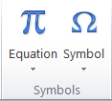
Using the Symbol Group with Equations
Once you open the equation editor in Word 2010, you'll have access to a variety of symbols for equations through the Symbols group in the Equation Tools.
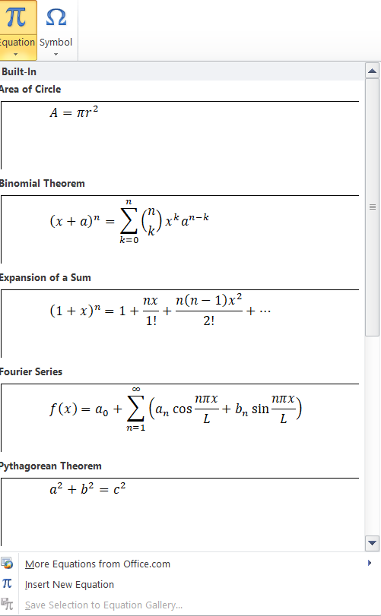
- When you're inside the equation editor, you'll see a new Design tab appear with various options in the Symbols group.
- The Symbols group in the Equation Tools ribbon gives you access to a wide range of symbols that are commonly used in mathematical and scientific equations, such as:
- Greek letters (e.g., α, β, γ, θ)
- Mathematical operators (e.g., +, −, ×, ÷)
- Relations (e.g., ≤, ≥, ≠)
- Fractions, radicals, and integrals
- Set notation symbols (e.g., ∈, ⊂, ∪)
Equation
In Microsoft Word, an equation is a tool that allows you to insert complex mathematical expressions, formulas, or scientific notations into your document. It provides a structured way to create and format equations using a variety of symbols, operators, and formatting options. The equation feature is especially useful for academic papers, scientific research, or any work that requires presenting mathematical or technical content.
More Equation from Office.Com
The More Equations option from Office.com in Microsoft Word allows users to access a library of predefined, commonly used mathematical and scientific equations. It provides a quick way to insert complex formulas such as quadratic equations, binomial expansions, and integrals without manually typing them.
Insert New Equation
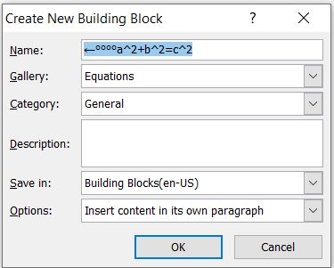
"Insert New Equation" in Microsoft Word allows you to create a custom mathematical equation from scratch using the equation editor.
Save Selection to Equation Gallery
In Microsoft Word, the option "Save Selection to Equation Gallery" allows you to save a custom equation for future use. This feature is useful when you frequently use the same equation in different documents.
Helping Tool of Equation Design Menu
When you insert an equation in Microsoft Word, the Equation Design Menu appears under the Equation Tools - Design tab. This menu provides various tools to help you create, format, and modify mathematical equations easily.
There are 3 Groups in Design Menu
- Tools
- Symbols
- Structures

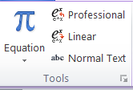
Tools Group in the Equation Design Menu (MS Word)
The Tools Group in the Equation Design Menu of MS Word provides essential features to format and manage equations effectively. This group allows users to switch equation formats, apply text styles, and use automatic corrections for mathematical symbols.
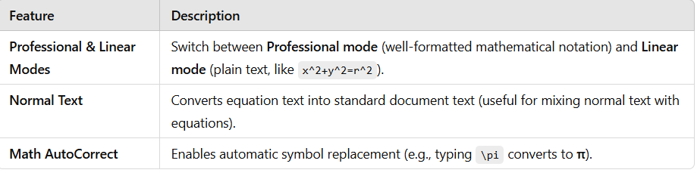

Symbols Group in MS Word
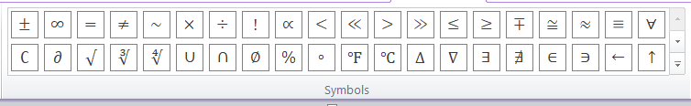
The Symbols Group in the Equation Design Menu of Microsoft Word provides commonly used mathematical symbols, making it easy to insert them into equations. It contains various categories of symbols, including basic math operators, Greek letters, and advanced mathematical notation.

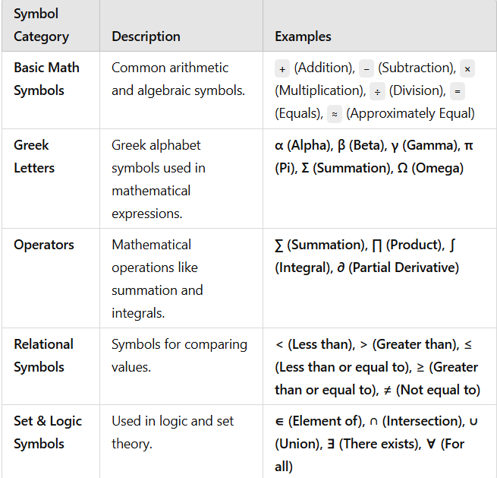

S
Structure Group in MS Word
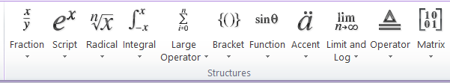
The Structure Group in the Equation Design Menu provides predefined mathematical structures to help users create complex equations easily. These structures include fractions, scripts (subscripts and superscripts), radicals, integrals, summations, brackets, functions, and matrices.

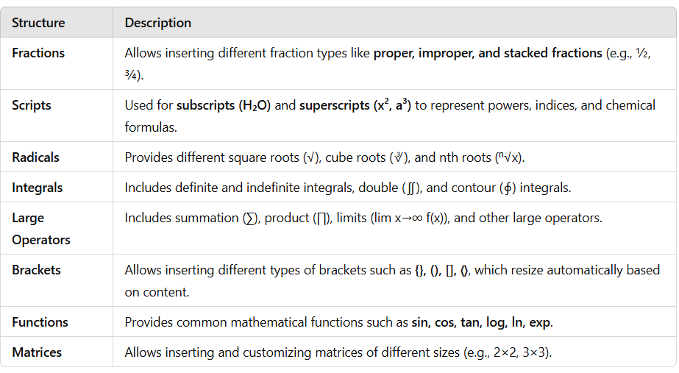

Make this Following Assignment in MS Word

