Microsoft Excel

Module 21 - Use of Sum IF and Sum IFs Function in MS-Excel

Sum IF and Sum IFs Function:

In Excel, the SUMIF and SUMIFS functions both sum the cells in a range that meet a certain condition, but they use slightly different behaviors: The SUMIF function sums the number of cells in a range that meet one condition. The SUMIFS function counts the number of cells in a range that meet several conditions.

SUMIF Function
The SUMIF function adds up the values in a range that meet a single condition or criteria.

FORMULA:

=SUMIF(range, criteria, [sum_range])
- range: The range of cells that you want to apply the condition to.
- criteria: The condition that defines which cells to sum. It can be a number, expression, or text.
- sum_range (optional): The actual cells to sum. If omitted, Excel sums the cells in the range.

Example:
If you have a list of sales in column B and the regions in column A, you can sum the sales for a specific region:
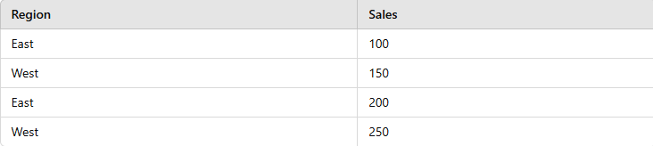

To sum the sales in the "East" region:
Formula =SUMIF (A2:A5, "East", B2:B5)

This formula will return 300 (100 + 200) because it adds the sales in column B where the region in column A is "East."

SUMIFS Function
The SUMIFS function adds up the values based on multiple conditions or criteria.

Formula:
=SUMIFS(sum_range, criteria_range1, criteria1, [criteria_range2, criteria2], ...)
- sum_range: The range of cells to sum.
- criteria_range1: The first range to apply the first condition to.
- criteria1: The condition for the first range.
- criteria_range2, criteria2, (optional): Additional ranges and conditions.

Example:
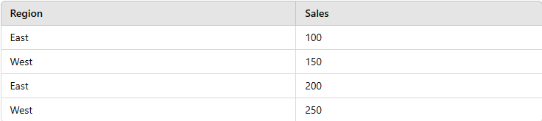
Continuing with the previous table, if you want to sum the sales in the "East" region and where the sales are greater than 150, you can use SUMIFS:

To sum the sales for the "East" region with sales greater than 150:
Formula:
=SUMIFS (B2:B5, A2:A5, "East", B2:B5, ">150")
This formula will return 200 because it adds the sales in column B where the region is "East" and the sales are greater than 150.

Application of SUM, SUMIF, and SUMIFS Functions in MS Excel

Each of these functions serves a different purpose. Below is a guide on when to use each function and its real-world application.

SUM Function: General Addition
When to Use?
Use SUM when you need to add a range of numbers without any condition.

Applications:
Total Sales Calculation: Add all sales values in a dataset.
Total Expenses Calculation: Add up all expenses in a budget sheet.
Adding Multiple Cells: Example - =SUM(A1:A10) sums all values from A1 to A10.

SUMIF Function: Conditional Addition (Single Condition)
When to Use?
Use SUMIF when you need to sum values based on one specific condition.

Applications:
- Calculate Total Sales for a Specific Region:

Example: Add sales only for "North" region.
Formula: =SUMIF(A2:A10, "North", B2:B10)

- Summing Expenses for a Category:
Example: Add expenses only for "Marketing".
Formula: =SUMIF(A2:A10, "Marketing", B2:B10)

- Calculate Total Salary for a Specific Department:
Example: Add salary values where Department = "HR".

SUMIFS Function: Conditional Addition (Multiple Conditions)
When to Use?
Use SUMIFS when you need to sum values based on multiple conditions.

Applications:
- Calculate Sales for a Specific Region AND Product Type:

Example: Sum sales where Region = "North" AND Product = "Laptop".
Formula: =SUMIFS(C2:C10, A2:A10, "North", B2:B10, "Laptop")

- Calculate Total Salary for a Specific Department & Job Role:

Example: Sum salary where Department = "HR" AND Job Role = "Manager".

- Summing Transactions Within a Date Range:

Example: Sum sales between 01-Jan-2024 and 31-Jan-2024.
Formula: =SUMIFS(B2:B10, A2:A10, ">=01-Jan-2024", A2:A10, "<=31-Jan-2024")

ASSIGNMENT:

Using the following data find the Sum IF and Sum IFs:

