Microsoft Word

Module 34 - Autocorrect and Bookmark in MS Word

Autocorrect

In Microsoft Word, AutoCorrect is a feature that automatically fixes common typing errors as you type. It can correct mistakes like misspelled words, capitalization errors, and even replace shortcuts with full text. This tool helps improve typing efficiency and ensures consistency throughout the document.

Key Features of AutoCorrect:
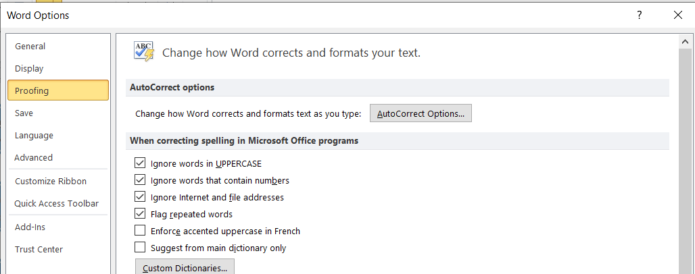
        - Fix Common Typos: AutoCorrect automatically corrects common spelling errors, such as typing "teh" instead of "the."
Click on This.
        - Automatic Capitalization: It can correct capitalization errors like automatically capitalizing the first letter of a sentence.
        - Replace Abbreviations with Full Text: For example, typing "omw" could be automatically replaced with "On my way."
        - Custom Shortcuts: You can set up your own abbreviations or shortcuts that Word will replace with longer text as you type (e.g., typing "addr" could automatically expand to "address").

How to Use and Customize AutoCorrect:
- Enable AutoCorrect: By default, AutoCorrect is enabled in Word, so it works automatically.
- Customize AutoCorrect:
- Go to the File tab and select Options.
- In the Word Options dialog box, select Proofing.
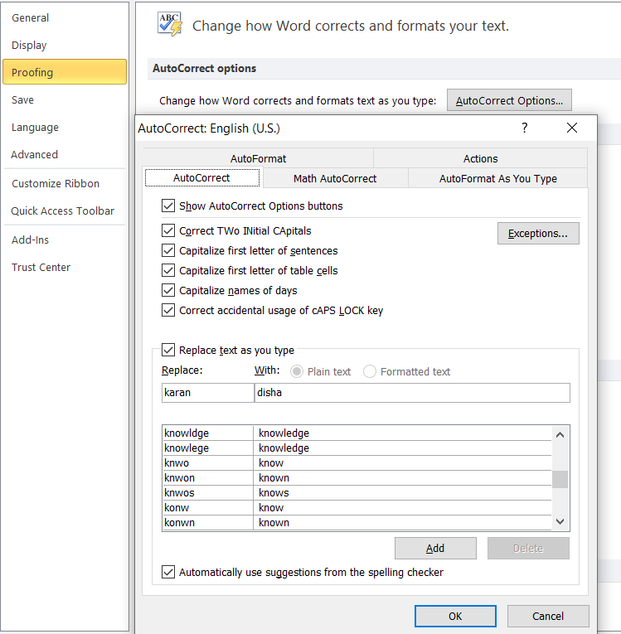
- Click AutoCorrect Options to open the AutoCorrect dialog box.
- Here, you can add new entries (e.g., create a shortcut like "btw" that automatically expands to "by the way"), or remove or modify existing ones.
- View AutoCorrect Entries: In the AutoCorrect tab, you can see the list of commonly corrected words or set up new replacements.

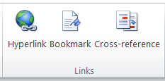
Links Group (Insert Menu)
In Microsoft Word, the Links group is a section found on the Insert tab of the ribbon that provides tools for adding and managing links within your document. It allows you to insert various types of links, such as hyperlinks, bookmarks, and cross-references, which can help navigate or connect information inside or outside your document.

Bookmark (Links Group)
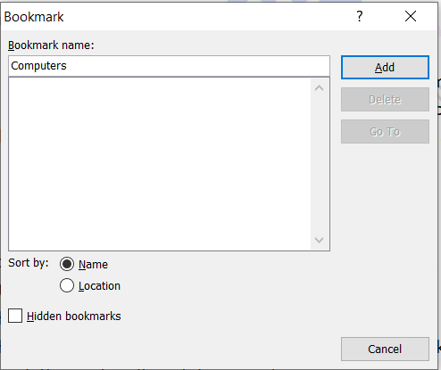
In Microsoft Word, a bookmark is a feature that allows you to mark a specific location or section in your document, so you can easily find and navigate to it later. Bookmarks are especially useful in long documents or when you're working on a large project and need to jump to specific sections quickly.

How to Add a Bookmark:
    - Place your cursor where you want to insert the bookmark.
    - Go to the Insert tab on the ribbon.
    - In the Links group, click Bookmark.
    - In the Bookmark dialog box, type a name for the bookmark (the name must start with a letter and can't contain spaces).
    - Click Add.

How to Navigate to a Bookmark:
- Go to the Insert tab and click Bookmark.
- In the dialog box, select the name of the bookmark you want to go to.
- Click Go To to quickly jump to the location marked by the bookmark.

How to Delete a Bookmark:
- Follow the same steps to open the Bookmark dialog box.
- Select the bookmark you want to delete.
- Click Delete.

Bookmarks are invisible when you print the document and are used only for your reference within the Word file. They're a great tool for keeping large documents organized and easy to navigate.

Assignment

Write this Following Paragraph In MS Word

The first day of school is always an exciting and nervous experience. As I walked into the school building, I felt a mixture of emotions—eager to meet new friends but also a bit anxious about what the day would bring. The hallways were filled with students, some chatting with their friends, while others looked around with a sense of curiosity. The sound of lockers opening and closing echoed throughout the school. In the classroom, the teacher introduced herself and went over the rules, and we did a few icebreaker activities to get to know each other. Even though it was a bit overwhelming at first, by the end of the day, I felt more comfortable and excited for the year ahead. The first day of school is always the start of something new, and it marked the beginning of a journey filled with learning, growth, and new friendships.

My classmates, some familiar and others unfamiliar, were all adjusting to their new routines, just like me. The teacher, with a welcoming smile, made us feel at ease as she explained what we would be learning and the fun activities planned for the year.

Instructions:
- Highlight the new Friendship with blue color.
- And add a bookmark with the name “First Day”

