Microsoft Word

Module 35 – Hyperlink and Cross Reference in MS Word

What is Hyperlink?
A hyperlink is a special type of link used in MS Word and other programs that let you quickly go to another place with just one click. It can connect your document to a website, another file, a location within the same document, or even an email address. When you click on a hyperlink, it takes you directly to the place it is linked to, like opening a webpage or starting an email. Hyperlinks are usually shown as blue and underlined text, and when you move your mouse over them, the pointer changes to a hand symbol. They are useful for giving extra information or making your document more interactive and easy to navigate.

Why use Hyperlinks?
Hyperlinks are useful when you want to:
- Add extra information from a website
- Link to a related document
- Help the reader move quickly within your document
- Make your document interactive
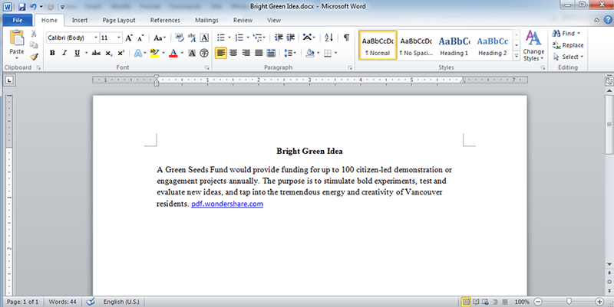

Hyperlink

Steps to Create a Hyperlink in MS Word Using Menu Options:
Open your MS Word document.
- Select the text or image you want to turn into a hyperlink.
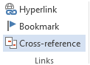
  - Example: Select the text "Click for more".
- Click on the "Insert" tab.
- In the Insert tab, look for the "Links" group.
- Click on the "Link" option (or it may show as "Hyperlink" depending on your version).
- A dialog box called "Insert Hyperlink" will appear.

- In the "Address" box at the bottom, type or paste the website URL or choose a file or location.
- For website: Type https://www.wikipedia.org
- For file: Browse and select a file
  - For document location: Click "Place in This Document"
  - For email: Click "E-mail Address"
  - After entering the link, click OK.
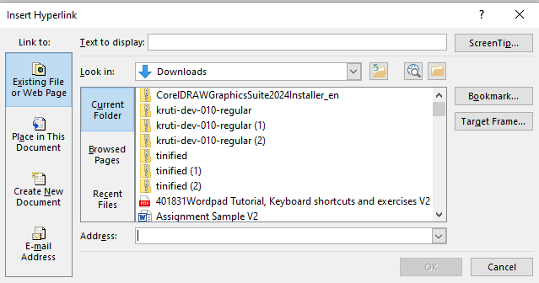

What is Cross-Referencing?
Cross-referencing is a technique used in various fields, including writing, research, and data management, to direct the reader or user from one part of a document, dataset, or system to another related part. The goal is to establish connections or relationships between different pieces of information so that they can be easily found and understood in context.

In simple terms, it means pointing out where similar, complementary, or related information can be found elsewhere, often providing more context, background, or examples.

Steps to Insert a Cross-Reference in MS Word

      - Open the Word document in which you want to insert the cross-reference.
      - Place the Cursor:
      - Position the cursor where you want to insert the cross-reference (e.g., within the text, after a sentence, or paragraph).
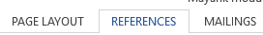
      - Go to the "References" Tab:
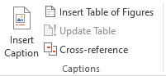
      - In the top menu, click on the "References" tab. This tab contains options for adding citations, footnotes, and cross-references.
      - Click on "Cross-reference":
      - In the "Captions" group (toward the right), click on the "Cross-reference" button. This will open the "Cross-reference" dialog box.
      - Choose the Type of Item to Cross-Reference:
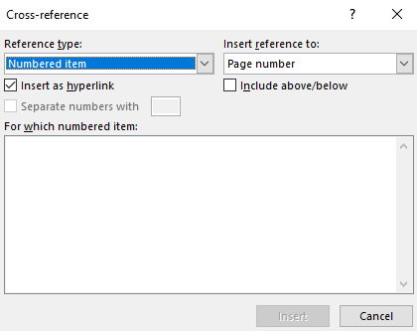
      - In the "Cross-reference" dialog box, you’ll see a dropdown menu under "Reference type". This menu allows you to choose the type of item you want to reference:
      - Heading: Refers to the heading in the document.
      - Figure: Refers to a figure (if you have inserted captions for figures).
      - Table: Refers to a table (if you've inserted captions for tables).
      - Numbered Item: Refers to numbered lists or items.
      - Footnote/endnote: Refers to footnotes or endnotes.
      - Bookmark: Refers to a bookmark within the document (if bookmarks are set).
      - Select the appropriate reference type for your needs (e.g., Heading, Figure, etc.).
      - Select the Item to Reference:
      - After selecting the reference type, the "For which" box will display the available items (e.g., all the headings, figures, or tables in your document).
      - Click on the item you want to reference. For example, if you're referencing a heading, you’ll see a list of all the headings in your document. Click on the appropriate heading.
      - Choose the Cross-Reference Format:
      - Under "Insert reference to", you can choose how you want the cross-reference to appear. There are several options, such as:
      - Only label and number: Only the label (e.g., “Figure 1”) or number is inserted.
      - Heading text: The full text of the heading is inserted.
      - Page number: Insert the page number of the referenced item.
      - Above/below: Shows whether the referenced item is above or below in relation to the cross-reference.
      - Choose the format that fits your needs.
      - Insert the Cross-Reference:
      - Once you've selected the item and the format, click the "Insert" button.
      - Word will insert the cross-reference in the location where your cursor was.
      - Close the Dialog Box.

