Microsoft Word

Module 42 – Using Drop Cap, Quick Parts and Signature Line in MS Word

What is Drop Cap?

In MS Word, a Drop Cap is a large capital letter that appears at the beginning of a paragraph. It drops down into the lines below, making the paragraph look stylish and decorative. Drop Caps are often used in storybooks or magazines to make the first letter stand out. You can find this option in the Insert tab.

Steps to use Drop Cap:
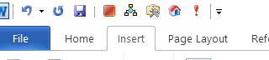
- Open MS Word and type your paragraph.
- Click on the Insert tab at the top.

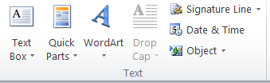
- Click on Drop Cap in the “Text” group.

- Choose Dropped (inside the paragraph) or In Margin (outside the paragraph).
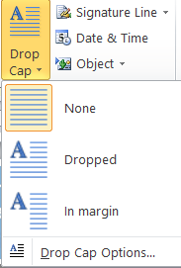
- The first letter of your paragraph will now appear bigger as a Drop Cap.

What is Quick Parts option in MS Word?
The Quick Parts option in MS Word is a feature that lets you save and reuse pieces of content, like text, images, tables, or document properties. It’s helpful when you have something you use often—like a signature, disclaimer, or company info—so you don’t have to type or copy-paste it every time.

You can find Quick Parts under the Insert tab. Once saved, these reusable items are stored in the Building Blocks Organizer, and you can quickly insert them into any document. It saves time and keeps your formatting consistent across documents.

For example, if you always add a specific paragraph at the end of your reports, you can save it as a Quick Part. Then, instead of typing it out each time, just click to insert it—fast and easy!

Steps to Use Quick Parts in MS Word:

1. Select the Content
Highlight the text, image, table, or content you want to save as a Quick Part. This can be anything you use often in documents.

2. Go to Insert Tab
Click on the Insert tab at the top of Word. In the Text group, click on Quick Parts.
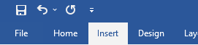

3. Save to Quick Parts
From the dropdown, choose Save Selection to Quick Part Gallery. Give it a name and click OK to save it.
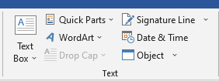

4. Use a Quick Part
To reuse it, place your cursor where you want it, go to Insert > Quick Parts, and click the item you saved.
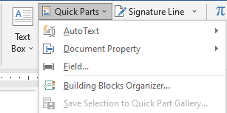

5. Manage Quick Parts
To edit or delete, click Quick Parts > Building Blocks Organizer. From there, you can manage all your saved entries.

What is Signature Line in MS Word?

A Signature Line in MS Word is a special placeholder used to show where a document needs to be signed. It’s commonly used in formal documents like agreements, letters, or forms to indicate the space for a signature.

When you insert a signature line, it includes fields like the signer’s name, title, and instructions. This makes it easy for someone to know exactly where and how to sign, either by hand or digitally.

In digital documents, the signature line can also be used for electronic signatures if the signer has a digital certificate. This helps in making the signing process more secure and professional.

Steps to use Signature Line in MS Word:

1. Place the Cursor
Click where you want to insert the signature line in your document.

2. Go to Insert Tab
Click on the Insert tab at the top of the screen.

3. Click on Text Group
In the Text group, click Add a Signature Line (under "Text" tools).
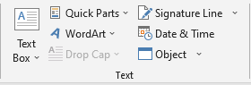

4. Choose Microsoft Office Signature Line
Select Microsoft Office Signature Line from the dropdown menu.
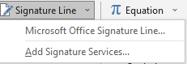

5. Fill in Details
In the pop-up box, enter the signer’s name, title, and any instructions.
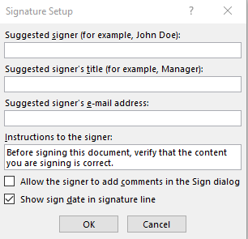

6. Click OK
Click OK to insert the signature line into your document.

Assignment

Write the given paragraph with H as Drop Cap

H
oli, also known as the Festival of Colors, is a vibrant Indian festival celebrated to mark the arrival of spring and the victory of good over evil. It's a time of joyous gatherings, playful color-throwing, and the sharing of sweets and treats. The night before Holi, people celebrate Holika Dahan by burning bonfires, and the following day is dedicated to playing with colored powders and water balloons. Holi brings people together in a spirit of fun and festivity, creating a memory of colorful joy.

