Microsoft Word

Module 47 - Creating an OMR Sheet in MS Word

What is an OMR Sheet?
OMR stands for Optical Mark Recognition. An OMR sheet is a special kind of paper used to capture human-marked data. It is commonly used in exams, surveys, and other forms where users fill in bubbles or boxes to mark their answers or choices.

Purpose of OMR Sheets
OMR sheets are used mainly in multiple-choice exams. Candidates fill in bubbles with a dark pencil or pen, and machines quickly scan and read these marks. This helps in fast and accurate evaluation, especially when thousands of sheets need to be checked.

Benefits of Using OMR Sheets
OMR sheets save time and reduce human error in checking answer sheets. They are helpful in large competitive exams like NEET, JEE, and government job tests. The data collected through OMR sheets can also be stored and analyzed easily on computers.

Other Uses of OMR Sheets
Apart from exams, OMR sheets are used in surveys, polls, feedback forms, and registration processes. Schools, colleges, and research organizations use them to gather information quickly and accurately from a large number of people.

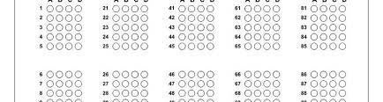

Codes for Making Circles with option:
Press (24d0Alt+x) for ⓐ
Press (24d1Alt+x) for ⓑ
Press (24d2Alt+x) for ⓒ
Press (24d3Alt+x) for ⓓ

