Microsoft Excel

Module 47 – Using Thesaurus and Macros in MS Excel

What is Thesaurus option in MS Excel?

The Thesaurus in MS Excel is a tool that helps users find synonyms (words with similar meanings) and antonyms (words with opposite meanings). It is useful when working with text in Excel, especially for creating reports, labels, or descriptions where better or more appropriate words may be needed.

To use the Thesaurus, you can right-click on a word and select Synonyms or go to the Review tab and click on Thesaurus. This feature helps improve the quality of written content by offering word suggestions, making your text more professional and varied.

Steps to use Thesaurus option in MS Excel:
- Select the cell that contains the word you want to look up.

- Click on the Review tab on the ribbon.

- Click on the Thesaurus button in the Proofing group.
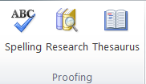

- The Research pane will open on the right with synonyms for the selected word.
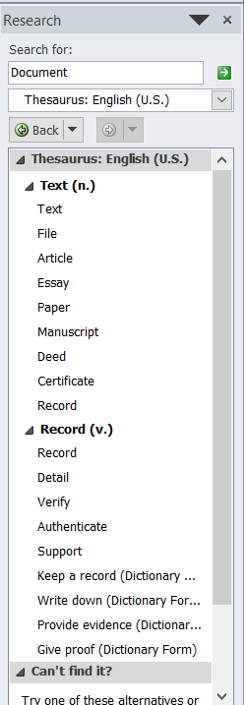
- Click on a synonym to see more options or right-click to insert it into the cell.

What is Macros in MS Excel?
The Macro option in the View tab of MS Excel is a feature that helps you automate repetitive tasks by recording your actions and saving them as a macro. A macro is a set of instructions that Excel follows to repeat tasks automatically, such as formatting cells, creating reports, or performing calculations.

In the View tab, the Macros group contains the "Macros" dropdown menu, where you can choose to Record Macro, View Macros, or Use Relative References. When you click Record Macro, Excel starts tracking every action you do—like typing, formatting, or sorting. Once you stop recording, you can replay those actions anytime by running the macro.

This option is very useful when you have to do the same task again and again, as it saves time and ensures accuracy. The macros created from the View tab are stored using VBA (Visual Basic for Applications) in the background, but you don’t need to know coding to use this feature.

Steps to use Macro option in MS Excel:
- Open your Excel file and go to the View tab.

- Click on the Macros dropdown in the Macros group.
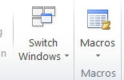
- Select Record Macro from the list.
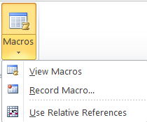
- Give your macro a name and click OK to start recording.
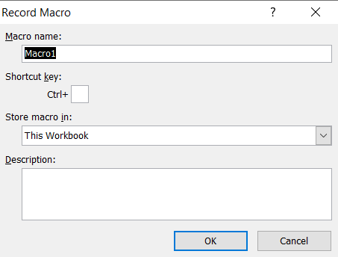
- Perform the actions you want Excel to remember (like formatting or calculations).
- Once done, go back to the View tab, click Macros, and choose Stop Recording.
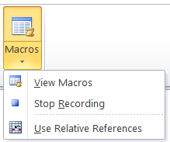

- To run the macro later, click Macros, select your macro name, and click Run.
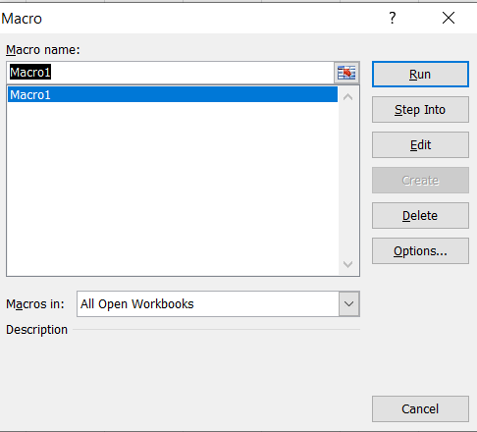

Assignment

Create an Excel spreadsheet that contains:
- A dataset (e.g., student marks, sales report, attendance record — choose any one).
Roll No | Name | Subject 1 | Subject 2 | Subject 3
101 | Arjun Mehra | 78 | 85 | 90
102 | Priya Singh | 88 | 79 | 92
103 | Rohan Khanna | 70 | 67 | 74
104 | Meena Joshi | 95 | 89 | 93
105 | Aman Gupta | 60 | 72 | 68

- Use a macro to automate at least two of the following tasks:
  - Formatting the data (bold headers, color rows)
  - Calculating totals or averages: find total marks of all students and average marks.
  - Sorting the data by a specific column
  - Inserting a timestamp
- Create a button in the worksheet that runs your macro.
- Add a brief description in a separate worksheet explaining what your macro does.

