Microsoft Power Point

Module 8 – Formatting Text, Color and Text Alignment in Power Point

1. Formatting Text in MS PowerPoint
Formatting text means changing the appearance of the text to make it look attractive and clear. This includes changing the font style, font size, making the text bold, italic, or underlined.

PowerPoint gives many options to format the text using the Home tab. You can also use bullets, numbering, and word spacing to improve the presentation’s readability. Well-formatted text helps highlight important information.

Steps to Format Text in Power Point:
- Open PowerPoint and select the slide where you want to format text.
- Click inside the text box that has the text you want to format.
- Highlight the text using your mouse.
- Go to the Home tab on the Ribbon.
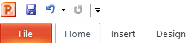

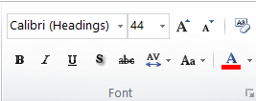
- Choose a font style from the Font dropdown list.

- Select a font size from the size box.

- Click Bold (B), Italic (I), or Underline (U) as needed.

- Use the Font Color button to change the text color.

- Use the Text Shadow or Text Effects for special styles.
- Click outside the text box to see your formatted text.
2. Color in MS PowerPoint
Color options allow you to change the text color, background color, or highlight color. This is useful to make text stand out or to match the color theme of the presentation.

You can find color tools under the Font group in the Home tab. Using color properly adds beauty and draws attention to key points in the slides.

3. Text Alignment in MS PowerPoint
Text alignment is used to set the position of text on a slide. You can align the text to the left, center, right, or justify it so that it spreads evenly.

You can find alignment options in the Paragraph group on the Home tab. Correct alignment makes the content look neat and well-arranged, which helps the audience read easily.

Steps to use Text Alignment in MS Power Point:
- Open your PowerPoint presentation and select the slide with the text.
- Click inside the text box that you want to align.
- Highlight the text you want to align.
- Go to the Home tab on the Ribbon.

- In the Paragraph group, choose one of these alignment buttons:
  - Align Left – to align text to the left side.
  - Center – to place text in the middle.
  - Align Right – to align text to the right side.
  - Justify – to evenly space the text on both sides.

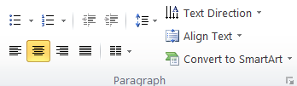

- Click the desired alignment, and the text will adjust automatically.

Ordered List:
An ordered list uses numbers to show the order of items. It's useful when the order is important, like steps in a process or ranking.

Unordered List (Bulleted List)
An unordered list uses symbols (bullets) instead of numbers. It's used when the order doesn't matter.

- Open your PowerPoint presentation.
- Click on the slide where you want to add bullets.
- Click inside a text box or insert a new one.
- Type your first item.
- Press Enter to type the next item.
- Select the text you typed.
- Go to the Home tab on the ribbon.
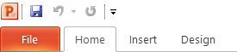
- Click the Bullets icon (•) in the Paragraph group.
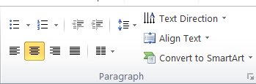

- Your list will now have bullets.
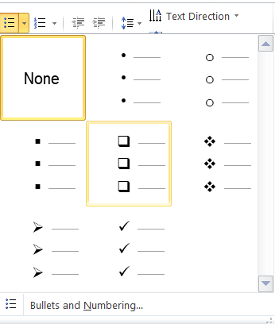
- Click the arrow next to the Bullets icon to change the bullet style.

How to Make Numbered List in Power Point?
- Select the text you want to number.
- Click on the "Home" tab on the Ribbon.
- Click on the "Numbering" icon (it looks like 1, 2, 3) in the Paragraph group.
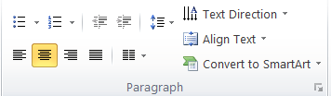
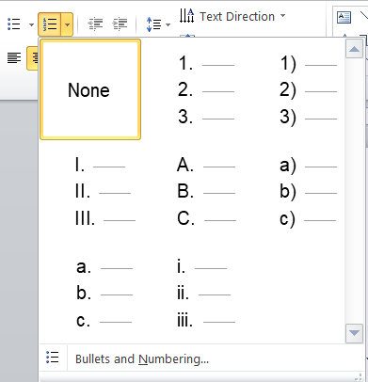
- Choose a numbering style if needed.

What is Line Spacing Option in MS Power Point?
Line spacing refers to the amount of vertical space between lines of text in a paragraph. It helps make text easier to read and can give a cleaner look to the slide. In PowerPoint, you can increase or decrease line spacing to fit content better or make it more visually appealing. Common options include single, 1.5, and double spacing.

Steps to use Line Spacing Option in MS Power Point:
- Select the text where you want to change the line spacing.
- Click on the "Home" tab on the Ribbon.
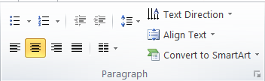
- Click on the "Line Spacing" button in the Paragraph group (it looks like lines with arrows).

- Choose a spacing option like 1.0, 1.5, or 2.0 from the dropdown.

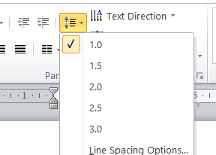

Assignment

📢 Slide 1: Introduction to Social Media

Title:
Social Media: Connecting the World Digitally
(Bold, Font Size 36, Color: Dark Blue, Center Aligned)

Content:

- Social media refers to web-based platforms that allow people to create, share, and interact with content.
- Popular platforms include Facebook, Instagram, Twitter (X), LinkedIn, and TikTok.
- Social media enables communication, collaboration, and content creation globally.

🖌️Formatting Instructions:

- Set body text font to Calibri, Size 24
- Bold key terms like create, share, interact
- Use Dark Gray color for body text
- Center align the title; left align the content

🌐Slide 2: Benefits of Social Media

Title:
Why Social Media Matters
(Bold, Font Size 32, Color: Teal, Center Aligned)

Content (Bullet Points):

- Staying Connected: Talk to friends & family across the globe
- Information Access: Follow current news & trends
- Business Growth: Promote products and build brands
- Learning Opportunities: Access educational content
- Community Building: Join groups and share common interests

🖌️ Formatting Instructions:

- Use Arial, Size 22 for bullet text
- Bold all benefit titles (e.g., Staying Connected)
- Use Royal Blue for benefit titles and Black for details
- Keep all text left aligned
- Add a relevant icon or visual for each benefit (optional)

⚠️ Slide 3: Risks and Responsible Use

Title:
Be Smart, Be Safe
(Bold, Font Size 30, Color: Red, Center Aligned)

Content:

- Privacy Risks: Oversharing personal info can lead to identity theft
- Misinformation: Always fact-check before believing or sharing
- Digital Addiction: Balance screen time with offline activities
- Cyberbullying: Be respectful and report harmful behavior

🖌️ Formatting Instructions:

- Use Verdana, Size 20 for body text
- Highlight Privacy Risks, Misinformation, etc., in Bold Red
- Use Italic for tips like "fact-check" and "Balance screen time"
- Align content left, and use bullets or icons for each point

