Microsoft Excel

Module 48 – Using Track Changes in MS Excel

What are Track Changes Option in MS Excel?
The Track Changes option in MS Excel is a feature used to keep a record of all the changes made to a workbook. It is especially useful when multiple people are working on the same file. When Track Changes is turned on, Excel highlights any edits made—such as data changes, formatting, or cell deletions—so that you can see who made the change, what was changed, and when it happened. This allows for easy monitoring of edits and helps in maintaining the integrity of the data.

This feature is commonly used in collaborative work environments where you want to review and approve changes before they become permanent. All tracked changes can be reviewed, accepted, or rejected by the workbook owner.

To use this feature, you usually need to share the workbook (in older Excel versions) by going to Review > Track Changes > Highlight Changes. In newer versions like Excel for Microsoft 365, this feature has been replaced by co-authoring and version history, but it's still available under legacy sharing settings. Track Changes ensures transparency and accountability in shared Excel files.

Steps to use Track Changes option in MS Excel:

- Open your Excel file.
- Click on the Review tab in the ribbon.

- Click Track Changes in the Changes group.
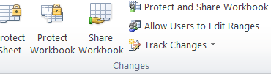

- Select Highlight Changes from the dropdown menu.
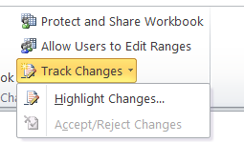

- In the dialog box, check "Track changes while editing. This also shares your workbook."
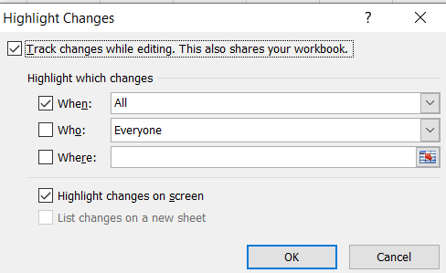
- Choose when and for whom to highlight changes (e.g., "All" and "Everyone").
- Click OK, and then save the workbook when prompted.
Use of Track Change feature in MS Excel:
Track Changes in MS Excel is a feature that shows all the edits made to a workbook. It highlights who made the changes, when they were made, and what was changed. It is very useful when many people are working on the same file, so everyone can see and review what has been changed.

Uses of Track Changes in MS Excel:

Collaboration:
Helps when multiple users are editing the same sheet. Everyone can see who changed what.
Reviewing Edits:
You can easily review, accept, or reject changes one by one.
Record Keeping:
It keeps a history of changes, so if a mistake happens, you can find out when and where it was made.
Accountability:
You can know which user made specific changes, which helps in tracking responsibility.
Protect Data:
You can protect the sheet so that unauthorized users cannot turn off track changes.

Need of Track Changes option in MS Excel:

Teamwork on Same File:
When many people work on the same Excel file, it helps everyone see what changes were made, by whom, and when.
Review and Approval:
Before finalizing a report or data sheet, changes can be reviewed, accepted, or rejected easily.
Error Tracking:
If there is a mistake, you can check the change history and find out who made the error.
Accountability:
Each change is recorded with the user’s name and time, so there is clear responsibility.
Record of Changes:
It keeps a log of all edits, useful for important documents like financial reports, project tracking, or audits.
Data Protection:
Helps to protect important data by carefully checking and approving changes.
Easy Comparison:
You can compare the original data with the changed data without guessing.

Assignment

Create a Simple Dataset

Student ID | Name | Subject | Marks
101 | Alice Johnson | Math | 85
102 | Bob Smith | Science | 78
103 | Carol Davis | English | 92
104 | David Wilson | History | 88

Make Changes to the Dataset
Suppose you need to update some records:
- Change Bob Smith's marks from 78 to 82.
- Update Carol Davis's subject from English to Literature.
- Add a new student:
  - Student ID: 105
  - Name: Eva Brown
  - Subject: Math
  - Marks: 90

Make these changes in the worksheet accordingly.

Enable Track Changes in Excel:
To track the modifications:
- Enable Track Changes:
- Go to the Review tab on the Ribbon.
- Click on Track Changes in the Changes group.
- Select Highlight Changes from the dropdown.
- Configure Highlight Changes:
In the dialog box that appears:
- Check the box for Track changes while editing. This also shares your workbook.
- Ensure Highlight changes on screen is checked.
- Optionally, check List changes on a new sheet to view a summary.
- Click OK.

