Microsoft Excel

Module 49 – Workbook and Worksheet Protection in MS Excel

Workbook Protection

Workbook protection in Excel is used to secure the structure of the entire workbook. When you apply this, users cannot add, delete, rename, or move worksheets within the workbook. This is useful when you want to keep the overall layout and sheet arrangement unchanged.

You can enable workbook protection by going to:
Review tab → Protect Workbook → Choose “Protect structure” and set a password (optional).

Worksheet Protection

Worksheet protection helps you lock specific cells or the entire sheet so users can’t change formulas, enter data, or modify formatting. You can allow some actions like selecting or formatting cells even when protection is on.

To protect a worksheet:
Go to Review tab → Protect Sheet, and then choose what users are allowed to do and optionally set a password.

Steps to Protect Worksheet:

- Open your Excel file and go to the sheet you want to protect.
- Click on the “Review” tab from the top menu.

- Click on “Protect Sheet” in the Review tab.
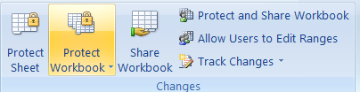

- A box will appear – type a password (optional) and select the actions you want to allow (like select cells, format, etc.).
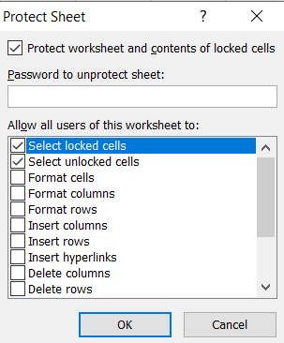
- Click OK, and if you entered a password, confirm the password.
- The worksheet is now protected – users can only do what you allowed.

Steps to Protect Workbook in MS Excel:
- Open your Excel file that you want to protect.
- Click on the “Review” tab from the top menu.
- Click on “Protect Workbook”.

- In the pop-up, check “Structure” to prevent adding, deleting, or moving sheets.
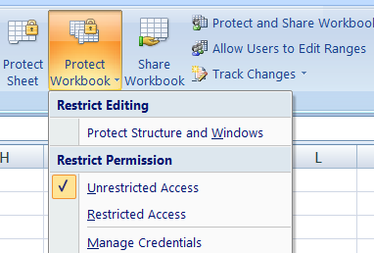
- Enter a password (optional) and click OK.
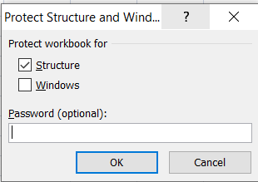
- If you used a password, re-enter it to confirm and click OK again.

Why do we need to Protect Workbook and Worksheet in MS Excel:

1. Prevent Accidental Changes
People might delete or change formulas or data by mistake. Protection helps keep important information safe.

2. Control What Others Can Edit
You can allow users to change only certain cells (like input fields) and lock the rest.

3. Protect Formulas and Calculations
If your sheet has important formulas, protection stops others from editing or deleting them.

4. Restrict Structure Changes
You can protect the workbook so users can't:
- Add or delete sheets
- Move or rename sheets
5. Useful in Shared Files
In team projects, it ensures that only specific people can make changes, keeping the data consistent.

