Microsoft Power Point

Module 23 - Using Smart Art in Power Point

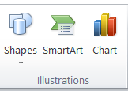
Smart art (ILLUSTRATION)

SmartArt is a feature that allows you to visually represent information and ideas using a variety of pre-designed layouts, transforming text and bullet points into engaging graphics.

How to Insert Smart Art in PowerPoint?

- Open PowerPoint and navigate to the slide where you want to insert the SmartArt graphic.
- Click the "Insert" tab on the ribbon.
- In the "Illustrations" group, click the "SmartArt" button.
- A dialog box will appear with various SmartArt layouts categorized by type (e.g., List, Process, Cycle, Hierarchy, Relationship, Matrix, Pyramid).
- Select the category and the specific SmartArt layout you want to use.
- Click "OK" to insert the SmartArt graphic onto your slide.
- A text editor will appear on the left side of the graphic, allowing you to enter your text.

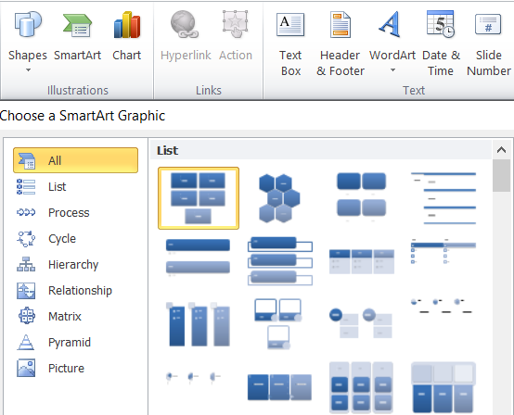

Types of Smart Art:

- List: This category includes layouts like "Horizontal Bullet List" and "Vertical Block List" for simple, visually appealing lists.
- Process: Illustrates steps or stages in a sequential order, often used for workflows or timelines.
- Cycle: Depicts cyclical or repeating processes, showing how elements are interconnected in a loop.
- Hierarchy: Represents organizational structures, showing levels of subordination or relationships within a system.
- Relationship: To show connections between different things, like relationships in a family tree.
- Matrix: For displaying data in a grid-like format for comparisons, like a table of product features.
- Pyramid: To illustrate a hierarchy with the most important element at the top, like a company structure.
- Picture: To create a collage or gallery of images.

Helping Tool of Smart Art (Design And Format Tab) :-
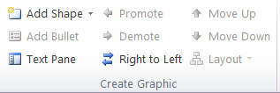

Add Shape
It means inserting a visual element like a rectangle, circle, line, arrow, star, etc., onto a slide.

Add bullets
Bullets in PowerPoint, we’re referring to the small symbols or dots that appear in front of lines of text — usually in lists.

Text pane
It’s a side panel that shows a text-based outline of your SmartArt graphic or other structured content.Think of it as the “behind-the-scenes” text editor for visual objects.

Promote
To promote something means to move it up one level in the outline or hierarchy.

Demote
“Demote” is the opposite of “Promote.” It means to move an item down a level in a bulleted list or SmartArt graphic.

Move up
"Move Up" refers to the action of shifting an object, text, or item higher in the order.

Move down
"Move Down" refers to the action of shifting an item, text, shape, or object lower in the order.

Right to left
"Right to Left" refers to the direction in which the text or content flows.

Layouts
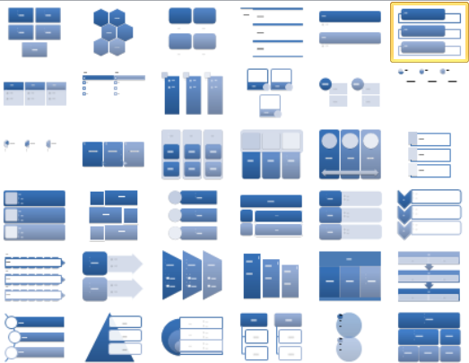
In PowerPoint, a layout refers to a predefined arrangement of placeholders on a slide, dictating where content like text, images, and charts can be placed, ensuring a consistent and organized presentation.

Smart Styles

In PowerPoint, SmartArt Styles are pre-defined visual effects that enhance the look of SmartArt graphics, including line styles, bevel effects, and 3-D options. You can apply them to change the overall visual style of your SmartArt.
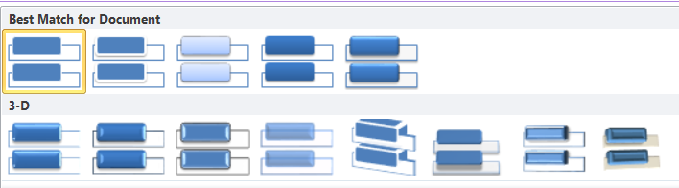

Reset
In PowerPoint, "Reset Graphic" returns a SmartArt graphic to its original, default formatting, including layout and colors, effectively undoing any customizations.
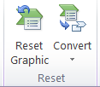
Convert
It can refer to changing the format of a file, or it can be used to describe the process of transforming text or objects in a slide to appear or move in a specific way. For instance, you might convert a presentation from one version to another, or you might animate text to appear one line at a time.

Design Tab:

The Design tab for SmartArt in MS PowerPoint appears when you select a SmartArt graphic on a slide. This tab provides tools to customize the layout, style, and formatting of the SmartArt.

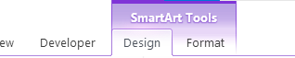

Create Graphic Group
This group helps you add or remove shapes and change the order of items in the SmartArt.

- Add Shape – Adds a new shape to your SmartArt (e.g., another bullet or box).
- Add Bullet – Adds a bullet point inside the selected shape (if the layout allows).
- Text Pane – Opens a side pane to type text for the SmartArt.
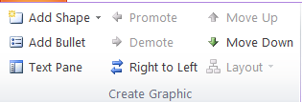
- Promote – Moves a shape up one level (makes it more important).
- Demote – Moves a shape down one level (makes it less important).
- Right to Left – Reverses the direction of the SmartArt layout.
- Move Up/Move Down – Changes the position of shapes in the structure.

Layouts Group
This group allows you to change the entire structure of the SmartArt.

- Layouts Gallery – Shows different layout options (like list, process, cycle, hierarchy, etc.).
- You can choose a layout that better fits your content type.
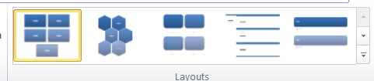

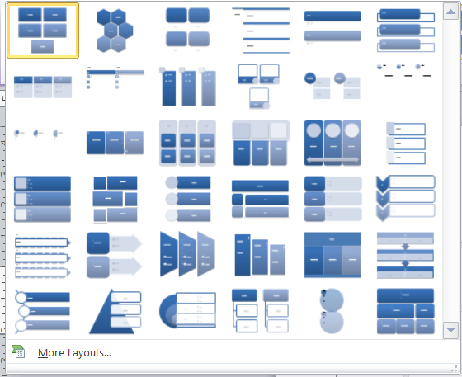

SmartArt Styles Group
This group lets you change the appearance of your SmartArt quickly.

- SmartArt Styles – Offers pre-designed looks like 3D, shaded, metallic, etc.
- Change Colors – Changes the color scheme of the entire SmartArt.
- Options include colorful styles, monochromatic styles, and theme-based styles.
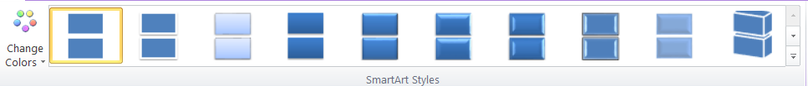

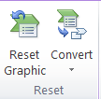
Reset Group
This group is used to undo customizations.
- Reset Graphic – Removes all custom formatting and restores the original layout and style.

Format Tab:
The Format tab for SmartArt in MS PowerPoint appears along with the Design tab when you select a SmartArt graphic. This tab helps you customize the appearance of individual shapes inside the SmartArt (like changing shape color, size, text style, etc.).

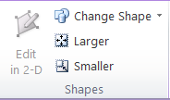
Insert Shapes Group
- Insert Shapes – Lets you add a new shape to your SmartArt.
- Edit Shape – Allows you to:
  - Change Shape – Replace the selected shape with another (e.g., rectangle to circle).
  - Edit Points – Adjust shape corners manually (advanced option).

Shape Styles Group
Used to change the look of the selected shape.

- Shape Fill – Change the inside color of the shape.
- Shape Outline – Change the border color or thickness.
- Shape Effects – Add special effects like shadow, glow, 3D, bevel, etc.
- Quick Styles – Apply a preset style with one click (combines fill, outline, and effect).

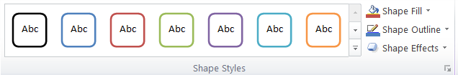

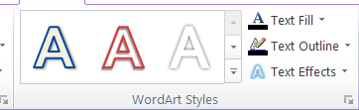
WordArt Styles Group
Used to style the text inside a shape.

- Text Fill – Change the color of the text.
- Text Outline – Change the border/edge color of the text.
- Text Effects – Add glow, reflection, shadow, 3D effects, etc., to the text.
- Quick Styles – Ready-made text styles for fast formatting.

Arrange Group
Helps you position and layer shapes.
- Bring Forward / Send Backward – Move a shape in front of or behind others.
- Selection Pane – Shows a list of all objects on the slide, useful for selecting.
- Align – Align shapes (left, center, middle, etc.).
- Group / Ungroup – Combine multiple shapes into one group or split them apart.
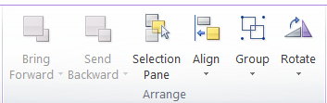
- Rotate – Turn shapes in different directions (e.g., 90°, flip horizontally).

Assignment

Make the following Two Slides using Smart Art

