Microsoft Excel

Module 45 – Using Pivot Table and Chart in MS Excel

What is Pivot Table?

- A pivot table is a tool in MS Excel used to summarize, organize, and analyse large amounts of data quickly and efficiently.
- It allows you to rearrange (or “pivot”) the data to view it from different angles without changing the original data.
- It can perform automatic calculations such as sum, average, count, min, max, etc., on your data.
- Data fields can be dragged and dropped into rows, columns, values, and filters to change the layout and get different summaries.
- Pivot tables are useful for grouping data, for example by months, product categories, or regions.

- Helps to quickly answer specific questions like:
- How many products were sold in each region?
- What are the total sales per salesperson?
- Which month had the highest revenue?
- You can filter, sort, and rearrange the data easily without using formulas.
- The pivot table is dynamic, meaning it updates automatically when the source data is changed or refreshed.
- Saves time and effort compared to manually creating summaries or using multiple formulas.
- Often used in business reports, data analysis, sales tracking, and decision-making processes.
Need for Pivot Table in MS Excel:
A Pivot Table in Microsoft Excel is a powerful tool used to summarize, analyze, explore, and present large amounts of data. Here are the main reasons why Pivot Tables are needed:
- Summarize Large Data Sets Easily:
Pivot Tables allow you to quickly condense large data sets into meaningful summaries without using complex formulas.
Example: Total sales per region from thousands of sales records.
- Dynamic Data Analysis:
You can easily drag and drop fields to rearrange and analyze your data from different perspectives.
Example: View sales by product, then by salesperson, then by region — all in seconds.
- Automatic Grouping and Sorting:
Pivot Tables automatically group data (e.g., dates into months or quarters) and allow sorting based on values or labels.
Example: Group transactions by month and then sort them by highest revenue.
- Quick Calculations:
They support built-in calculations like sum, average, count, min, max, etc., without writing formulas.
Example: Find the average sales per employee without =AVERAGEIF().
Steps to Create a Pivot Table in Excel
Step 1: Select Your Data
Click anywhere inside your data table (the range of data you want to analyze).
Make sure your data has headings (like "Product", "Sales").
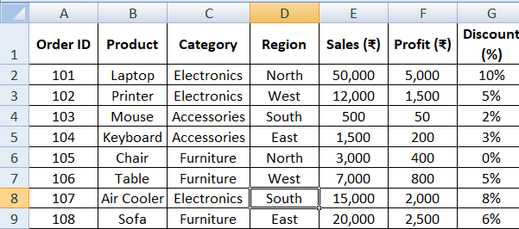

Step 2: Insert Pivot Table
- Go to the Insert tab on the top menu.


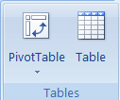
- Click on PivotTable.

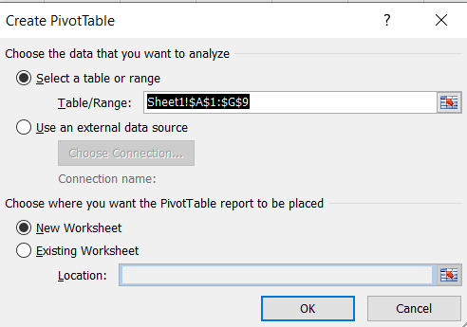
- A box will pop up — Excel will automatically select your data.

    - Choose where you want the Pivot Table to appear.
    - New Worksheet (recommended)
    - Or Existing Worksheet
- Click OK.

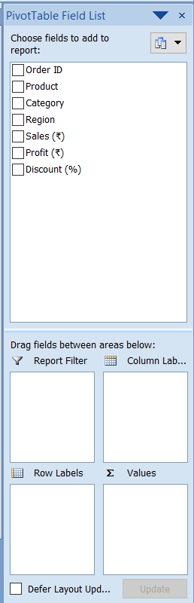
Step 3: Add Fields to Your Pivot Table
- You will now see the PivotTable Field List on the right side of the screen.
- Drag fields into these areas:
  - Rows: To group data (e.g., Product Name, Region
  - Values: To calculate numbers (e.g., Total Sales)
  - Columns: To compare data side-by-side (e.g.Discount)
  - Filters: To filter data (e.g., Category)

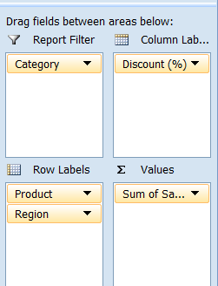

Step 4: Your Pivot Table Is Ready
Excel will automatically create a summary table based on your choices.
You can change it anytime by moving fields around.
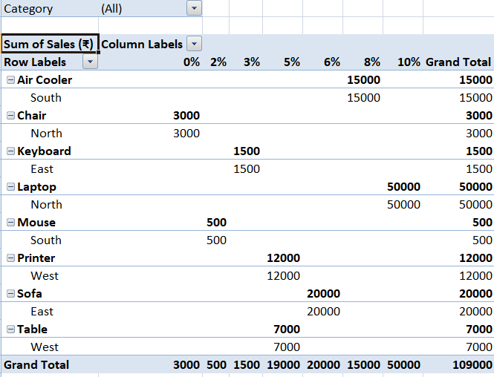

What is Pivot Chart in MS Excel?
A Pivot Chart in MS Excel is a visual representation of the data that comes from a Pivot Table. It helps you to quickly understand and analyze large amounts of data by showing it in the form of charts like bar charts, column charts, line charts, or pie charts.
A Pivot Chart makes it easier to spot trends, patterns, and comparisons within your data. Since it is directly linked to the Pivot Table, any changes you make in the Pivot Table (like filtering, sorting, or updating the data) are automatically reflected in the Pivot Chart.
This makes it a powerful tool for creating interactive and easy-to-read data reports. Pivot Charts are especially useful when you want to present summarized information in a clean and visual way, making it easier for others to understand your findings without going through detailed numbers in a table.
Need of Pivot Chart:
1. To Understand Big Data Easily
When you have a lot of data in a table, it’s hard to read. A Pivot Chart shows the same data as a graph, which is much easier to understand.
2. To See Trends and Patterns
A Pivot Chart helps you see:
- Which product is selling the most
- Which city has the highest sales
- How sales are changing over time
These trends are hard to see in plain tables.
3. To Save Time in Analysis
Instead of checking rows and doing manual calculations, you can quickly create a Pivot Chart to summarize and visualize the data.
4. To Present Data Visually
In presentations or reports, a chart looks more professional than a long table. Pivot Charts help make data look clean and attractive.
5. To Make Interactive Reports
Pivot Charts allow filtering and sorting. You can click and choose what you want to see—like data from one city, one product, or one year.
6. To Update Charts Automatically
When the Pivot Table is updated, the Pivot Chart also updates. No need to make a new chart every time your data changes.

Steps to use Pivot Chart in MS Excel:
- Select your data
Click anywhere inside your data table (with headings).
Example:

- Go to the “Insert” tab
On the top menu, click on “Insert”.

- Click on “Pivot Chart”
In the Charts group, click on the small arrow under Pivot Table, then choose “PivotChart”.
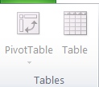
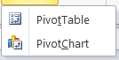

- Drag fields into areas
- Choose data range
- A box will appear.
- Make sure your data range is correct.
- Choose where to place the Pivot Chart (New Worksheet or Existing Worksheet).
- Click OK.
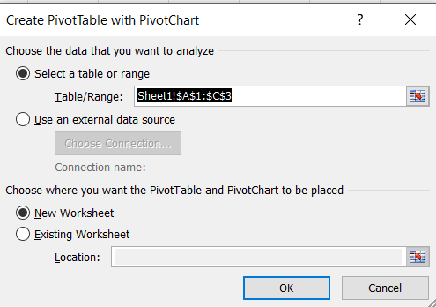

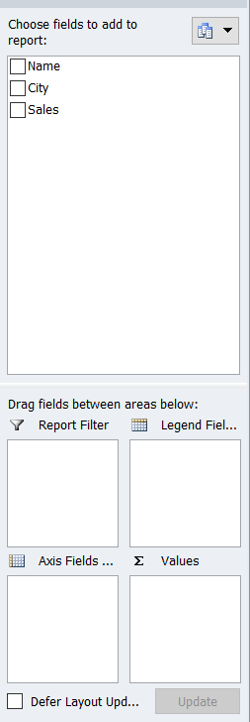

Build your Pivot Chart
- A blank chart and Pivot Table Field List will appear.
- Now drag fields from the field list to these areas:
  - Axis Fields – (e.g., drag “City”)
  - Values – (e.g., drag “Sales”)
  - Columns – (optional)
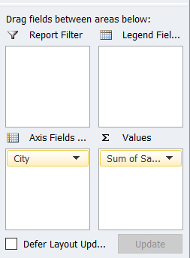
  - Filters – (optional)

See your Pivot Chart
- Your Pivot Chart will appear showing a graph (like a bar chart) based on your selected data.
