Module 3 – Introduction to SQ Commands

SQL Commands
SQL (Structured Query Language) is used to manage and work with databases. SQL commands are instructions used to communicate with the database to perform specific tasks like:
- Creating tables
- Inserting data
- Updating records
- Retrieving data
- Deleting records, etc.
SQL commands are divided into five main categories:
1. DDL – Data Definition Language
These commands define the structure of the database (like tables, schemas, etc.).
2. DML – Data Manipulation Language
These commands deal with the data stored in the tables.
3. DQL – Data Query Language
This is used to retrieve data from the database.

4. DCL – Data Control Language
These commands are used to control access to data in the database
5. TCL – Transaction Control Language

These commands manage transactions in a database. A transaction is a group of SQL statements that are executed as a single unit.

Introduction to Microsoft Access
Microsoft Access is a relational database management system (RDBMS) developed by Microsoft. It combines a graphical user interface with software development tools and is part of the Microsoft 365 Office suite.
It allows users to:
- Create and manage databases.
- Store data in tables.
- Create forms for data entry.
- Generate queries to retrieve and manipulate data.
- Design reports for printing or viewing.
It's particularly useful for small to medium-sized database applications and is widely used for personal or departmental projects.

Key Components of MS Access

- Tables – Store data in rows and columns (like Excel).
- Queries – Retrieve, filter, and analyze data (you can use SQL here).
- Forms – User-friendly interface for data entry and editing.
- Reports – Format and summarize data for printing or presentation.
- Macros and Modules – Automate tasks and extend functionality using VBA (Visual Basic for Applications).

Where to Write SQL Commands in MS Access
You can write SQL commands in queries. Here's how:

Steps to Write SQL in MS Access
- Open Microsoft Access and your database.
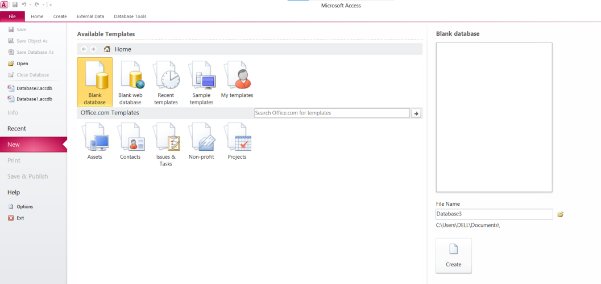
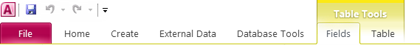
- Go to the “Create” tab on the ribbon.

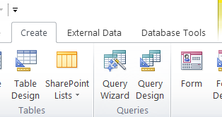
- Click on “Query Design”.

- When prompted to add tables, you can either:
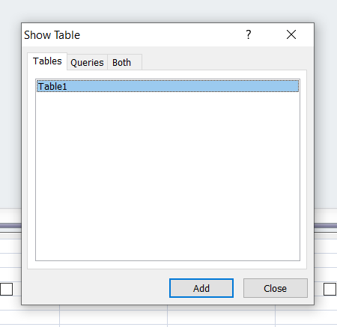
  - Add them if you want to build with a visual aid, or
  - Close the dialog box to write SQL manually.

- Then go to the “Design” tab > click “SQL View”.

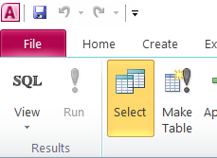
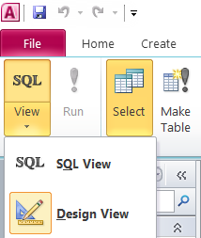
- You'll see a blank area where you can type your SQL commands.
- Click on Run Button to run your SQL command.
