Module 4 – DDL Command in SQL
What is DDL (Data Definition Language)?
DDL stands for Data Definition Language. It includes SQL commands that are used to create, modify, or delete the structure of database objects like:

- Tables
- Views
- Indexes
- Schemas
- Databases

Important:

DDL does not manage the data inside the tables. That’s what DML (Data Manipulation Language) like INSERT, UPDATE, and DELETE does.

DDL statements are auto-committed, meaning changes are immediately saved to the database and cannot be rolled back (undone) in many systems.

What is the CREATE Command?
The CREATE command is used in SQL to make something new in a database. Usually, we use it to create a table, but it can also be used to create a database, view, index, and more.
In most cases, when you’re starting a new project, you first use the CREATE command to make the tables where your data will be stored.
Syntax of CREATE TABLE
CREATE TABLE table_name (
column1 data_type [constraint],
column2 data_type [constraint],
...
);
Example
CREATE TABLE students (
student_id INT,
name VARCHAR(100),
age INT
);

Explanation:
Part | Meaning
CREATE TABLE | You are telling the database to make a new table.
students | This is the name of the table. You can name it whatever makes sense.
student_id INT | This is the first column. It will store whole numbers (e.g., 1, 2, 3).
name VARCHAR(100) | This column will store names. VARCHAR means "variable-length text" — up to 100 characters.
age INT | This column stores the age, using whole numbers.

Common Data Types Used in CREATE

Adding Constraints (Optional)
Example With Constraints
CREATE TABLE students (
student_id INT PRIMARY KEY,
name VARCHAR(100) NOT NULL,
age INT
);

Explanation:
- student_id is a primary key (must be unique and not null).
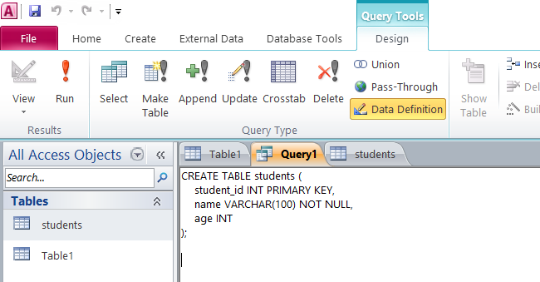
- name is required (can’t be empty).

Click to run it will create a table with name student

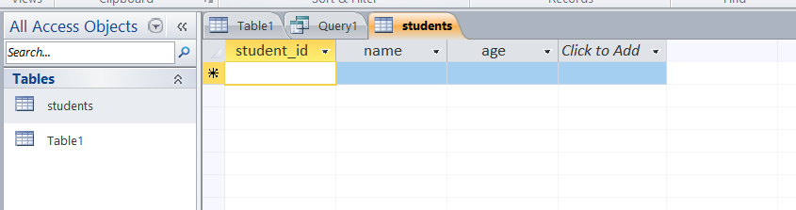

What is the ALTER Command in SQL?
The ALTER command in SQL is used to modify the structure of an existing table in a database.
It allows you to:
- Add new columns
- Delete existing columns
- Change data types of columns
- Rename columns or the table itself
- Add or remove constraints (like PRIMARY KEY, NOT NULL)
You use ALTER when the table already exists, but you want to change something about its structure.
Syntax of Alter command
Syntax to add new Column:
ALTER TABLE table_name
ADD column_name datatype;
This adds a new column to an existing table.
Example:
ALTER TABLE students
ADD Email VARCHAR(100)
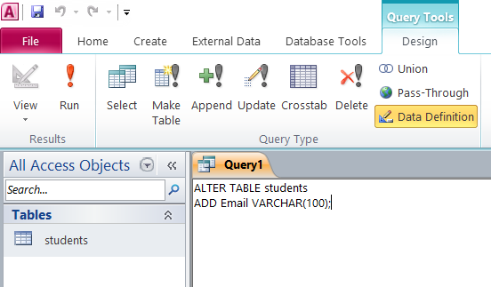
Click on run to add Column name Email
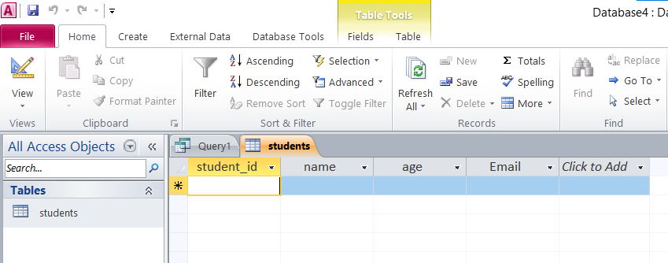
Syntax to Delete a Column:
ALTER TABLE table_name
DROP COLUMN column_name;

This removes a column from an existing table.

Example
ALTER TABLE students
DROP COLUMN Email
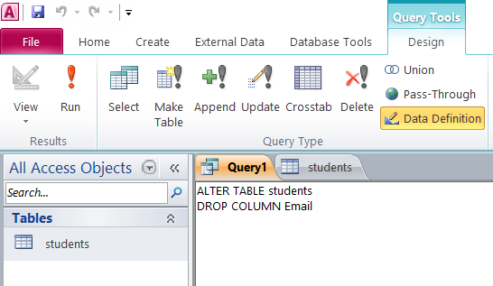

Click Run to delete a column

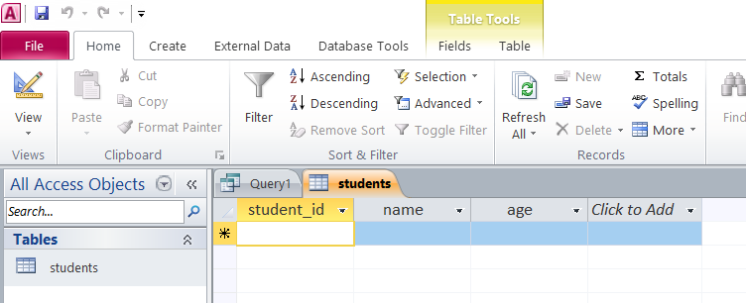

Syntax to Modify Column data type

ALTER TABLE table_name
ALTER COLUMN column_name new_datatype;

Example:

ALTER TABLE students
ALTER COLUMN age Int

This will Changes the data type of an existing column

What is the DROP Command in SQL?
The DROP command is a Data Definition Language (DDL) command used to completely delete database objects such as tables, databases, indexes, or views.
- When you use the DROP command, the object is permanently removed from the database.
- All the data stored in that object is also deleted.
- This action cannot be undone (unless you have backups).

Meaning of DROP Command
- DROP means to remove or delete something entirely.
- In SQL, it means you are telling the database system to remove the whole structure and its data.

What can you DROP?
You can use DROP to delete:
- Tables: Remove the entire table and all its data.
- Databases: Delete an entire database.
- Indexes: Delete indexes to improve or change performance.
- Views: Remove a saved query or view.
- Other objects depending on the database system.
Note:
- MS Access does NOT support dropping databases via SQL — because the database is a file managed outside SQL commands.
- MS Access does NOT support DROP COLUMN to remove a column via SQL — you need to remove columns manually in table design or by using VBA.
- You can use DROP INDEX to delete indexes on tables.
- Dropping a table or index in MS Access cannot be undone unless you have a backup of the database file.
Syntax of Drop command to drop a table:
DROP TABLE table_name
Example:
DROP TABLE students
Note : it will delete the entire table

