Module 5 – DML Command in SQL
What is a DML Command in SQL?
DML stands for Data Manipulation Language. It is a subset of SQL (Structured Query Language) used to manipulate the data stored in relational databases. DML commands allow users to retrieve, insert, update, and delete data from database tables.

Key DML Commands

SELECT Command in SQL
The SELECT command is one of the most commonly used SQL commands. It is part of DML (Data Manipulation Language) and is used to retrieve data from one or more tables in a relational database.

Purpose of SELECT
To query and fetch data from a database table. It allows you to:
- View all or specific columns
- Filter rows based on conditions
- Sort, group, or join data
- Perform calculations using functions
Syntax of Select Command:
SELECT column1, column2,...
FROM table name
WHERE condition
Examples and Usage

1. Selecting All Columns
SELECT * FROM employees;
This returns all columns and all rows from the employees table.
Example
Employee table:
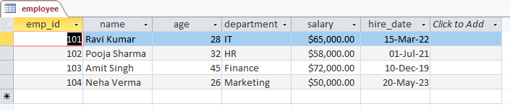
After Running query
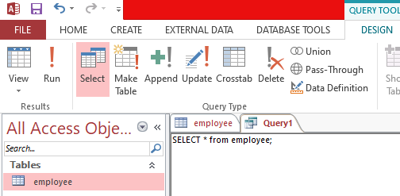

Click on Run to display all columns

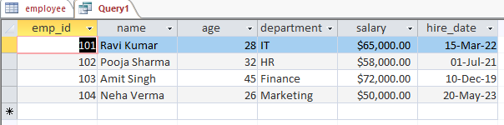

Selecting Specific Columns
SELECT name, salary FROM employees;
Returns only the name and salary columns.
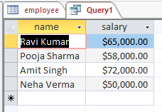

3. Using WHERE to Filter Rows
SELECT name, department FROM employees
WHERE salary > 50000;
Returns employees with a salary greater than 50,000.
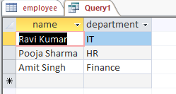

INSERT Command in SQL
The INSERT command in SQL is used to add new rows (records) into a table. It is part of DML (Data Manipulation Language) and is essential for inserting data into a relational database.
Syntax:
INSERT INTO table_name (column1, column2, ...)
VALUES (value1, value2, ...);

Example:
INSERT INTO employee (emp_id, name, age, department, salary, hire_date)
VALUES
(102, 'Pooja Sharma', 32, 'HR', 58000.00, '2021-07-01');

Insert without Column list:
INSERT INTO employee
VALUES (104, 'Neha Verma', 26, 'Marketing', 50000.00, '2023-05-20');

Example:
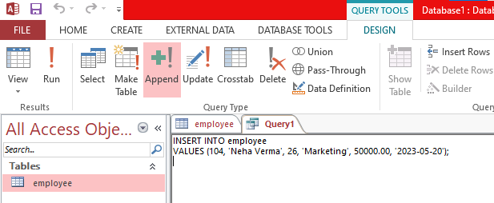

Click Run to add one row

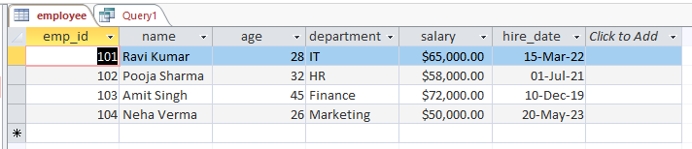
After Insertion Table:

Update Command in SQL
The UPDATE command in SQL is a DML (Data Manipulation Language) statement used to modify existing records in a table. It changes the values of one or more columns for all rows that meet the specified condition.
Syntax of UPDATE
UPDATE table_name
SET column1 = value1, column2 = value2, ...
WHERE condition;
- table_name: The name of the table you want to update.
- SET: Specifies the columns and their new values.
- WHERE: Filters the rows to be updated; only rows matching this condition will be updated.

Example:
UPDATE employee
SET name = "Arun", age = 29
WHERE emp_id=101;

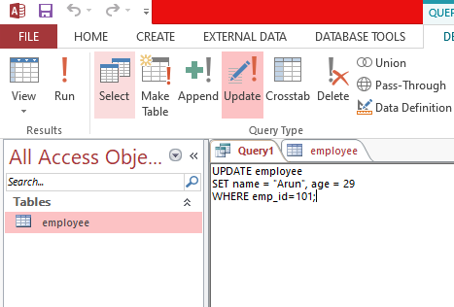

Click run to update record of Employee id 101

Updated Table:
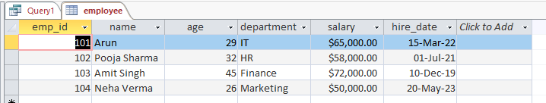

Updated value

Examples

Example 1: Update a single row

UPDATE employee
SET department = 'Marketing'
WHERE emp_id = 101;
- This changes the Department of the employee with ID 101 to "Marketing".

Example 2: Update multiple rows

UPDATE employee
SET salary = salary * 1.05
WHERE department = “IT”;
- This gives a 5% salary raise to all employees in the Engineering department.

Example 3: Update multiple columns

UPDATE employee
SET department = 'Finance', salary = 70000
WHERE emp_id = 102;
- Changes both the Department and salary for employee 102.

What happens without WHERE clause?

UPDATE employee
SET department = 'HR';
- All rows in the employee table will have their Department set to "HR".
Delete Command in SQL
The DELETE command in MS Access is used to remove one or more records from a table. It is part of the Data Manipulation Language (DML) in SQL.
Syntax:
DELETE FROM table_name WHERE condition;
- table_name is the name of the table from which you want to delete records.
- The WHERE clause specifies which records should be deleted.
Important: If you omit the WHERE clause, all records in the table will be deleted.
Example:
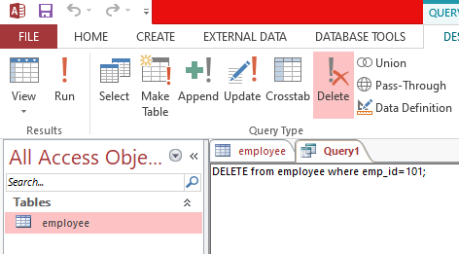
Click run to delete the records of emp_id 101

Resultant Table
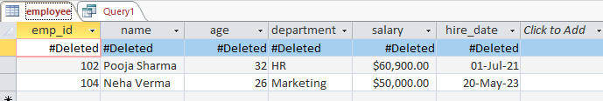

Record Deleted

Examples:
- Delete a specific record:
DELETE FROM Employees WHERE EmployeeID = 101;
This deletes the employee with ID 101.
- Delete multiple records:
DELETE FROM Employees WHERE Department = 'HR';
This deletes all employees in the HR department.
- Delete all records from a table:
DELETE FROM Employees;
This deletes all records from the Employees table but keeps the table structure.

