Module 8 – DQL Command in SQL

What is DQL Command in SQL?
DQL stands for Data Query Language. It is a part of SQL that is used to get or retrieve data from a database.
When you want to look at data stored in a database — like finding a list of employees, or checking customer orders — you use DQL commands.

The main DQL command is SELECT
- It helps you choose which data you want to see.
- You can select one or more columns (pieces of information).
- You can also decide which rows (records) to get based on conditions.

How it works:
- You write a SELECT statement.
- You tell it what columns you want.
- You say which table to get the data from.
- You can add conditions to filter the data.
- You can sort or group the data to better understand it.

Simple example:
SELECT name, age FROM employees;
This means: "Give me the names and ages of all employees."

Adding conditions:
SELECT name, age FROM employees WHERE age > 30;
This means: "Give me the names and ages of employees who are older than 30."

Other useful features:
- ORDER BY: Sort results by a column, like by age or name.
- GROUP BY: Group data, for example, count employees in each department.
- HAVING: Filter groups (like departments with more than 5 employees).
- LIKE: Find data matching a pattern, like names starting with ‘A’.
- DISTINCT: Show only unique values, no duplicates.

WHERE Clause
Purpose:
Filter rows based on a condition.
Syntax:
SELECT columns
FROM table_name
WHERE condition;
Example:
SELECT * FROM employees WHERE age > 30;
Gets all employees older than 30.
Example table:
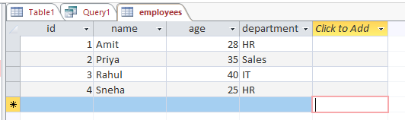
Run: SELECT * FROM employees WHERE age > 30;
Result of Query:
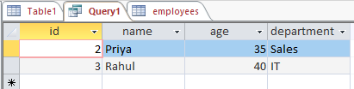

LIKE Clause
Purpose:
Search for a pattern in a column.
Syntax:
SELECT columns
FROM table_name
WHERE column LIKE pattern;
Example:
SELECT * FROM employees WHERE name LIKE 'A%';
Finds employees whose names start with "A".
(% means any number of characters)
- Important Note for Access:
Access uses different wildcards than many other SQL databases.
  - Use * (asterisk) instead of % to represent any number of characters.
  - Use? (Question mark) instead of _ to represent a single character.
- Example in Access:
SELECT * FROM employees WHERE name LIKE 'A*';
This finds employees whose names start with "A".
So, in Access, if you want to find names starting with "A", use 'A*' not 'A%'.
Example Table:
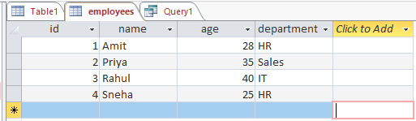
Run this Query: SELECT * FROM employees WHERE name LIKE 'A*';

Result of Query:
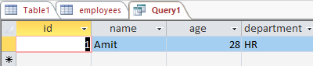

ORDER BY Clause
Purpose:
Sort the result set by one or more columns.
Syntax:
SELECT columns
FROM table_name
ORDER BY column1 [ASC|DESC], column2 [ASC|DESC];
Example:
SELECT name, age FROM employees ORDER BY age DESC;
Sort employees by age in descending order.
Example table:
Run: SELECT name, age FROM employees ORDER BY age DESC;

Result of Query:
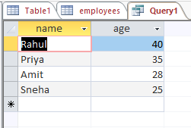

GROUP BY Clause
Purpose:
Group rows that have the same values in specified columns. Often used with aggregate functions like COUNT(), SUM(), etc.
Syntax:
SELECT column, aggregate_function(column)
FROM table_name
GROUP BY column;
Example:
SELECT department, COUNT(*) FROM employees GROUP BY department;
Counts how many employees are in each department.
Example table:

Run: SELECT department, COUNT(*) FROM employees GROUP BY department;
Result of Query:
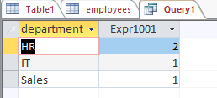

HAVING Clause
Purpose:
Filter groups created by GROUP BY.
Syntax:
SELECT column, aggregate_function(column)
FROM table_name
GROUP BY column
HAVING condition;
Example:
SELECT department, COUNT(*)
FROM employees
GROUP BY department
HAVING COUNT(*) > 1;
Shows departments with more than 1 employees.
Example table:

Run: SELECT department, COUNT(*)
FROM employees
GROUP BY department
HAVING COUNT(*) > 1;
Result of Query:
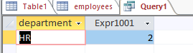

DISTINCT Keyword
Purpose:
Remove duplicate rows from the result set.
Syntax:
SELECT DISTINCT column1, column2
FROM table_name;
Example:
SELECT DISTINCT department FROM employees;
Gets a list of unique departments.
Example table:

Run: SELECT DISTINCT department FROM employees;

Result of Query:

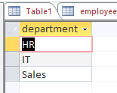

AND / OR Operators
Purpose:
Combine multiple conditions in the WHERE or HAVING clause.
Syntax:
SELECT columns
FROM table_name
WHERE condition1 AND condition2;
Or
SELECT columns
FROM table_name
WHERE condition1 OR condition2;
Example with AND:
SELECT * FROM employees WHERE age > 30 AND department = 'HR';

Example table:

Run: SELECT * FROM employees WHERE age > 30 AND department = ‘Sales';

Result of Query:

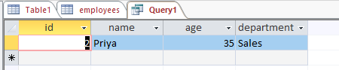

Example with OR:
SELECT * FROM employees WHERE department = 'HR' OR department = 'Sales';
Example table:

Run: SELECT * FROM employees WHERE department = 'HR' OR department = 'Sales';

Result of Query:
