Module 3 – Types of Database Model

What is a Database Model?
A database model is a way to organize data inside a database. It defines how data is stored, connected, and accessed.
Just like you use different ways to organize your room (books on shelves, clothes in drawers), databases use different models to organize data.

Main Types of Database Models:

- Hierarchical Model
- Network Model
- Relational Model
- Object-Oriented Model
- Entity-Relationship (ER) Model

1. Hierarchical Model

Idea:
Data is arranged like a tree. One parent has one or more children, but each child has only one parent.

Structure:
Like folders and subfolders on your computer.

Example:
A company database:
- Company (Parent)
      - Departments (Child)
        - Employees (Child of Department)

Limitations:
- Can’t handle complex relationships (e.g., if an employee works in two departments).
- Difficult to change structure.
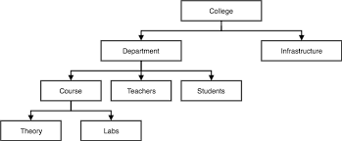
Real-life Analogy:
Family tree — one parent, many children.

2. Network Model

Idea:
More flexible than hierarchical. A child can have more than one parent.
Data is organized as records connected by pointers (links).

Structure:
Like a graph with multiple connections.

Example:
In a university:
- Students can enroll in many courses
- Courses can have many students

Advantages:
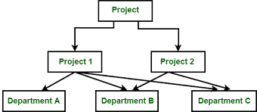
- Represents many-to-many relationships well.

Limitations:
- Complex to manage
- Harder to design than relational

3. Relational Model

Idea:
Data is stored in tables (rows and columns).
Each table is called a relation.

Structure:
Simple and organized like spreadsheets.

Example:
A table of students:
ID | Name | Age
1 | Ravi | 20
2 | Sita | 22
Another table for courses:
A third table links students and courses:
CourseID | CourseName
101 | Math
102 | Physics

StudentID | CourseID
1 | 101
2 | 102

Advantages:
- Easy to use SQL
- Popular and widely used (MySQL, Oracle, PostgreSQL)

Limitations:
- Not the best for very large or unstructured data

4. Object-Oriented Model

Idea:
Stores data as objects (like in object-oriented programming).
Each object contains both data and behavior (methods).

Structure:
Similar to how Java or C++ defines classes.

Example:
An object for a "Student" might contain:
- Data: Name, Age, ID
- Methods: enroll(), updateMarks()

Advantages:
- Works well with complex data
- Good for multimedia, CAD, etc.

Limitations:
- Less common in commercial DBs
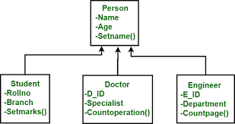
- Harder to learn than relational model

5. Entity-Relationship (ER) Model

Idea:
Used for database design. Not used to store data, but to plan and visualize relationships before building the database.

Structure:
- Entities: objects (like Student, Course)
- Attributes: properties (like Name, ID)
- Relationships: connections (like “enrolls in”)

Example:
Student —(enrolls in)—> Course

Advantages:
- Helps design before creating the real database

Limitations:
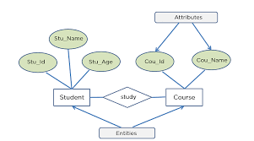
- Not used for storage — only for planning

