Module 2 - Understanding and Exploring the CorelDRAW Interface

When you open CorelDRAW, you’ll see a screen with different tools, menus, and space to draw.

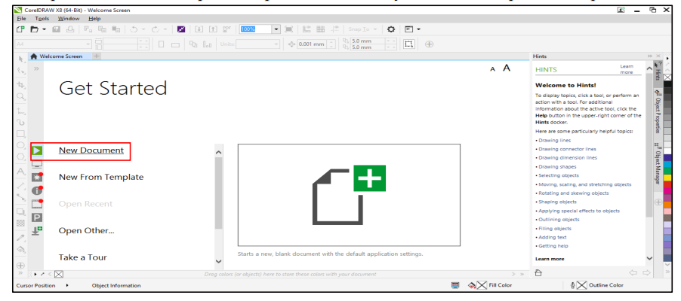

Title Bar: A horizontal bar at the top of a window, bearing the name of the program and typically the name of the currently active document include three buttons minimize, maximize and close button. Or display the title of the open document.

Menu Bar: Corel customization features let you modify the menu bar and the menus it contains. You can change the order of menus and menu commands; add, remove, and rename menus and menu commands. You can search for a menu command if you do not remember the menu in which it belongs. You can also reset menus to the default setting. The customization options apply to the menu bar menus as well as to shortcut menus that you access by right-clicking.

Tool Box: The toolbox contains tools for drawing and editing images. Some of the tools are visible by default, while others are grouped in flyouts. Flyouts open to display a set of related CorelDraw tools. A small flyout arrow in the lower-right corner of a toolbox button indicates a flyout. You can access the tools in a flyout by clicking the flyout arrow.

- After you open a flyout, you can easily scan the contents of other flyouts by hovering over any of the toolbox buttons which have flyout arrows.
- Flyouts function like toolbars when you drag them away from the toolbox. This lets you view all the related tools while you work.

Document Tab: A tab displays for each open document to allow you to quickly move between documents.

Update Text Toolbar: A temporary toolbar that allows you to update documents created in CorelDraw X7 (or earlier) in order to edit the text.

Drawing Window: The area outside the drawing page bordered by the scroll bars and application controls.

Property Bar: A detachable bar with commands that relate to the active tool or object. For example, when the text tool is active, the text property bar displays commands that create and edit text.

Docker: A window containing available commands and settings relevant to a specific tool or task.

Rulers: Horizontal and vertical borders that are used to determine the size and position of objects in a drawing.

Document Palette: A dockable bar that contains color swatches for the current document.

Document Navigator: The area at the bottom left of the application window that contains controls for moving between pages and adding pages.

Drawing Page: The rectangular area inside the drawing window. It is the printable area of your work area.

Status Bar: An area at the bottom of the application window that contains information about object properties such as type, size, color, fill, and resolution. The status bar also shows the current cursor position.

Navigator: A button at the lower-right corner that opens a smaller display to help you move around a drawing. Color Palette. A dockable bar that contains color swatches.

