Module 3 - Navigating the Workspace and Viewing Designs

CorelDRAW X7 is a professional graphic design software. To work efficiently, it's important to understand how to move around the workspace and view your designs properly.

Understanding the Workspace Layout
When you open CorelDRAW X7, the screen you see is called the workspace. It includes all the tools and panels you need to design.

Key parts of the workspace:
- Menu Bar: Contains dropdown menus like File, Edit, View, etc.
- Toolbox (Left Panel): Has all drawing tools like Pick Tool, Shape Tool, Freehand Tool, etc.
- Property Bar: Changes based on the selected tool – shows options for the selected object.
- Drawing Page: The white area where you design your artwork.
- Rulers & Guidelines: Help with accurate placement and alignment.
- Color Palette: Found on the right side, used for filling colors quickly.
- Docker Panels: Show additional settings, like Object Properties and Layers.
- Page Navigator: Lets you switch between multiple pages at the bottom.
- Status Bar: Displays information about the selected object (size, position, color, etc.).

Navigating the Page (Moving Around)
Sometimes your design is too big to see all at once. CorelDRAW gives you navigation tools to move around easily.
- Zoom Tool 🔍: Lets you zoom in or out of your design. Shortcut key: Z
- Pan Tool (Hand Tool) ✋: Lets you drag the page to view other areas. Shortcut key: H or hold down Spacebar
- Scrollbars: Use the vertical and horizontal scrollbars to move your view.
- Zoom Levels: Use Ctrl + Mouse Wheel to zoom in and out quickly.
- Zoom Presets: Found in the Property Bar, lets you quickly zoom to 100%, Fit Page, Fit Width, etc.

Viewing Modes
CorelDRAW X7 provides different viewing modes to see your design in various ways:

- Simple Wireframe: Simple wireframe displays an outline of the drawing by hiding fills, extrusions, contours, drop shadows, and intermediate blend shapes; also displays the bitmaps in monochrome. This mode lets you quickly preview basic elements in a drawing.
- Wireframe: Wireframe displays a drawing in simple wireframe mode plus intermediate blend shapes.
- Draft View: Draft displays fills and bitmaps with a low resolution. This mode eliminates some detail to allow you to focus on the color balances in a drawing.
- Normal View: Normal displays a drawing without PostScript fills or high-resolution bitmaps. This mode refreshes and opens slightly faster than the Enhanced mode.
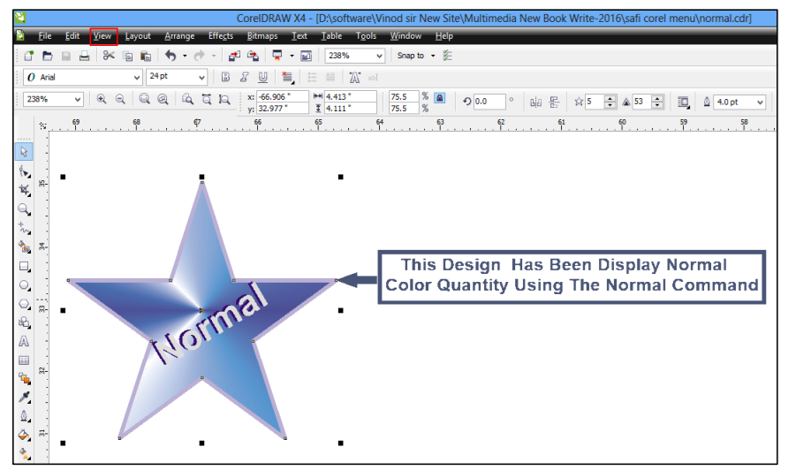
- Enhanced Mode: Shows your artwork in full quality with all effects. Best for final viewing.
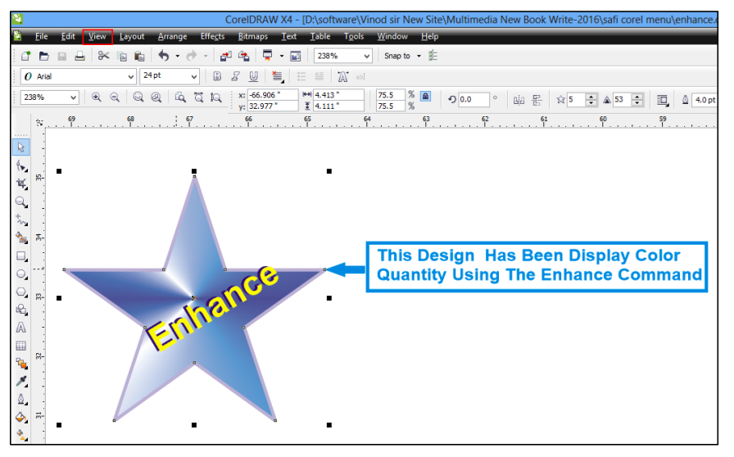
👉 You can switch modes by going to the View menu → Display Mode or using the drop-down in the Standard Toolbar.

Beginner Tips for Navigating
- Use F4 to zoom and fit all objects on screen.
- Use F9 for full-screen preview (great for presentations).
- Double-click Zoom Tool to reset view to 100%.
- Use guidelines and grids (View → Guidelines/Grid) to align your objects perfectly.

Pixels View
What it does:
- Shows your design as it would look with pixels, like an image.
- Helps you place and size things more accurately.
Why it's useful:
- When you're exporting your design to formats like JPEG or PNG, this view helps you see how it will look as a real image.
Example:
If you're creating a logo and want to see how it will appear on a website, use the Pixels view.

Simulate Overprints
What it does:
- Shows how colors look when one printed color overlaps another (used in professional printing).
- Displays things like PostScript fills, smooth edges, and high-quality images.
Why it's useful:
- Helps you preview print results on screen before sending to a printing press.
- Especially useful when designing for offset printing.
Example:
If you are designing brochures that will be printed in layers of ink, this lets you see how overlapping colors will mix.

Rasterize Complex Effects
What it does:
- Converts special effects (like drop shadows, transparency, or bevels) into bitmaps for display.
- Only works in Enhanced View.
Why it's useful:
- Makes sure complex effects are displayed accurately.
- Also gives you a good preview of how the design will print.
Example:
If your poster has glow or shadow effects, this view shows how they will appear in the printed copy.

Proof Colors (Soft Proofing)
What it does:
- Shows how your colors will look after printing, especially when using a CMYK printer.
Why colors may look dull:
- CMYK (used in printing) has a smaller range of colors than RGB (used on screens).
- This feature adjusts the screen colors to match printed output.
Example:
If your design is bright red on screen, it may look darker when printed. Proof Colors helps you see that before printing.

Full Screen Preview (F9): This command is used to shows our work in full screen mode.

Rulers
- Rulers appear along the top and left of the drawing area.
- Help you measure and align objects accurately.
- You can change units (e.g., inches, mm), set starting point (origin), and customize marks.

Preview Selected Only
- Lets you preview only specific objects from your drawing before printing or exporting.
- Useful to check how certain parts look without distractions.
- The rest of the drawing becomes hidden while previewing.

Page Sorter View
- Lets you see all pages in a multi-page document together.
- Good for arranging page order or working with booklets or brochures.
- Can show left and right pages together (facing pages view).

View Manager (Ctrl + F2)
- Helps you save and switch between different views of your drawing.
- You can preview selected objects, just like "Preview Selected Only."
- Useful for managing complex documents with many layers.

Page Border & Bleed
- Page Border: Shows the edges of your page.
- Bleed Area: The extra area outside the page that gets trimmed after printing.
  - Important in printing to avoid white edges.
  - You can adjust the bleed area in settings.

Printable Area
- Shows the part of the page your printer can actually print on.
- Displayed using dotted lines.
- Helps ensure that important content stays within print-safe zone.

Baseline Grid
- A grid that helps align text neatly across different frames.
- Useful when using different fonts and sizes.
- Objects can snap to the grid, keeping layout tidy and professional.

Gridlines and Guidelines
- Gridlines: Regularly spaced horizontal and vertical lines that help with alignment.
- Guidelines: Custom lines you can drag to help position objects exactly.
- Two types:
  - Corel presets: Like 1-inch margin guides.
  - User-defined: You set them yourself.
- You can remove or change guidelines anytime.

Assignment

1. What is the main area where you create and edit your design in CorelDRAW called?
A. Property Bar
B. Menu Bar
C. Drawing Page
D. Status Bar

2. Which tool lets you move around the page by dragging it?
A. Zoom Tool
B. Pick Tool
C. Shape Tool
D. Pan Tool

3. Which keyboard shortcut is used to zoom in and out quickly?
A. Ctrl + Z
B. Ctrl + S
C. Ctrl + Mouse Wheel
D. Ctrl + P

4. What does the Color Palette help you do?
A. Resize objects
B. Rotate text
C. Fill objects with color
D. Group objects

5. Which viewing mode shows all effects and high-quality graphics?
A. Draft
B. Wireframe
C. Enhanced
D. Simple Wireframe

6. What do the rulers in CorelDRAW help with?
A. Changing colors
B. Aligning and measuring objects
C. Adding effects
D. Printing the page

7. What is the shortcut for Full Screen Preview?
A. F9
B. F4
C. Ctrl + F
D. Alt + Enter

