Module 1 - Managing Pages in CorelDRAW

In CorelDRAW, you can work with multiple pages in a single document. This is helpful when creating brochures, booklets, flyers, or any multi-page designs.

Inserting and Deleting Pages

Inserting a Page:
- You can add a new page to your document from the bottom page navigation bar.
- Click the “+” icon next to the current page tab or go to:
  - Layout → Insert Page Before/After.
- You can add one or many pages at once.

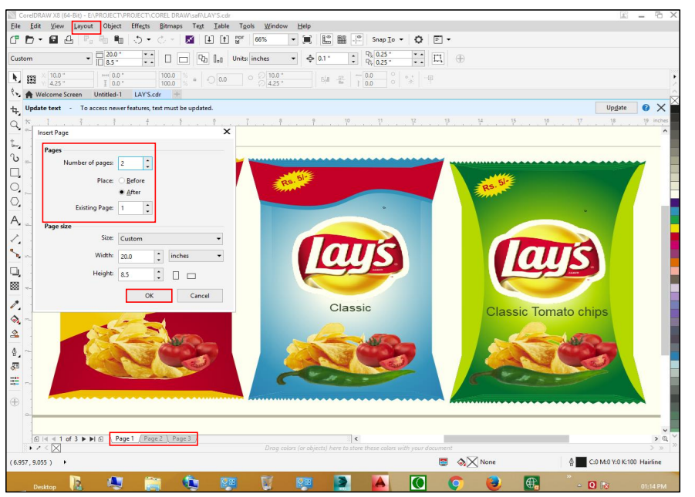

Duplicate Page:

In the insert new page area of the duplicate page dialog box, choose one of the following options. Before selected page, after selected page, copy layers only — lets you duplicate the layer structure without copying the contents of the layers. Copy layer(s) and their contents — lets you duplicate the layers and all their contents. You can also duplicate a page by right-clicking a page name and choosing duplicate page.

Deleting a Page:
- Select the page from the page tab at the bottom.
- Right-click on the page tab → choose “Delete Page”.
- Or go to: Layout → Delete Page.
📝 Tip: Be careful while deleting pages—unsaved designs on that page will be lost.

Changing Between Pages
- Use the page navigation tabs at the bottom of the window to move between pages.
- You can also use:
  - Page Up/Page Down keys on the keyboard.
  - Go to: View → Go to Page.
📌 Each page in CorelDRAW has its own layout area but shares the same document settings (like size, color mode).

Assignment

Quick Steps to Create "Education Industry" Poster

- New Document
  - Open CorelDRAW X7 → File > New
  - Page: A4, Portrait
- Set Background
  - Use Rectangle Tool (F6) → Draw full-page rectangle
  - Fill color: Dark navy blue → Remove outline
- Add Title
  - Use Text Tool (F8) → Type EDUCATION INDUSTRY
  - Font: Bold (Arial Black/Montserrat), Color: White
  - Align center (press P)
- Add Icons
  - Use File > Import to bring icons (pencil, globe, book, ABC blocks, etc.)
  - Or draw using Ellipse, Rectangle, Polygon, Freehand Tools
- Color and Arrange
  - Apply flat colors (red, yellow, blue, etc.)
  - Arrange icons neatly around the central open book
- Final Touch
  - Use Align tools to center all
  - Save as .CDR
  - Export as PDF or PNG



