Module 2 - Setting Up Page Layout and Orientation

Setting the correct page layout is very important in CorelDRAW, especially if you're designing for print (posters, brochures, flyers, etc.). It helps you control how your design will look on paper or screen.

Page Size
What it means:
Page size is the width and height of your design area — just like the size of a physical sheet of paper.
🛠️ How to Set Page Size:
- Go to the top menu and click on:
Layout → Page Setup
OR use the Property Bar at the top (appears when you click on a blank area of the page).
- Choose from standard page sizes like:
  - A4 (210 × 297 mm)
  - Letter (8.5 × 11 in)
  - Legal, A3, etc.
- Or you can set custom page size by typing the height and width yourself.
📌 Example:
If you're making a business card, you might set:
- Width = 90 mm
- Height = 50 mm
NOTE: Setting the right page size ensures that your design fits well when printed.
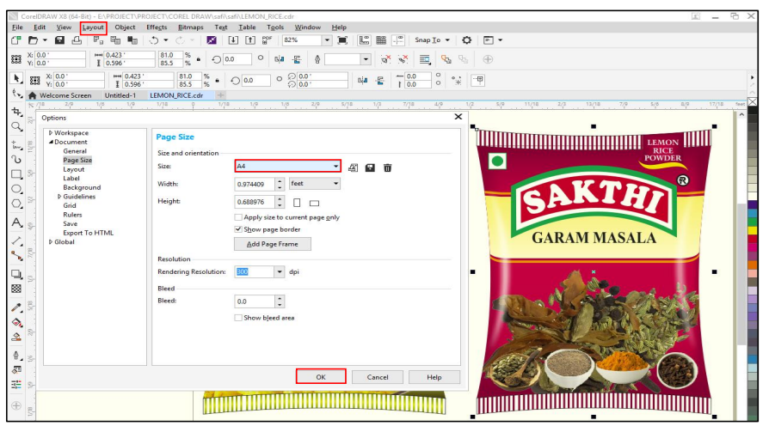
Orientation
What it means:
Orientation decides whether the page is tall (Portrait) or wide (Landscape).
🛠️ How to Set Orientation:
- You’ll see two buttons on the Property Bar or in Layout → Page Setup:
  - Portrait: Taller than wide (used for most documents)
  - Landscape: Wider than tall (good for banners, certificates)
📌 Example:
- A poster or letter might be Portrait
- A certificate or wide banner might be Landscape
NOTE: Choosing the correct orientation helps your content fit and look better.

Margins and Bleed
🧾 Margins
- Margins are the empty spaces around the edge of your page where no text or images should go.
- Helps avoid cutting off important content during printing.
🎨 Bleed
- Bleed is the area outside the page border where the design extends slightly beyond the actual page size.
- It is used in printing to avoid white edges when the paper is trimmed.
🛠️ How to Set Bleed:
- Go to: File → Print Setup
- Look for the Bleed settings
- Set how much bleed you want (commonly 3 mm or 0.125 in)
📌 Example:
- If your page size is A4 (210 mm x 297 mm), and you set a 3 mm bleed, the total design size becomes:
  - 216 mm x 303 mm (with bleed)
NOTE: Bleed ensures that there are no white lines at the edge after trimming the paper.

Assignment

Steps to Design This Visiting Card in CorelDRAW X7

Step 1: Set Up Page
- Open CorelDRAW X7.
- File > New.
- Set page size: 3.5 inches x 2 inches (Landscape orientation).
- Units: Inches.

Step 2: Create Background & Wave Shapes
- Draw White Background:
  - Use the Rectangle Tool (F6) → draw to fit the page.
  - Fill: White (no outline).
- Create Blue Wave Layers:
  - Use the Bezier Tool or Freehand Tool to draw wavy shapes.
  - Make 3 waves: one dark blue, one medium blue, and one light blue.
  - Fill each with a different blue gradient or solid color.
  - Position them at the bottom-right part of the card.

Step 3: Add Circle Frame for Photo
- Use the Ellipse Tool (F7) → draw a perfect circle while holding Ctrl.
- Make a thick outline (white) and outer border (blue).
- Import photo: File > Import, then place it inside the circle.
  - Use PowerClip: Right-click photo → PowerClip Inside → click the circle.

Step 4: Add Name and Designation
- Select Text Tool (F8) → Click to type:
  - Name: “Olivia Wilson” → Use bold font like Montserrat Bold or Arial Black.
  - Below: “Real Estate Agent” → Normal font.
- Add a small blue line under the designation using the Rectangle Tool.

Step 5: Add Contact Icons and Info
- Use Ellipse Tool to draw small circles (blue fill).
- Place icons (phone, globe, location):
  - Use File > Import to bring icons.
  - Alternatively, draw simple icons with shapes or download vector icons.
- Use Text Tool to write:
  - Phone numbers, website, email, and address.
  - Align text properly with each icon.

Step 6: Final Adjustments
- Use Align & Distribute Tool (Arrange > Align and Distribute) to position everything evenly.
- Group related items (Ctrl + G) to keep layout intact.
- Preview with F9.

Step 7: Save and Export
- Save as .CDR file.
- Export to PDF or PNG: File > Export.



