Microsoft Word

Module 35 – Hyperlink and Cross Reference in MS Word

What is Hyperlink?
A hyperlink is a special type of link used in MS Word and other programs that let you quickly go to another place with just one click. It can connect your document to a website, another file, a location within the same document, or even an email address. When you click on a hyperlink, it takes you directly to the place it is linked to, like opening a webpage or starting an email. Hyperlinks are usually shown as blue and underlined text, and when you move your mouse over them, the pointer changes to a hand symbol. They are useful for giving extra information or making your document more interactive and easy to navigate.

Why use Hyperlinks?
Hyperlinks are useful when you want to:
- Add extra information from a website
- Link to a related document
- Help the reader move quickly within your document
- Make your document interactive
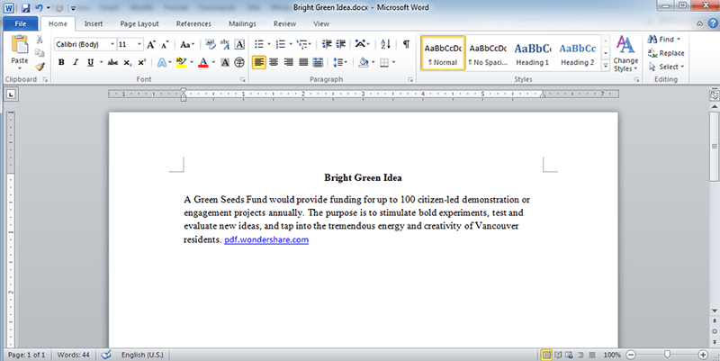

Hyperlink

Steps to Create a Hyperlink in MS Word Using Menu Options:
Open your MS Word document.
- Select the text or image you want to turn into a hyperlink.
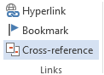
  - Example: Select the text "Click for more".
- Click on the "Insert" tab.
- In the Insert tab, look for the "Links" group.
- Click on the "Link" option (or it may show as "Hyperlink" depending on your version).
- A dialog box called "Insert Hyperlink" will appear.

- In the "Address" box at the bottom, type or paste the website URL or choose a file or location.
- For website: Type https://www.wikipedia.org
- For file: Browse and select a file
  - For document location: Click "Place in This Document"
  - For email: Click "E-mail Address"
  - After entering the link, click OK.
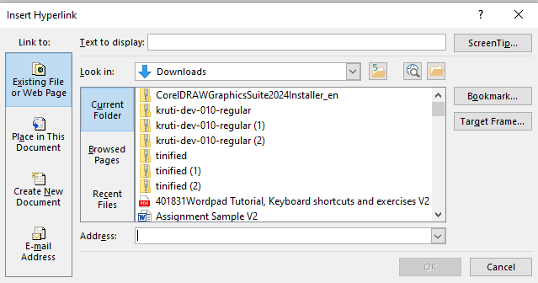

What is Cross-Referencing?
Cross-referencing is a technique used in various fields, including writing, research, and data management, to direct the reader or user from one part of a document, dataset, or system to another related part. The goal is to establish connections or relationships between different pieces of information so that they can be easily found and understood in context.

In simple terms, it means pointing out where similar, complementary, or related information can be found elsewhere, often providing more context, background, or examples.

Steps to Insert a Cross-Reference in MS Word

Step 1.
Make the document, select your document heading that you want to show in the Index and convert it into Heading Style (Like, Heading 1 and Heading 2 etc.)

Step 2.
(i) Go to the Insert tab, select Cross-reference. or

(ii) Go to the References tab > go to Captions Group > Click Cross- reference

Step 3.
In the Reference type box, select the “Heading” drop-down list to pick.
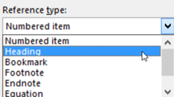

Step 4.
In the Insert reference to box, select the Heading Text .
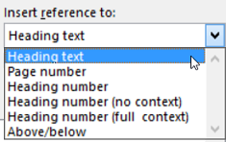

Step 5.
Insert a table For example (3 Columns and 4 Rows) and write alike ( 1st column Sr. no., 2nd Column Topic Name, and 3rd Column Page umber)

Step 6.
In the Topic name column Select the heading text and click on Insert.
cl

Step 7.
In the Page No. name column Select the heading text and In Insert Reference to Select Page No. and click on Insert.

Step 8.
From the Index Select the Heading with Pressing Ctrl Key, which you want to see or read your document will directly go to on that page.

