Module 1 – Overview of Vector Graphics for Adobe Illustrator

What are Vector Graphics?
Vector graphics are images made using mathematical formulas. They are constructed from points, lines, curves, and shapes — not pixels.

This means when you zoom in or resize a vector image, it never gets blurry or pixelated. The image stays crisp and sharp no matter how large or small it is.

Example:
- A logo created in vector format can be printed on a tiny pen or a giant billboard — and it will still look perfect.
- A company’s icon designed using pixels (like in Photoshop) may blur when enlarged. But a vector version (like in Illustrator) will remain clean.

Advantages of Vector Graphics
- ✅ Scalability without Quality Loss
You can resize vector images infinitely without making them blurry.
- ✅ Smaller File Size
Since they store shapes and paths, not millions of pixels, vector files are usually lighter.
- ✅ Easy to Edit
You can easily move, reshape, recolor, or duplicate parts of a design.
- ✅ Perfect for Printing
High-resolution printing is easier and cleaner with vectors.
- ✅ Reusable Design Elements
Shapes, logos, or symbols created in one file can be reused across projects without rebuilding.

Vector vs Raster Graphics
Feature | Vector Graphics | Raster Graphics
Made of | Paths and shapes | Pixels (tiny squares)
Scalability | Infinite without quality loss | Quality drops when scaled up
File Size | Usually smaller | Usually larger
Best Use | Logos, icons, illustrations | Photos, paintings
File Types | .AI, .SVG, .EPS, .PDF | .JPG, .PNG, .BMP, .GIF

Where Are Vector Graphics Used?
- 🎨 Logo Design – To keep logos clear across different sizes and materials.
- 📱 Web & App Icons – So they scale smoothly on all screen sizes.
- 📰 Print Materials – Flyers, business cards, posters, brochures.
- 🧩 Infographics – Clean, sharp diagrams and visuals.
- 🛠️ Product Packaging – Crisp edges and detailed layouts.

How Adobe Illustrator Uses Vector Graphics
Adobe Illustrator is a vector-based design tool. Every object you create — whether it’s text, a shape, or a line — is a vector by default.
Common tools used in Illustrator for creating vector artwork:
- Pen Tool – For drawing precise custom shapes and curves.
- Shape Tools – For drawing circles, rectangles, polygons, etc.
- Pathfinder & Shape Builder Tool – To combine or cut shapes.
- Type Tool – Even text is vector-based and fully scalable.
When you save an Illustrator file, it typically uses the .AI format — a fully editable vector file.

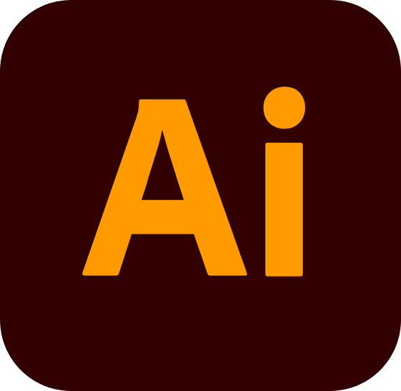
Common Vector File Formats
- .AI – Adobe Illustrator (editable vector project)
- .SVG – Scalable Vector Graphics (best for web and apps)
- .EPS – Encapsulated PostScript (for printers and publishers)
- .PDF – Portable Document Format (can include vector + text)
- .CDR – CorelDRAW file (used in Corel software)

