Module 3 - Workspace and Interface Customization

Introduction: What is a Workspace?

When you open Adobe Illustrator, everything you see — tools, menus, canvas — is part of the workspace. It is the environment where you do your design work.

The default workspace is called Essentials, but Illustrator allows you to customize everything — from which tools are shown to where panels are placed.
This is useful because every designer works differently — and a clean, well-organized workspace can speed up your workflow and reduce mistakes.

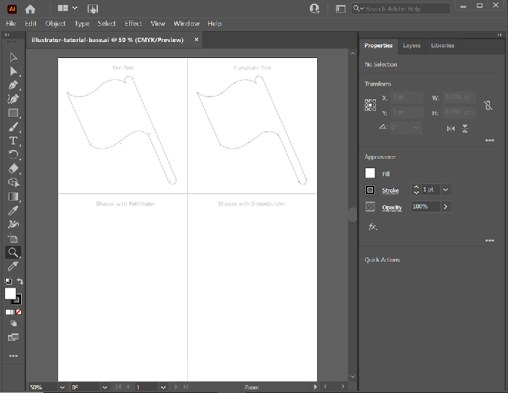

Main Parts of the Illustrator Interface
Here’s a breakdown of the key areas in the Illustrator workspace:

Interface Element | Purpose
Menu Bar | Located at the top. Contains options like File, Edit, Object, Type, etc.
Tools Panel | On the left. Holds tools for selection, drawing, text, shape, etc.
Control / Properties Panel | Displays context-sensitive settings for selected tools or objects
Artboard | The main white area where you create your design
Panels Dock | On the right. Contains panels like Layers, Color, Swatches, etc.
Workspace Switcher | At the top-right. Helps you switch between different workspace layouts

Customizing the Illustrator Workspace

A. Moving Panels Around
- You can drag any panel (like Layers, Swatches, Stroke) and dock it to the left, right, top, or even keep it floating.
- Click and drag the panel tab (e.g., “Color”) to reposition it. You can also collapse panels to icons to save space.

B. Showing & Hiding Panels
Go to Window > [Panel Name] to open any panel you don’t see on screen.
For example:
- Window > Layers → opens the Layers panel
- Window > Pathfinder → opens the Pathfinder panel

To hide all panels temporarily, press Tab.

C. Save a Custom Workspace
Once you’ve arranged your workspace how you like it:
- Go to Window > Workspace > New Workspace
- Name it (e.g., “Logo Design”)
- Click OK

Now, you can always return to this layout by selecting it from the Workspace Switcher.
D. Reset a Workspace
If your layout becomes messy, you can restore it:
Window > Workspace > Reset [Workspace Name]

Default Workspace Options in Illustrator
Illustrator provides several preset workspaces tailored to different design needs:
Workspace Name | Best For
Essentials | Beginners or general use
Essentials Classic | For those used to older Illustrator versions
Typography | For text-heavy work and font styling
Web | For UI/UX design and pixel preview
Tracing | For converting images into vectors
Painting | For freehand drawing and brushes
Each workspace comes with relevant panels already open. You can still adjust and save your own version.

Must-Know Panels and Their Uses

Panel Name | Function
Layers | Manage different objects and organize them across levels
Swatches | Store and apply colors or gradients
Stroke | Adjust outline thickness and dashed lines
Align | Precisely align and distribute objects
Appearance | Shows all effects applied to an object (like multiple fills or strokes)
Pathfinder | Combine, subtract, and intersect shapes easily
To make your workflow faster, pin the panels you use the most and collapse the rest.

6. Productivity Tips
- Use Shortcuts:
Press Tab to hide all panels, or use keys like F6 for Color panel.
- Group Panels:
Drag one panel over another to group them into tabs.
- Use the Search Bar:
In newer Illustrator versions, search directly for tools, commands, or panels.
- Dark Theme:
Set a dark background in Edit > Preferences > User Interface to reduce eye strain.
- Save Time:
Avoid opening/closing panels again and again — save your preferred setup.

Useful Terminology for Adobe Illustrator

Path Terms
➤ Path
A path is the basic building block of vector graphics.
It’s a line that connects a series of anchor points, which together make shapes like circles, stars, letters, or complex designs.
Paths can be:
- Open (like a straight or curved line that doesn’t connect back to the start)
- Closed (like a triangle or circle where the last point connects to the first)

➤ Anchor Point
An anchor point is a dot placed on a path that marks a corner, curve, or change in direction.
- Corner anchor points create sharp angles (e.g., points of a star).
- Smooth anchor points create curves (e.g., sides of a circle or wave).
By moving anchor points, you reshape the path.

➤ Handles (Direction Handles)
- Handles appear on smooth anchor points and look like little lines with circles at their ends.
- Dragging these direction handles changes the direction and curve of the path segment connected to that anchor point.
- Think of them like levers for adjusting how steep or shallow a curve is.

Fill vs Stroke
➤ Fill
The fill is the inside color of a shape.
- When you draw a circle and fill it with red, the entire inside of the circle shows red.
- Fills can be solid colors, gradients, or even patterns.
➤ Stroke
The stroke is the outline or border of a path or shape.
- Strokes have a color, width (thickness), and style (solid, dashed, dotted).
- For example, a blue circle can have a black stroke 5 pt thick.
📌 You can set both a fill and a stroke for any shape. Illustrator keeps them separate so you can control them independently.

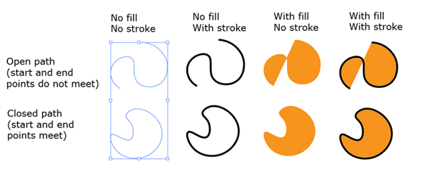
➤ Bezier Curve
A smooth, curved line defined by anchor points and handles. Illustrator’s Pen and Curvature tools let you create and edit these curves.

➤ Bounding Box
A rectangular box that appears when you select a shape. You can use it to resize, rotate, or skew the object directly.

➤ Artboard
The workspace in Illustrator — like a canvas. It defines the area where your artwork lives.
You can have multiple artboards in a single document for things like brochures or social media graphics.

➤ Group
A collection of two or more shapes combined so you can move, resize, or style them together. Shortcut: Ctrl/Cmd + G to group, Shift + Ctrl/Cmd + G to ungroup.

➤ Layers
Layers help organize your artwork. Each layer can contain multiple paths, shapes, and images. You can hide, lock, or reorder layers to manage complex designs.

