Module 1 – Brushes and Freehand Drawing

Introduction
Not all vector artwork needs to be made from strict shapes and straight lines.
Sometimes, you want a more hand-drawn, organic, or artistic feel.
That’s where Illustrator’s freehand drawing tools and brushes come in.
These tools allow you to:
- Draw naturally with your mouse, stylus, or drawing tablet
- Create artistic strokes like calligraphy, watercolor, or textures
- Turn your own designs into reusable brushes

Paintbrush Tool (B)
The Paintbrush Tool lets you draw freehand paths that Illustrator smooths and applies a brush style to.
How to Use:
- Select the Paintbrush Tool (B).
- Choose a brush style from the Brushes Panel (Window > Brushes).
- Click and drag to draw — Illustrator creates a path and applies the chosen brush.
Features:
- Automatically follows the brush shape (e.g., calligraphy, artistic, scatter, bristle).
- Can be edited like any vector path using the Direct Selection Tool (A).
- Stroke thickness can be changed in the Control Bar or Stroke Panel.
📌 Tip: Adjust smoothing in the Paintbrush Tool Options for cleaner or more natural lines.

Blob Brush Tool (Shift + B)
The Blob Brush Tool is different from the Paintbrush because it creates filled shapes instead of strokes.
Why it’s useful:
- Perfect for coloring areas or building solid forms.
- Great for tablet drawing because it reacts to pressure sensitivity.
How to Use:
- Select the Blob Brush Tool.
- Choose a fill color (not stroke).
- Draw — each stroke becomes a solid vector shape.
- Overlapping strokes with the same fill color automatically merge into one shape.
📌 Tip: Use the Eraser Tool (Shift + E) to trim shapes made with Blob Brush.

Pencil Tool (N)
The Pencil Tool is best for quick sketches or outlines that can be refined later.
How to Use:
- Select the Pencil Tool (N).
- Click and drag to draw a freehand path.
- Release the mouse/stylus — the path is created.
Editing:
- Double-click the Pencil Tool icon to open settings.
- Adjust Fidelity (smoothness) and Fill New Pencil Strokes options.
- To edit a path, redraw over part of it — Illustrator replaces that section.
📌 Tip: The Pencil Tool is more basic than the Paintbrush, but great for rough shapes.

Creating Custom Brushes
You can design your own brush style in Illustrator.
Steps:
- Draw the shape or pattern you want as a brush.
- Select it, then open Brushes Panel > New Brush.
- Choose a brush type:
  - Calligraphic – Flat, angled, or round tip
  - Scatter – Scattered copies of your shape
  - Art – Stretches along the stroke path
  - Bristle – Simulates real paintbrush bristles
  - Pattern – Repeats a design along a path
- Name and save your brush.
💡 Once saved, your custom brush appears in the Brushes Panel for future use.

Types of Brushes:
There are different types of brushes in Illustrator: calligraphic, scatter, art, pattern, and bristle. You can achieve the following effects using these brushes:
- Calligraphic brushes: Create strokes that resemble those drawn with the angled point of a calligraphic pen and are drawn along the center of the path. When you use the Blob Brush tool, you can paint with a calligraphic brush and automatically expand the brush stroke into a fill shape that merges with other filled objects of the same color that intersect or are adjacent in stacking order.
- Scatter brushes: Disperse copies of an object (such as a ladybug or a leaf) along the path.
- Art brushes: Stretch a brush shape (such as Rough Charcoal) or object shape evenly along the length of the path.
- Bristle brush: Create brush strokes with the appearance of a natural brush with bristles.
- Pattern brushes: Paint a pattern—made of individual tiles—that repeats along the path. Pattern brushes can include up to five tiles, for the sides, inner corner, outer corner, beginning, and end of the pattern.

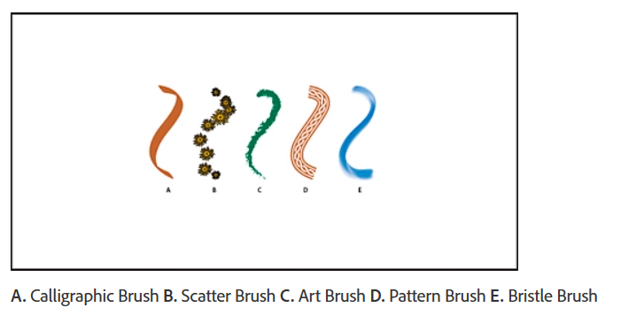

Real-World Uses
- Paintbrush Tool – Decorative borders, floral designs, artistic illustrations.
- Blob Brush Tool – Cartoon coloring, comic shading, flat style illustration.
- Pencil Tool – Rough sketches, concept art, quick path edits.
- Custom Brushes – Signature strokes for brand identity or unique textures.

Assignment
Scenario: You’re designing an artistic greeting card.
Tasks:
- Open a new Illustrator document (A5 size, RGB Mode).

- Use the Paintbrush Tool with an Artistic Brush to create a wavy border.
- Switch to the Blob Brush Tool and add solid floral shapes in the corners.
- Use the Pencil Tool to draw a handwritten “Happy Birthday” (or similar message).
- Create a custom scatter brush of small stars and apply it to a path around the card.
- Save the file as .ai and export as .png.

