Module 2 – Using Layers for Organization

Introduction: Why Layers Matter

In Illustrator, layers are like transparent folders that hold your artwork.
They don’t affect the appearance of the design directly, but they control how objects are organized, selected, hidden, and edited.
Think of layers like sheets of clear plastic stacked on top of each other:
- The top sheet covers what’s below.
- You can rearrange sheets anytime.
- Each sheet can hold multiple items.
Layers help you:
- Keep complex artwork organized.
- Quickly find and edit specific elements.
- Protect important parts from accidental changes.
- Export or print only specific elements.

Understanding the Layers Panel
You can open it from Window > Layers.
The Layers Panel shows:
- Main Layers (big colored bars) – The highest-level folders.
- Sub-layers – Separate objects inside a layer.
- Target Circles – Select objects for applying effects or appearance changes.
- Visibility Icons (Eye) – Show or hide a layer/object.
- Lock Icons – Prevent accidental editing.
💡 Tip: Each layer has its own color outline that appears when the object is selected.

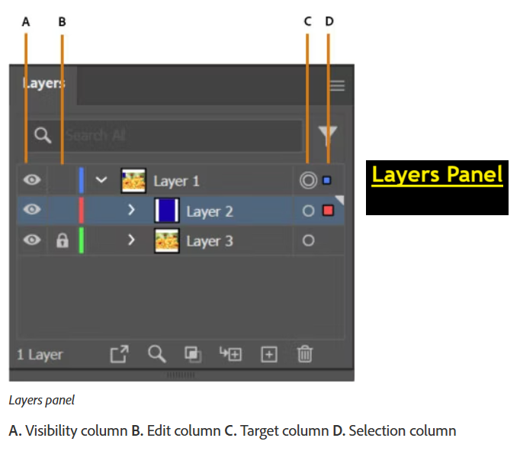

Creating and Naming Layers
Creating Layers:
- Click the Create New Layer button at the bottom of the Layers Panel.
- A new layer appears above the currently selected layer.
Naming Layers:
- Double-click the layer’s name to rename it.
- Use descriptive names like "Text", "Background", "Logo", or "Photos".
📌 Good practice: Naming layers clearly makes collaboration and revisiting files easier.

Organizing Artwork in Layers
You can drag objects from one layer to another to separate content:
- Example: Keep text in one layer, images in another.
- Group similar items (like icons) in the same layer.
Reordering Layers:
- Drag a layer up/down in the panel to change its stacking order.
Sub-layers:
- When you draw, Illustrator automatically creates sub-layers.
- These can be rearranged or grouped for finer control.

Layer Management Tools
- Locking Layers: Click the empty box next to the eye icon to lock it. Locked layers can’t be selected or edited.
- Hiding Layers: Click the eye icon to hide a layer.
- Selecting All in a Layer: Click the layer name — all objects inside get selected.
- Isolating Layers: Double-click a layer to work only inside it, hiding everything else temporarily.
💡 Locking and hiding are essential when working on detailed projects to avoid accidental changes.

Practical Example: Using Layers in a Poster Design

Imagine you’re creating a travel poster. You could organize layers like this:
- Layer 1: Background color and textures
- Layer 2: Main photo or illustration
- Layer 3: Decorative graphics and icons
- Layer 4: Title and text
- Layer 5: Logos and branding
This setup allows you to:
- Hide the background to check contrast.
- Lock the photo layer so you don’t move it accidentally.
- Edit text without affecting other design parts.

Layer Color and Preferences
- Each layer has a color (used for selection outlines).
- Change it by double-clicking the layer and selecting a new color.
- For better visibility, use different colors for different content types.

Shortcuts and Tips
- Ctrl/Cmd + [ or ] – Send object backward/forward within a layer.
- Ctrl/Cmd + Shift + [ or ] – Send object to back/front.
- Alt/Option + Click eye icon – Hide all other layers.
- Keep fewer objects per layer for easier navigation.

Assignment
Scenario: You are designing a multi-page brochure.
Tasks:
- Create a new Illustrator document with 5 layers:
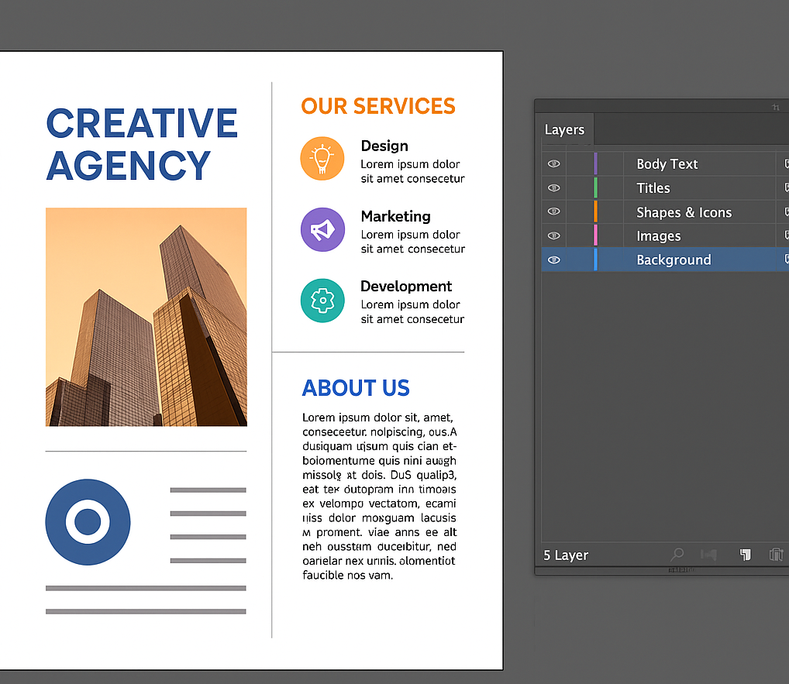
  - Background
  - Images
  - Shapes & Icons
  - Titles
  - Body Text
- Draw and place at least 3 objects in each layer.
- Lock the "Background" layer and hide the "Images" layer temporarily.
- Rename each layer with descriptive names.
- Change each layer’s outline color.
- Save the document as .ai and export a .pdf.

