Module 3 – Transformations and Effects

Introduction
In Adobe Illustrator, you don’t just create shapes and text — you can transform them and enhance them visually with effects.
Transformations change the size, position, or orientation of objects.
Effects add visual styles like shadows, blurs, or warps, without changing the actual shape’s vector structure.
Why use them?
- To adjust composition quickly without redrawing.
- To add depth and style to flat designs.
- To create dynamic and professional-looking graphics.

Transformations in Illustrator
You can apply transformations using the Transform Panel (Window > Transform), the Selection Tool, or menu commands under Object > Transform.
✅ Common Transformations:
- Move
  - Shifts the position of an object by X/Y coordinates.
  - Shortcut: Use arrow keys for small nudges; Shift + Arrow for bigger steps.
- Scale
  - Changes the size of an object proportionally or non-proportionally.
  - Hold Shift while scaling to maintain proportions.
- Rotate
  - Rotates objects around a reference point.
  - Hold Shift to rotate in 45° increments.
- Reflect
  - Flips an object horizontally or vertically.
  - Useful for symmetrical designs.
- Shear
  - Slants an object along a chosen axis to create a skewed effect.
📌 Tip:
Use Object > Transform > Transform Each to apply transformations individually to multiple selected objects.

Using the Transform Panel
The Transform Panel shows:
- X & Y position
- Width (W) & Height (H)
- Rotation Angle
- Shear Angle
💡 If you enter exact values, you can make precise adjustments — perfect for corporate or technical designs.

Visual Effects in Illustrator
Once you apply an effect to an object, the effect appears in the Appearance panel. You can edit the effect, move, duplicate, delete, or save it as part of a graphic style. When you use an effect, you must expand the object before you can access the new points.
- The effects in the top half of the Effects menu are vector effects. In the Appearance panel, you can apply these effects only to vector objects or to the fill or stroke of a bitmap object.
- The effects in the bottom half of the Effects menu are raster effects. You can apply them to either vector or bitmap objects.

Illustrator’s Effects menu offers two main categories:
- Illustrator Effects (vector-based, scalable without quality loss)
- Photoshop Effects (raster-based, may lose quality if enlarged too much)

Drop Shadow (Effect > Stylize > Drop Shadow)
Adds a shadow behind an object for depth.
Settings:
- Mode: Usually Multiply (blends shadow naturally)
- Opacity: Darkness level of the shadow
- X/Y Offset: How far the shadow is from the object
- Blur: Softens edges of the shadow
- Color: Usually black or a darker tone of the object
📌 Tip: Use subtle shadows for a clean, professional look.

Gaussian Blur (Effect > Blur > Gaussian Blur)
Softens edges and details for:
- Glow effects
- Depth of field simulation
- Atmospheric effects
Settings:
- Adjust Radius for how much blur is applied.
📌 Tip: Works well for highlights, shadows, or creating a soft-focus look.

Other Popular Effects:
- Outer Glow / Inner Glow – Adds a glowing halo outside or inside an object.
- Warp – Bends or distorts objects into arcs, waves, fish shapes, etc.
- Feather – Softens the edges of an object.

Feather the edges of an object
- Select the object or group (or target a layer in the Layers panel).
- Select Effect > Stylize > Feather.
- Set the distance the object fades from Opaque to Transparent, and select OK.

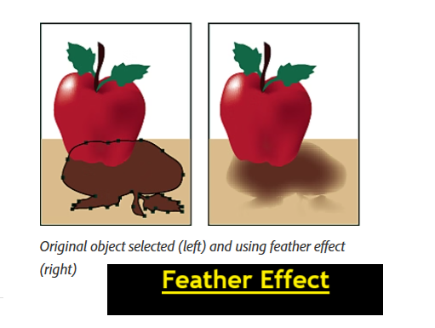

Appearance Panel & Editable Effects
The Appearance Panel (Window > Appearance) lets you:
- See all applied strokes, fills, and effects.
- Edit or remove effects anytime.
- Stack multiple effects on one object.
💡 Effects are non-destructive — you can turn them off or change them without redrawing.

Best Practices
- Keep transformations proportional unless you intentionally want distortion.
- Use subtle effects for a professional look.
- Remember that heavy raster effects (like blurs) can make files larger and slower.
- Save an original, untransformed copy of important objects.

Assignment
Scenario: You are designing a tech conference flyer.
Tasks:
- Create a new Illustrator document (A4 size, RGB mode).
- Draw a large title text and scale it proportionally to fit the top area.
- Use the Reflect Tool to create a symmetrical graphic element below the title.
- Apply:
  - A Drop Shadow to the title text.
  - A Gaussian Blur to a circular background shape for depth.
- Rotate one decorative shape at a 30° angle for a dynamic look.
- Save the file as .ai and export as .jpg.



