Module 1 - Color Modes and Application

Why Colors Matter
In design, color is not just decoration — it’s essential for brand identity, mood, and communication.
Using the right color mode and tools ensures your design looks correct whether it’s printed or viewed on a screen.

Color Modes: RGB vs CMYK
✅ RGB Color Mode
- Stands for: Red, Green, Blue.
- Used for digital screens: websites, social media, apps, presentations.
- Colors are created by mixing light; adding more light makes colors brighter.
- Has a wider range of bright, vivid colors.
💡 Use RGB when your design is meant for computers, tablets, or phones.

✅ CMYK Color Mode
- Stands for: Cyan, Magenta, Yellow, Key (Black).
- Used for printed materials: brochures, posters, business cards.
- Colors are created by layering ink; adding more ink makes colors darker.
- Some bright colors in RGB can’t be printed exactly in CMYK.
💡 Use CMYK for anything you plan to print.

How to Check or Change Color Mode
- Go to File > Document Color Mode > RGB/CMYK Color.
- Important: always set color mode before starting your design to avoid color shifts later.

Tools to Apply and Manage Color
Illustrator offers multiple ways to set and edit colors:

✅ Color Picker
- Double-click the Fill or Stroke square at the bottom of the Tools panel or in the Color panel.
- Opens a window where you can:
  - Choose a color by clicking in the color field.
  - Enter precise color codes (like #FF0000 for red).
  - See your color values in RGB or CMYK.
- Shows a warning if the selected color isn’t printable in CMYK.
💡 Use the Color Picker for quick, precise color choices.

✅ Swatches Panel (Window > Swatches)
- Stores predefined colors, gradients, and patterns.
- You can:
  - Save custom colors for reuse
  - Access Pantone or spot color libraries
  - Create new swatches from selected objects
💡 Use Swatches to keep your colors consistent throughout a design.

Types of Swatches in Illustrator
The Swatches panel and swatch library panels let you save and reuse colors, gradients, and patterns in your artwork. Here’s what you can store there:

- Process Colors
- Made by combining the four CMYK inks: cyan, magenta, yellow, and black.
- These are the most common colors for printing.
- By default, new swatches in Illustrator are process colors.

- Global Process Colors
- A global color updates everywhere it’s used when you edit the swatch.
- Process colors can be local (only affect one object) or global (update all linked objects).
- Identified in the Swatches panel by a small triangle in the corner.

- Spot Colors
- A premixed ink used separately from CMYK.
- Ensures exact color matching (e.g., a company’s specific logo color).
- Identified in the Swatches panel by a small dot icon.

- Gradients
- A smooth blend between two or more colors or tints.
- Can use process, RGB, or spot colors.
- Transparency in gradient stops is saved in gradient swatches.
- Note: Aspect ratio/angle settings of elliptical gradients aren’t saved.

- Patterns
- Repeating (tiled) designs that can include shapes, paths, or text.
- Patterns automatically repeat across an object’s fill area.

✅ Color Panel (Window > Color)
- Lets you mix colors manually by adjusting sliders for RGB or CMYK values.
- Shows both Fill and Stroke colors at the top.
- Great for exploring shades, tints, or subtle color adjustments.
💡 Use the Color Panel when you want fine control over colors or need to tweak them quickly.

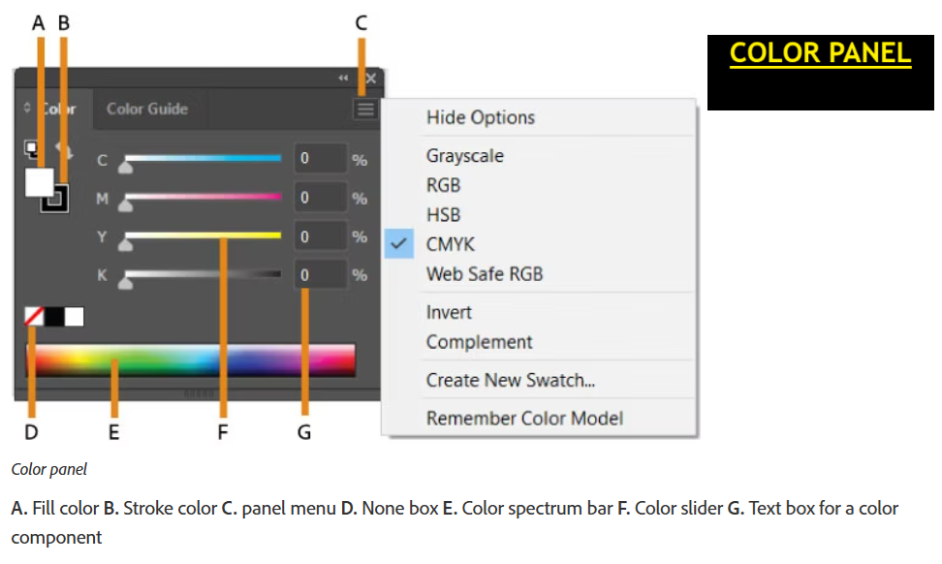

Fill and Stroke Colors
Remember:
- Fill is the inside of a shape.
- Stroke is the border/outline.
- You can set them separately in the Color Panel or Swatches.
🔄 To swap fill and stroke quickly, click the double-arrow icon near the Fill/Stroke boxes in the Tools panel or press Shift + X.

Tips for Applying Color
- Global Swatches: When you create a swatch, check “Global” so that any update to the swatch automatically updates all objects using it.
- Eyedropper Tool (I): Quickly copy color from one object to another.
- Kuler/Adobe Color Themes (Window > Color Themes): Explore professional color palettes for inspiration.
- Recolor Artwork: Use the Recolor Artwork feature (in the top Control bar) to change color schemes across your entire design.

Assignment

Scenario: You’re designing a promotional poster for a smoothie shop.
Tasks:
- Create a new Illustrator document in CMYK Color Mode (for print).
- Use the Color Picker to set:
  - A bright green for the smoothie cup.
  - A soft yellow for a background accent.
- Save these colors as new Global Swatches named “Smoothie Green” and “Accent Yellow.”
- Apply both colors to different shapes in your poster.
- Switch to RGB Color Mode and notice any changes in appearance (don’t save changes after this test).

