Module 2 - Gradients and Advanced Coloring

What is a Gradient?
A gradient is a smooth transition between two or more colors.
Instead of filling an object with a single flat color, a gradient allows colors to blend naturally across the shape, creating a more realistic, dimensional, or decorative look.
Gradients are used in:
- Backgrounds
- Buttons and icons
- Logos
- Illustrations
- Shadows and highlights

Types of Gradients in Illustrator
Illustrator offers several gradient types, each with different styles of color blending.
- Linear Gradient
- Colors blend along a straight line.
- The direction can be vertical, horizontal, or angled.
- Example: Blue fading to white from top to bottom.

- Radial Gradient
- Colors blend in a circular pattern from a center point outward.
- Good for spotlight effects, sun glows, or rounded objects.

- Freeform Gradient
- Allows you to place color points anywhere inside the object.
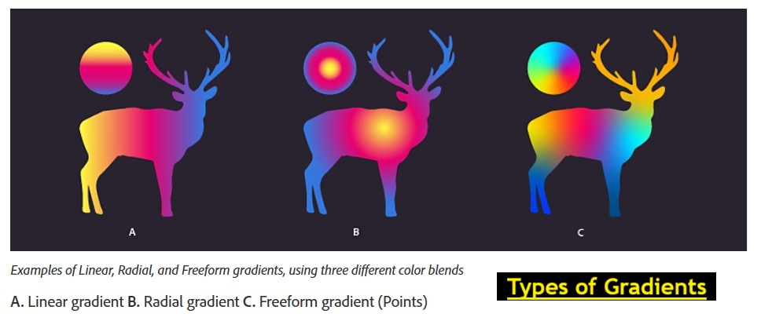
- Each point can have its own color and blend naturally with others.
- Great for organic color blending and complex shading.

Creating a Gradient
➤ Method 1: Using the Gradient Panel
- Select the object.
- Go to Window > Gradient to open the panel.
- Click the gradient slider to choose a Linear, Radial, or Freeform gradient.
- Double-click color stops to set colors (via Color Picker, Swatches, or Eyedropper).

➤ Method 2: Using the Gradient Tool (G)
- Select your shape.
- Select the Gradient Tool (G) from the Tools panel.
- Drag across your shape to apply and control gradient direction.
- Adjust length and angle by dragging.
💡 You can reposition and resize the gradient directly on the object.

NOTE: A color stop is a point on the Gradient Annotator (for linear and radial) or on the object (for freeform) that controls the gradient's color. You can change the color of the color stops to set a gradient

Create and apply a linear gradient
To create a linear gradient, do one of the following:

- Click the Gradient tool and then click the object on the canvas. The Gradient Type buttons are displayed in the Control panel or Properties panel. With the object selected, click Linear Gradient to apply the Linear gradient on the object.
- In the Gradient panel, click Linear Gradient.
- In the Properties panel, click Linear Gradient in the Gradient section.

Create and apply a radial gradient
To create or apply a radial gradient, do one of the following:

- Click the Gradient tool and then click the object on the canvas. The Gradient Type buttons are displayed in the Control panel or Properties panel. With the object selected, click Radial Gradient to apply the Radial gradient on the object.
- In the Gradient panel, click Radial Gradient.
- In the Properties panel, click Radial Gradient in the Gradient section.

Create and apply a freeform gradient
To create and apply a freeform gradient, do one of the following:

- Click the Gradient tool and then click the object on the canvas. The Gradient Type buttons are displayed in the Control panel or Properties panel. With the object selected, click Freeform Gradient to apply the Freeform gradient on the object.
- In the Gradient panel, click Freeform Gradient.
- In the Properties panel, click Freeform Gradient in the Gradient section.
After you click Freeform gradient, the following two options are available:
- Points: Select this option if you want to create color stops as independent points in the object.
- Lines: Select this option if you want to create color stops over a line segment in the object.

Editing Gradients
- Add color stops: Click directly under the gradient slider.
- Remove stops: Drag them away from the slider.
- Change colors: Double-click a stop and choose a new color.
- Change opacity: Select a stop and adjust opacity in the Gradient panel.
- Reverse colors: Click the reverse arrow in the Gradient panel.
📌 Tip: For print work, ensure colors are within CMYK range to avoid unexpected results.

Advanced Coloring Techniques
🎯 Opacity Stops
- Create fades to transparency for overlays or soft edges.
🎯 Global Colors in Gradients
- Use global swatches in your gradient so changes update everywhere.
🎯 Gradient Mesh (Advanced)
- Found under Object > Create Gradient Mesh.
- Turns an object into a mesh with adjustable color points for realistic shading.
🎯 Blending Modes
- Combine gradients with blending modes (in the Transparency panel) for creative effects.

Blending modes let you vary the ways that the colors of objects blend with the colors of underlying objects. When you apply a blending mode to an object, the effect of the blending mode is seen on any objects that lie beneath the object’s layer or group.
It’s helpful to think in terms of the following color terminology when visualizing a blending mode’s effect:
- The blend color is the original color of the selected object, group, or layer.
- The base color is the underlying color in the artwork.
- The resulting color is the color resulting from the blend.

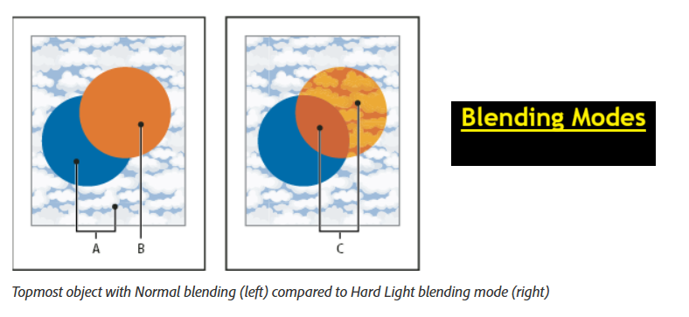
Real-World Examples
- 🌅 Sky backgrounds in posters.
- 🏆 Metallic effects for trophies or medals.
- 🍏 Shading on product illustrations.
- 🎨 Creative button and web icon designs.

Assignment
Scenario: You are designing a sunset background for a travel poster.
Tasks:
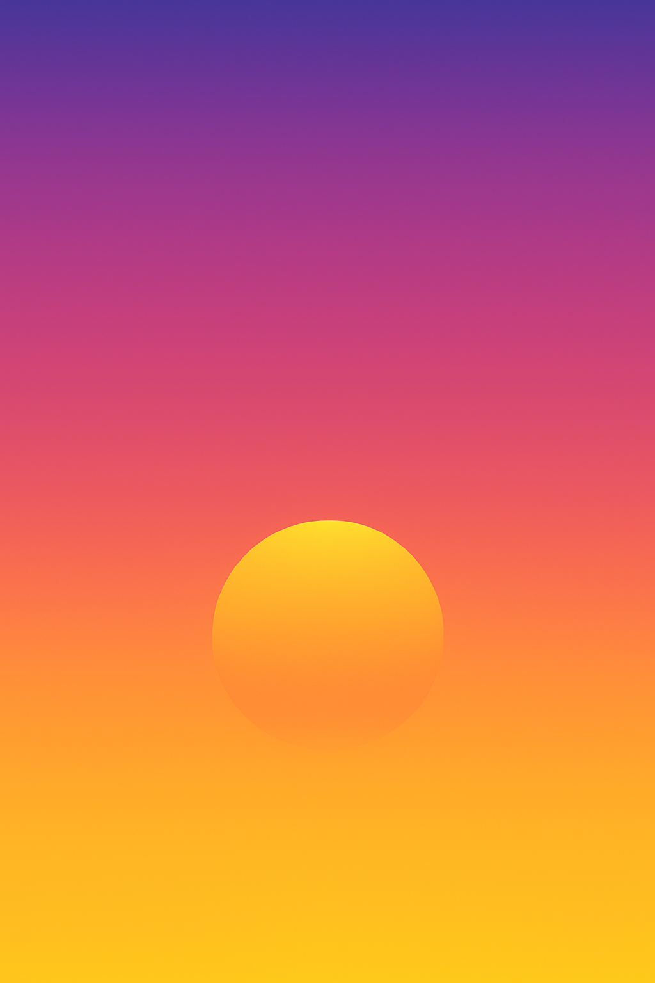
- Create a new Illustrator document in RGB Mode (for screen).
- Draw a rectangle that covers the artboard.
- Apply a Linear Gradient from orange to purple.
- Adjust the gradient angle to 90° so the colors blend vertically.
- Create a circle (sun) and apply a Radial Gradient from yellow (center) to transparent (edges).
- Place the sun over the gradient background.

