Module 3 - Typography and Text Effects

Introduction to Typography in Illustrator

Typography is the art and technique of arranging text so it’s clear, visually appealing, and matches your design’s purpose.
In Illustrator, text isn’t just words — it’s a design element that can be shaped, styled, and transformed.
Typography in Illustrator can be used for:
- Logos and branding
- Posters and flyers
- Social media graphics
- Packaging designs
Illustrator gives you precise control over every aspect of text, from font selection to advanced effects.

Adding Text in Illustrator

Type Tool (T)
- Select the Type Tool (T) from the toolbar.
- Click once on the artboard to create Point Type (best for short text like titles).
- Click and drag to create Area Type (text inside a box for paragraphs).
📌 Tip: Use Shift + Ctrl/Cmd + > or < to quickly change font size.
Add text at a point, in an area or shape, and on a path as per your design requirement:

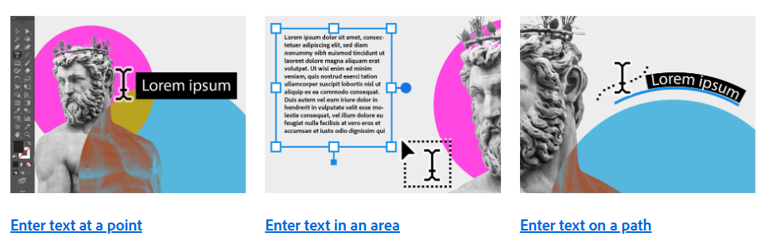
Type 1: Enter text at a point
Point type is a horizontal or vertical line of text that begins where you click and expands as you enter characters. Each line of text is independent. The line expands or shrinks as you enter or delete the text, but doesn’t wrap to the following line. Follow these steps to enter text at a point:
Add text at any point
- Select the Type tool (T) or the Vertical Type tool .
- Click anywhere to enter your text. Press Enter or Return to begin a new line of text within the same type object.
- Click the Selection tool (V) to select the type object.

Type 2: Enter text in an area
Area type (also called paragraph type) uses the boundaries of an object to control the flow of characters, either horizontally or vertically. When the text reaches a border, it automatically wraps to fit inside the defined area. Follow these steps to enter text in any area of your vector art:
- Use any of the following ways to define a bounding area:

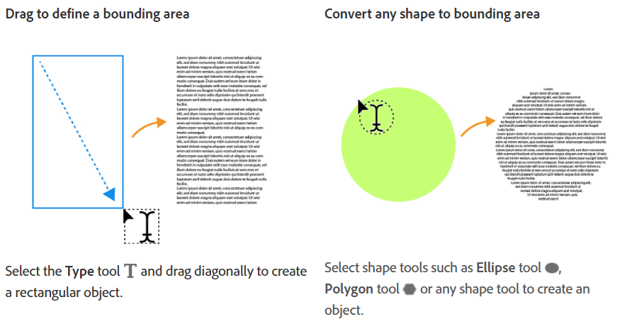

- Select Area Type tool or Vertical Area Type tool.
- Click anywhere on the path of your object. Your object is now filled with placeholder text.
- Enter your text.

Type 3: Enter text on a path
You can enter text on any path or shape outline. Follow these steps to learn how:

- Draw a path or shape.
- Select the Type on a Path tool or Vertical Type on a Path tool .
- Click at the beginning of the path or at any point on the shape border.
Your path or the border of your shape is now filled with placeholder text.
- Enter your text.

Create bulleted or numbered lists
Follow the steps below to start applying numbered and ordered lists to the text.
- Select the set of paragraphs that will become the list, or click to place the insertion point where you want the list to begin.
- Do any of the following:
  - Click the bulleted list button or the numbered list button in the Control panel (Windows > Control).
  - Click the more options icon in the Paragraph section of the Properties panel and click the Bulleted List button or the Numbered List button.
  - Select the text and right-click. Choose Bulleted and Numbered Lists and apply numbers or bullets.
  - Use the type context menu to click and apply lists.
- To continue the list in the next paragraph, move the insertion point to the end of the list and press Enter or Return.
Customize bullets
You can create custom bullets by using keyboard as follows:
- * <space>
- # <space>
- > <space>
- + <space>

Use presets and preview
Apart from the default types of bullets and numbers, you can also use some of the presets available in the panel. As shown in the Bullets and Numbering dialog, click the preset button and preview the effect instantly in the text.

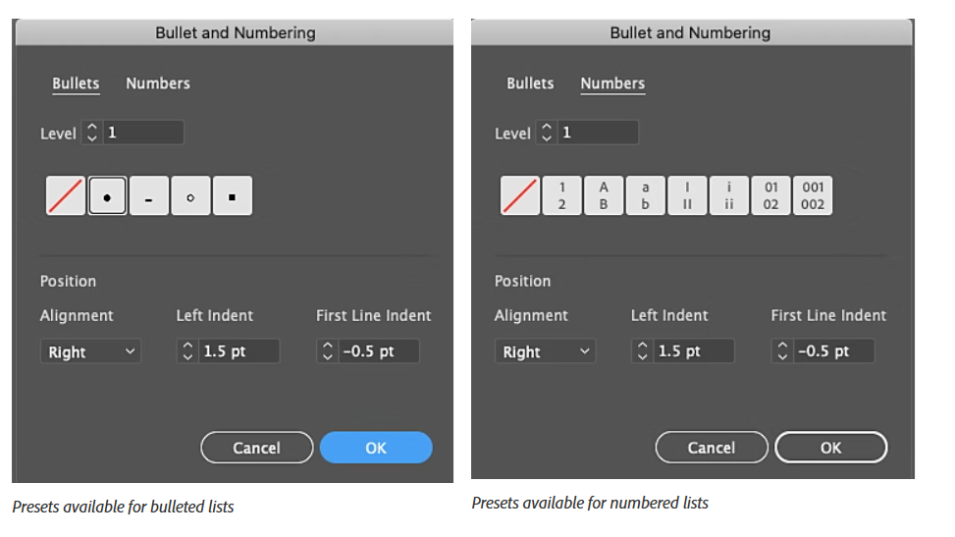

Formatting Text – Character Panel
The Character Panel (Window > Type > Character) lets you adjust individual letter details.
Key Settings:
- Font Family – Choose the style of letters (e.g., Arial, Times New Roman, custom fonts).
- Font Style – Regular, Bold, Italic, etc.
- Font Size – Height of the letters (in points).
- Leading – Space between lines of text.
- Kerning – Space between two specific letters.
- Tracking – Space between all letters in a selection.
- Baseline Shift – Moves letters up or down from the baseline.
💡 NOTE: Kerning and tracking improve readability and balance in designs.

Organizing Text – Paragraph Panel
The Paragraph Panel (Window > Type > Paragraph) controls how text is arranged in blocks.
Key Options:
- Alignment – Left, Center, Right, Justify
- Indentation – Space before the start of a line
- Spacing Before/After Paragraphs
- Hyphenation – Turn it on/off for cleaner layouts
📌 Good paragraph formatting is essential for brochures, articles, and multi-column layouts.

Applying Text Effects
Text effects help make your typography stand out. You can add effects without turning text into outlines (keeping it editable).
✅ Common Text Effects:
- Fill & Stroke
  - Fill: Inside color of the text.
  - Stroke: Outline of the letters (set thickness and color in the Appearance panel).
- Drop Shadow
  - Go to Effect > Stylize > Drop Shadow.
  - Adds depth and contrast.
- Outer Glow / Inner Glow
  - Creates a glowing effect around or inside text.
  - Adjust opacity, color, and spread for different looks.
- Warp Effects
  - Go to Effect > Warp (Arc, Flag, Wave, etc.).
  - Useful for banners, logos, and playful designs.
- Gradient Text
  - Apply gradients to text for colorful, modern styles.
  - Works best when text is converted to outlines.
📌 Tip: Use effects sparingly to keep text readable.

Advanced Text Options
- Type on a Path Tool – Lets you place text along curves or shapes.
- Outline Text (Type > Create Outlines) – Converts text into editable vector shapes.
- OpenType Features – Special font features like ligatures, stylistic alternates, and small caps.

Assignment
Scenario: You’re creating a promotional poster for a music festival.
Tasks:
- Open a new Illustrator document (A3 size, RGB mode).
- Add a festival title using Point Type. Choose a bold, decorative font.
- Apply:
  - A gradient fill to the text.
  - A drop shadow for depth.
- Add a subtitle in a clean, simple font using the Paragraph panel to center-align it.
- Include a block of event details (date, time, location) in Area Type.
- Use tracking and leading adjustments to improve readability.



