Module 1 - Basic Drawing Tools

1. Introduction to Drawing Tools in Illustrator
Adobe Illustrator is known for its precision drawing tools that help you create everything from basic shapes to complex illustrations.
These tools are designed to give you full control over:
- Lines and curves
- Angles and points
- Shapes and outlines
Learning how to use these basic tools is the first step toward becoming confident in vector design.

2. The Selection Tools
✅ A. Selection Tool (V)
- This is the black arrow tool.
- It lets you select whole objects (shapes, text, paths).
- You can move, scale, rotate, and delete objects with it.
💡 Shortcut: V

✅ B. Direct Selection Tool (A)
- This is the white arrow tool.
- It allows you to click and edit anchor points and paths.
- Useful for fine-tuning the shape or curve of an object.
💡 Shortcut: A
📌 Tip: Use the Direct Selection Tool when you want to bend or adjust just part of a shape.

✅ C. Magic Wand Tool (Y)
The Magic Wand Tool (Y) selects objects with similar attributes like fill colour, stroke colour, or stroke weight.
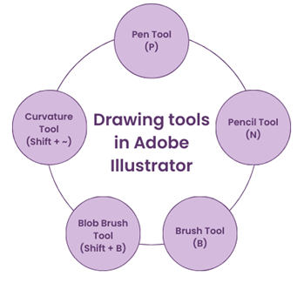
- Click an object with the desired attribute.
- Adjust tolerance in the Control panel for sensitivity.
- Hold Shift to add, Alt (Option on Mac) to subtract from the selection.

3. Shape Tools
Shape Tools allow you to create ready-made vector shapes.
✅ A. Rectangle Tool (M)
- Click and drag to draw a rectangle.
- Hold Shift to make a perfect square.
- You can edit the corners later using the Properties panel.

✅ B. Ellipse Tool (L)
- Click and drag to draw circles or ovals.
- Hold Shift to make a perfect circle.

✅ C. Polygon, Star, and Rounded Rectangle
- Click once to open a dialog box where you can enter specific values (e.g., 5 sides for a polygon).
- Use the arrow keys while dragging to increase or decrease points or corners.
🛠️ You can find these tools under the Rectangle Tool by clicking and holding it.

4. Pen Tool – The Most Powerful Drawing Tool
The Pen Tool (P) allows you to create custom shapes and paths by plotting anchor points.
🧩 How It Works:
- Click to create straight lines between points.
- Click and drag to create curved lines (Bezier curves).
- Close the shape by clicking back on the first point.
💡 Shortcut: P
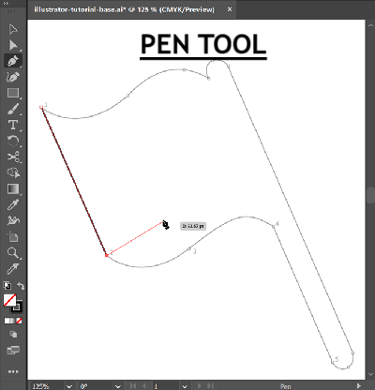
🔁 Extra Tools:
- Add Anchor Point Tool (+): Add points to a path
- Delete Anchor Point Tool (–): Remove points
- Anchor Point Tool (Shift + C): Adjust curves and angles
📌 Tip: It takes practice! Start with simple shapes and move up to complex paths.

5. Pencil Tool (N)
The Pencil Tool (N) offers a free-hand drawing experience, allowing you to draw freeform paths with a hand-drawn feel.
    - Select the tool and start drawing with your mouse or tablet.
    - Adjust the smoothing setting in the Control panel for cleaner or more organic lines.
6. Brush Tool (B)
The Brush Tool (B) lets you paint strokes with various brush presets, providing artistic and organic lines to your designs.
    - Choose a brush preset from the Brushes panel.
    - Adjust the stroke's size, opacity, and other settings in the Control panel.

7. Blob Brush Tool (Shift + B)
The Blob Brush Tool (Shift + B) combines the simplicity of a brush with the vector capabilities of Illustrator. It's perfect for creating organic and painterly shapes.
    - Draw freely like with the Pencil Tool.
    - The Blob Brush Tool automatically merges overlapping paths into a single shape.

8. Line Segment Tool
This tool draws a straight line from one point to another.
➤ How to Use:
- Select the Line Segment Tool (\)
- Click and drag on the artboard to draw a line
- Use the Stroke Panel to adjust line thickness or add arrowheads
💡 Hold Shift while dragging to constrain the line to 45° angles (horizontal, vertical, diagonal).

9. Arc Tool
The Arc Tool lets you create curved lines or half-circles.
➤ How to Use:
- Click and drag to create a curve
- Use the arrow keys while dragging to adjust direction or shape
- You can reflect or flip the arc while drawing
🎨 Use this tool to draw smiley faces, rainbows, or curved decorative lines.

10. Curvature Tool (Shift + `)
The Curvature Tool is a simpler alternative to the Pen Tool. It lets you draw smooth curves and straight lines without manually dragging handles.
➤ How to Use:
- Select the Curvature Tool from the toolbar.
- Click to add points — Illustrator automatically creates smooth curves between them.
- To make a corner, double-click a point.
- Click the starting point to close the shape.
💡 The Curvature Tool is great for organic shapes like leaves, waves, or icons with flowing curves.
➤ Editing:
- Click and drag anchor points to adjust curves.
- Add more points by clicking on a path.
- Delete a point by selecting it and pressing Delete.
📌 Tip: It’s easier for beginners than the Pen Tool, especially for drawing curved designs quickly.

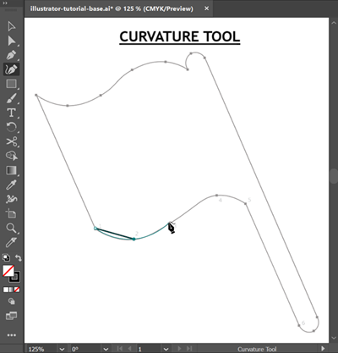

8. Helpful Tips When Drawing
- Hold Shift to keep things straight or proportional
- Use Smart Guides (View > Smart Guides) for better alignment
- To duplicate a shape, select it and press Alt + Drag
- Use the Eyedropper Tool (I) to copy stroke or fill style from another object

