Module 2 - Working with Paths and Anchor Points

Introduction: What are Paths and Anchor Points?
In Adobe Illustrator, every shape or line is made up of a path — a line that connects two or more points. These points are called anchor points.

Anchor points control the structure and direction of a shape.
Paths can be:
- Open paths (like a straight line)
- Closed paths (like a circle or triangle)
Each anchor point can be adjusted to change the curve, angle, or direction of the path.

Types of Anchor Points
There are two main types of anchor points:
✅ A. Corner Points
- Create sharp angles
- Used in squares, triangles, stars, etc.
- Add by clicking (with no dragging) using the Pen Tool
✅ B. Smooth Points
- Create curves with Bezier handles
- Used for wavy lines, circles, curves
- Add by clicking and dragging with the Pen Tool

Selecting and Editing Anchor Points
✏️ Direct Selection Tool (A)
- Lets you click and select individual anchor points
- You can move points, reshape curves, or fine-tune edges
✏️ Anchor Point Tool (Shift + C)
- Converts a smooth point into a corner point and vice versa
- Lets you adjust direction handles of curves manually

➤ How to Edit a Path:
- Select the shape using the Selection Tool (V)
- Switch to Direct Selection Tool (A)
- Click on any anchor point
- Drag it to change the shape
- If it’s a curve, you’ll see direction handles — drag them to adjust the curve
📌 Tip: Hold Shift while dragging a point to constrain movement to straight lines.

Adding and Removing Anchor Points
Sometimes you may want to add more detail to your shape or simplify it.
➕ Add Anchor Point Tool (+)
- Adds a new anchor point anywhere on the path
➖ Delete Anchor Point Tool (–)
- Removes unwanted anchor points without breaking the path
🧠 You can access both from the Pen Tool group or by using shortcuts:
- + = Add Anchor Point
- – = Delete Anchor Point

Useful Editing Tips
- Click + drag a handle to reshape a curve without affecting the entire path
- Alt/Option + click an anchor point to convert from smooth to corner
- Use Smart Guides (Ctrl + U) to align anchor points precisely
- Shift + Click multiple anchor points to move them together

Real-World Examples
Editing paths and anchor points is useful when:
- 🎯 Fine-tuning a custom logo shape
- 🌀 Adjusting the curve in a wave or ribbon design
- 🧩 Smoothing rough edges in a hand-drawn sketch
- 💡 Turning a square into a rounded or organic shape

Assignment

Scenario: You are designing a leaf-shaped icon for a wellness brand.
Tasks:
- Open a new Illustrator document (A4)
- Use the Pen Tool to draw a rough leaf shape
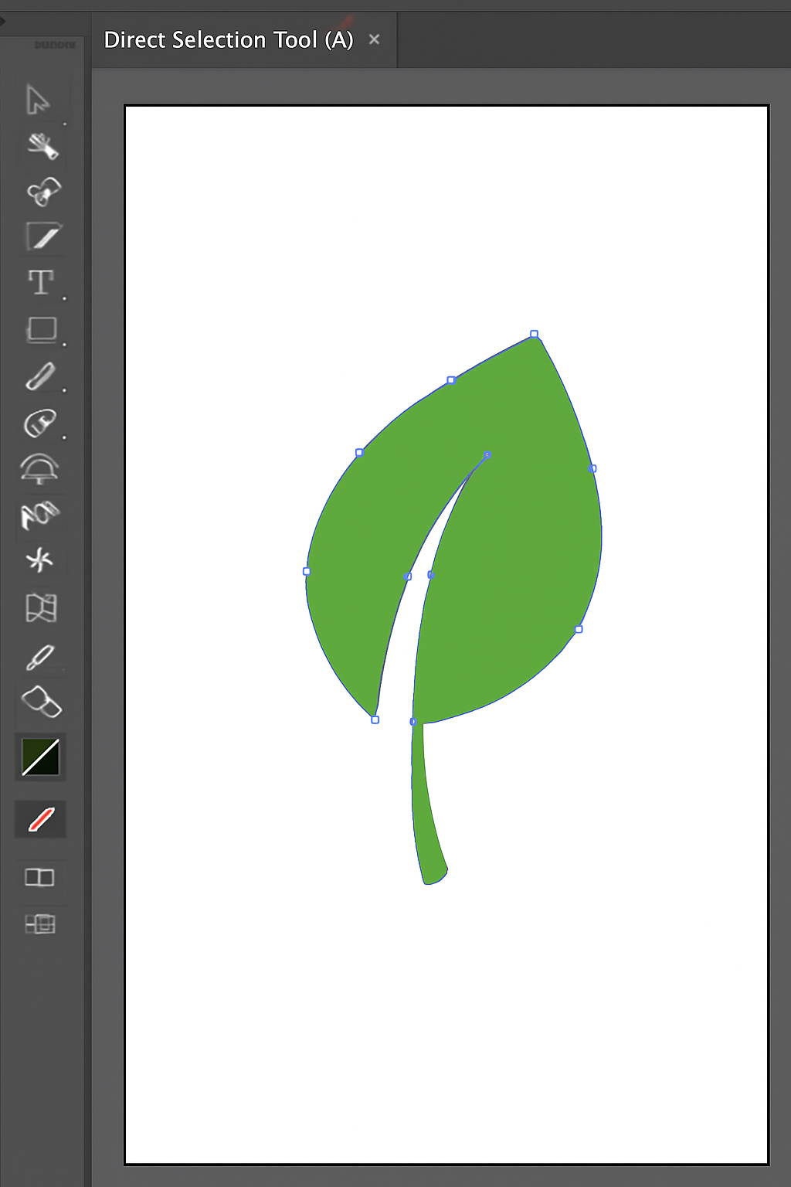
- Use the Direct Selection Tool (A) to:
  - Adjust anchor points
  - Smoothen curves
  - Fix any sharp corners
- Add a stem using the Line Segment Tool
- Use the Add Anchor Point Tool (+) to give more detail to the leaf tip
- Remove unnecessary points with the Delete Anchor Point Tool (–)

