Module 1 – Importing and Tracing Images

Introduction
In Illustrator, you can work with two main image types:
- Raster images (made of pixels) – e.g., JPG, PNG, BMP, TIFF
- Vector images (made of paths and anchor points) – scalable without losing quality
Sometimes, you need to:
- Place an existing raster image in your Illustrator project
- Convert it into vector format for scalability and easy editing
That’s where Image Trace comes in — it automatically converts raster images into editable vector shapes.

Importing (Placing) Raster Images
📌 Steps to Import:
- Go to File > Place.
- Choose your image file (e.g., JPG, PNG).
- Select Link if you want the file to remain separate (updates when the original changes)
OR Uncheck Link to embed the image in the Illustrator file.
- Click Place.
- Click anywhere on the artboard OR click-drag to size the placed image.

Linked vs Embedded Images:
- Linked: Smaller AI file size, but you must keep the original image file in the same location.
- Embedded: Larger AI file size, but all data is stored in the Illustrator file.
💡 Tip: You can see if an image is linked or embedded in the Links Panel (Window > Links).

What is Image Trace?
Image Trace automatically converts raster images into editable vector shapes.
This is useful for:
- Converting a hand-drawn sketch into vector art
- Turning a low-quality logo into a scalable version
- Creating a flat, colored vector from a photo
📌 Remember: Image Trace is best for images with clear shapes and limited colors.

Using Image Trace
Steps:
- Select the placed image.
- Open the Image Trace Panel (Window > Image Trace).
- Choose a Preset:
  - Black and White Logo – for solid shapes in black and white
  - High Fidelity Photo – keeps more details and colors
  - Low Fidelity Photo – fewer details, artistic look
  - 3 Colors / 6 Colors / 16 Colors – limited color vectorization
  - Line Art / Technical Drawing – for outlines
- Adjust Settings:
  - Mode: Color, Grayscale, or Black & White
  - Threshold: (Black & White mode) – controls what’s black vs white
  - Paths: More = detailed, Less = smoother
  - Corners: More = sharper edges, Less = rounded
  - Noise: Ignores small details/noise
- Click Preview to see changes before applying.

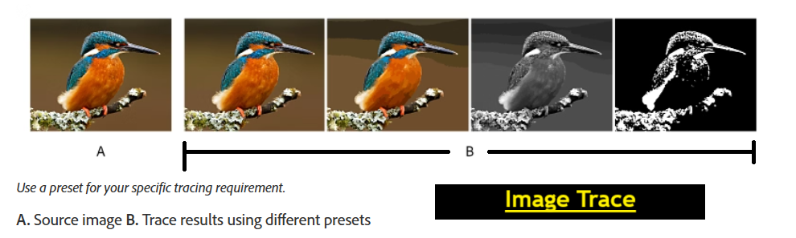

Expanding the Traced Image
When you’re happy with the Image Trace:
- Click Expand in the Control Bar.
- The traced object becomes editable vector shapes.
- Use the Direct Selection Tool (A) or Group Selection Tool to edit individual shapes and colors.
💡 Tip: After expanding, you may need to ungroup objects (Object > Ungroup) for easier editing.

Best Practices for Image Trace
- Start with the highest-quality raster image possible.
- Use simpler images for cleaner results.
- Reduce image noise and unnecessary background before tracing.
- Keep an original copy in case you need to redo the trace.

Real-World Applications
- Digitizing hand-drawn artwork.
- Re-creating old logos in vector format.
- Making clipart from photos.

Assignment

Scenario: You have a hand-drawn flower sketch scanned as a JPG file.
Tasks:
- Create a new Illustrator document (A4 size, RGB Mode).
- Place the scanned flower sketch into your artboard.
- Use Image Trace with the "Black and White Logo" preset.
- Adjust Threshold to keep all main details of the flower.
- Expand and ungroup the traced shapes.
- Color the petals with pink and the stem with green.
- Save the file as .ai and export a .png.

