Module 2 – Masks and 3D Tools

Introduction
Adobe Illustrator offers masking tools to hide or reveal parts of artwork and 3D tools to create realistic-looking depth and perspective.
- Clipping Masks – Show only part of an object/image inside a specific shape.
- Opacity Masks – Gradually fade artwork using transparency.
- Perspective Grid – Draw artwork in accurate 1-point, 2-point, or 3-point perspective.
- 3D Effects – Add depth and dimension to flat shapes.
These tools are essential for professional design work, such as:
- Product mockups
- Packaging designs
- Posters and advertisements
- Isometric illustrations

Clipping Masks
A clipping mask uses one shape (the mask) to hide everything outside its boundaries.
How to Create a Clipping Mask:
- Place the object you want to use as a mask on top.
- Select both the mask shape and the artwork beneath.
- Go to Object > Clipping Mask > Make (Shortcut: Ctrl + 7).
Example Uses:
- Show an image inside text.
- Reveal only part of a photo for design composition.
- Create patterns inside specific shapes.
📌 Tip: The top object becomes the mask; it can be a shape or text.

Opacity Masks
An opacity mask controls visibility using gradients or shades of gray:
- White areas = fully visible
- Black areas = hidden
- Gray areas = partially visible (transparency)
How to Create an Opacity Mask:
- Select the artwork.
- Open the Transparency Panel (Window > Transparency).
- Click the menu and select Make Opacity Mask.
- Edit the mask to control transparency.
Example Uses:
- Fade edges of an image.
- Create smooth blending between elements.
- Make glass or shadow effects.

Perspective Grid
The Perspective Grid tool helps you draw in realistic space.
How to Activate:
- View > Perspective Grid > Show Grid (Shortcut: Ctrl + Shift + I).

Types of Perspective:
- 1-Point Perspective: Objects face you directly.
- 2-Point Perspective: Shows two sides, often used for buildings.
- 3-Point Perspective: Adds depth and height (looking up or down).
How to Use:
- Activate the Perspective Selection Tool (Shift + V).
- Attach objects to different planes by clicking grid sides.
- Draw shapes aligned to the perspective lines.
Example Uses:
- Storefront designs
- Street scenes
- Isometric-style art

3D Effects
Illustrator can turn flat shapes into 3D-like objects.
Popular 3D Effects:
- Extrude & Bevel
  - Adds depth to shapes, making them look like blocks.
  - Bevel adds angled edges for style.
- Revolve
  - Spins a shape around an axis to create circular objects (e.g., bottles, wheels).
- Rotate
  - Simulates turning an object in 3D space.
How to Apply:
- Select an object.
- Go to Effect > 3D and Materials.
- Choose Extrude & Bevel, Revolve, or Rotate.
- Adjust depth, angle, lighting, and shading.
📌 Tip: Keep an eye on file size — 3D effects can make your file heavier.

4 Steps to create 3D effect
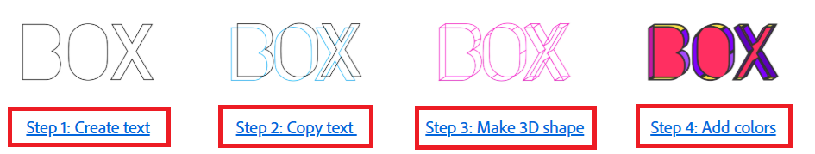
Step 1: Create your text

  - Type your text using the Type tool and assign a font.
  - Convert text to outlines by right-clicking and choosing Create Outlines.
  - Remove fill color, assign the stroke of 2pt and set color as black.
  - Ungroup the letters in the text. Right-click and choose Ungroup.
  - Right-click the letter and choose Release Compound Path. Select the inner sections of B and O and delete them.
  - After the inner sections are removed, the letters show a hollow shape.

Step 2: Create a copy of the text shape
To create a copy of the shape, press Alt and then drag the shape.

Step 3: Create a 3D shape for letters
    - Using the anchor points
- Select anchor points on the path around the area where 3D effect is to be created. The Anchor point options will become available on the Control panel when you select the anchor points.
- Press Command/Ctrl+C and Command/Ctrl+F to copy and paste in front or choose Edit > Paste in Front. This will copy the paths held by the selected anchor points and paste them in place on the top. This process helps you make an identical copy for precision. Assign these new paths a diff stroke color.
- Join loose ends to make a closed path.
- To make a closed path, select end points and click the Connect Selected End Points button in the Control panel.
- Complete the step for the whole letter 'O'.

    - Using the Pen tool

- Use the Pen tool to draw faces around all the edges of the letter.
- Use either of the two methods (Pen tool or anchor points) to create the 3D dimension for letter B.

Step 4: Add fill and stroke color

Best Practices
- For clipping masks, always keep a backup of your unmasked artwork.
- For opacity masks, use simple gradients for smooth fading.
- Use the Perspective Grid only when necessary — too many lines can clutter your workspace.
- Keep 3D effects subtle for print designs; use higher resolution for web designs.

Assignment
Scenario: You are creating a product mockup for a coffee brand.
Tasks:
- Create a new Illustrator document (A4, RGB mode).
- Import an image of a coffee cup.
- Draw a shape over the cup’s sleeve and apply a clipping mask to show a logo only on the sleeve.
- Use an opacity mask to fade the bottom of the cup into the background.
- Activate the Perspective Grid and draw a street scene behind the cup.
- Create a simple 3D coffee bean icon using the Revolve effect.
- Save as .ai and export as .png.



