Module 3 – Export and File Formats

Introduction
When you finish a design in Illustrator, you need to export it so others can view, print, or use it online.
The export method and file format depend on:
- Where the design will be used (print, web, animation, etc.)
- How much editing flexibility is required later
- The level of image quality and file size
Illustrator supports native vector formats (AI, PDF, SVG, EPS) and raster formats (PNG, JPG, TIFF).

Common File Formats
AI (Adobe Illustrator)
- Native format for Illustrator.
- Keeps all layers, effects, and editable paths.
- Best for storing master files you might need to edit later.
- Not ideal for sharing with people who don’t have Illustrator.

PDF (Portable Document Format)
- Keeps vector quality.
- Can be opened on almost any device.
- Supports layers, fonts, and transparency.
- Perfect for printing and sharing proofs.
- Can embed AI data for future editing.

SVG (Scalable Vector Graphics)
- Web-friendly vector format.
- Supported by browsers and design software.
- Keeps shapes editable in compatible apps.
- Best for web icons, logos, and animations.

EPS (Encapsulated PostScript)
- Older but widely supported vector format.
- Often used in printing and sign-making.
- Good for sharing with vendors who use older design software.

PNG (Portable Network Graphics)
- Raster image format (made of pixels).
- Supports transparency (good for logos over backgrounds).
- Best for web graphics.
- Does not scale well compared to vectors.

JPG (JPEG)
- Raster format for photos and web images.
- Smaller file size but lossy compression (reduces quality).
- No transparency support.
- Not recommended for logos or line art.

TIFF
- High-quality raster format.
- Common in professional printing.
- Supports transparency and large file sizes.

Exporting for Web
- Go to File > Export > Export As…
- Choose PNG, JPG, or SVG.
- In Export for Screens (Shift + Ctrl + Alt + E), you can:
  - Export multiple artboards at once
  - Choose resolution (72 ppi for web)
  - Set transparency background
💡 Tip: Use SVG for web icons to keep them sharp at any size.

Export as a .PSD file
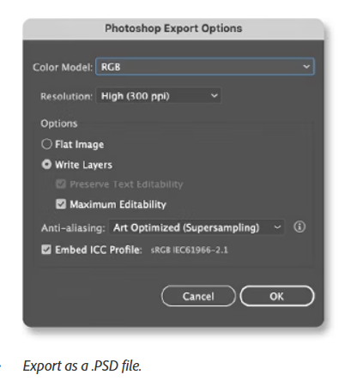
- You can use the PSD format to export your Illustrator files into Photoshop that preserves layers, resolution, and color profiles.
- When you export a .PSD file, the Illustrator layers are preserved as rasterized layers. In contrast, the layer groups and sublayers are converted into folders and subfolders. If your Illustrator artwork contains unsupported Photoshop®.
- Elements like colors, themes,
brushes, graphics, and text, Illustrator preserves the appearance of the artwork.

To export your Illustrator artwork into Photoshop, follow these steps:
- Select File > Export As and choose Photoshop (.PSD).
- Click Export and select options based on your requirements.
To edit your artwork, ensure that you have not applied Overprint fill or Transparency effects, and Export using these settings:
- Select File > Export > Export As.
- Select the Write Layers and Maximum Editability.

Exporting for Print
- Go to File > Save As or File > Save a Copy.
- Choose PDF or EPS.
- Ensure the document is in CMYK Color Mode for printing.
- Set resolution to 300 ppi for raster effects.
- Include bleed and crop marks if required by the printer.

Choosing the Right Format

Purpose | Best Format
Editable master file | AI
Professional print | PDF, EPS, TIFF
Web graphics (with text) | SVG
Transparent logo (web) | PNG
Web images/photos | JPG

Best Practices
- Keep an AI copy for future edits.
- For print, confirm the printer’s preferred format.
- For web, optimize file size without losing quality.
- Always check colors in the correct mode (CMYK for print, RGB for web).

Assignment
Scenario: You have designed a company logo in Illustrator.
You need to prepare it for:
- Printing on business cards.
- Using on the company’s website.
- Sending to a vendor who uses older software.
Tasks:
- Save your master file in AI format.
- Export a PDF (CMYK) for the printer.
- Export a PNG (transparent background) for the website.
- Export an EPS for the vendor.
- Compare the file sizes and quality between PNG and SVG.

