Module 2 – Creating and Setting Up Documents

Page Sizes
Page size determines the overall dimensions of your document. Choosing the right size is important for print or digital use.
- Standard Sizes:
  - A4 (210 × 297 mm) – Brochures, Flyers
  - A5 (148 × 210 mm) – Invitations, Small Booklets
  - Letter (8.5 × 11 in) – Business Documents
  - Tabloid (11 × 17 in) – Posters, Large Layouts
- Custom Sizes:
  - You can enter any height and width in the New Document window.
  - Example: Social media posts (1080 × 1080 px) for Instagram.
Tip: Choose the correct size before starting the design to avoid resizing problems later.
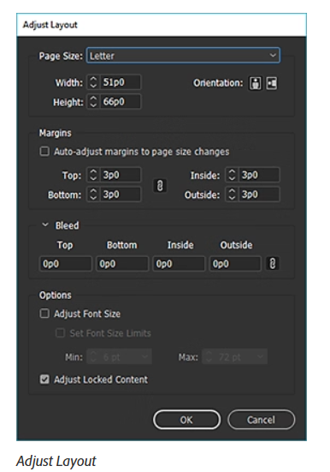

Margins
Margins are the empty spaces inside the edges of a page. They act as a safe area for placing text and graphics, ensuring nothing gets cut off during printing.
- Default Margins:
  - InDesign usually sets all margins equally (e.g., 12.7 mm or 0.5 in).
- Custom Margins:
  - Set different top, bottom, left, and right margins if your design needs more white space on one side (e.g., for binding).
- Why Margins Matter?
  - Keep important content within margin boundaries.
  - Prevents text from being too close to the edges.

Columns
Columns divide your page into vertical sections to organize text and images neatly.
- Single Column:
  - Used in posters, covers, or designs with minimal text.
- Two Columns:
  - Great for newsletters, brochures, or magazine layouts.
- Multiple Columns:
  - Used for heavy-text layouts like newspapers.
Gutter:
The space between columns is called the gutter. It ensures text doesn’t run into adjacent columns.

Bleeds
Bleed is the area that extends beyond the page edge where your background color or image continues. It ensures there are no white edges after printing and trimming.
- Typical Bleed Setting:
  - 3 mm (0.125 in) on all sides for print.
- Why Bleed Is Important?
  - During printing, small shifts may occur while cutting.
  - Bleed ensures the final product looks clean without unwanted borders.

Master Pages
Master Pages are templates applied to multiple pages in a document. They help maintain consistency in design elements like headers, footers, page numbers, or background graphics.
- Creating a Master Page:
  - Go to the Pages Panel → Double-click on "A-Master".
  - Add design elements like logos, grid lines, or running headers.
- Applying Master Pages:
  - Drag a master page thumbnail to any page or select pages and apply from the Pages Panel.
Advantages:
- Saves time in multi-page documents.
- Maintains a uniform look across the entire project.
- Easy to update – changing a master page updates all linked pages.

Practical Example
If you are designing a 12-page travel magazine:
- Page Size: A4 for easy printing.
- Margins: 15 mm all sides to keep text safe.
- Columns: Two columns per page for articles.
- Bleed: 3 mm bleed for full-page images.
- Master Pages: Add magazine name, page number, and footer design.

