Module 1 – Colors, Gradients, and Effects

Understanding Colors in InDesign
Adobe InDesign allows you to work with colors in two main modes:
- RGB (Red, Green, Blue) – Used for digital screens.
- CMYK (Cyan, Magenta, Yellow, Black) – Used for print.
Always choose the right mode at document setup to ensure accurate colors.

Methods to Apply Colors: You can use various tools to apply color in your InDesign documents: Toolbox, Swatches panel, Color panel, Color Picker, and Control panel.
When you apply color, you can choose if it affects the object's stroke or fill. The stroke is the border, while the fill is the background. For text frames, you can decide whether the color change applies to the frame or the text.

- Select the object you want to color by doing one of the following:
- For a path or frame, use the Selection tool or the Direct Selection tool, as necessary.
- For a grayscale or monochrome (1-bit) image, click the Content Grabber or use the Direct Selection tool. You can apply only two colors to a grayscale or monochrome image.
- For text characters, use the Type tool to change the text color of a single word or the entire text within a frame.

- In the Toolbox or in the Color or Swatches panel, select the Formatting Affects Text or Formatting Affects Container to determine if color is applied to the text or the text frame.

- In the Toolbox or in the Color or Swatches panel, select the Fill box or the Stroke box to specify the fill or stroke of the object. (If you selected an image, the Stroke box has no effect.)
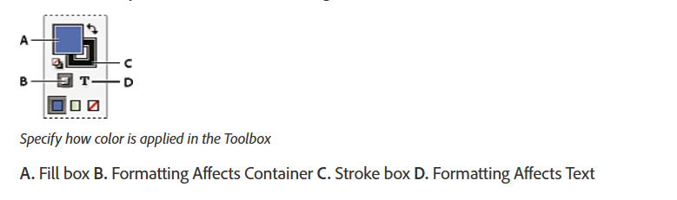

- Do one of the following:
- Select a color, tint, or gradient using the Swatches or Gradient panel.
- Select a color, tint, or gradient from the Fill or Stroke menu in the Control panel.
- Double-click either the Fill or Stroke box in the Toolbox or the Color panel to open the Color Picker. Select the desired color, and click OK.
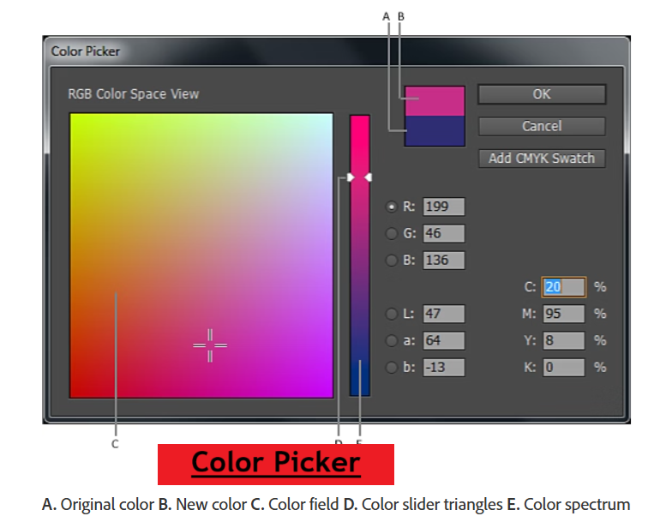

Swatches Panel
Swatches are pre-saved colors that can be applied to text, shapes, or frames.
Why Use Swatches?
- Maintains color consistency across your project.
- Makes it easy to update a color globally by changing the swatch.
How to Use
- Go to Window → Color → Swatches.
- Click New Swatch (+) to add a custom color.
- Apply the swatch to selected objects or text.

Gradients
Gradients create smooth color transitions between two or more colors.
Types of Gradients
- Linear Gradient – Colors blend in a straight line.
- Radial Gradient – Colors blend in a circular pattern.

How to Apply
- Select an object.
- Open the Gradient Panel (Window → Color → Gradient).
- Choose linear or radial and adjust sliders.
- Use the Gradient Tool (G) to change angle and position.

Transparency
Transparency allows you to make objects partially see-through.
How to Apply
- Select an object.
- Open Window → Effects.
- Adjust the Opacity Slider (0% = fully transparent, 100% = solid).
Use Case:
Transparency is great for watermarks, overlays, or soft background effects.

Drop Shadows
Drop shadows add depth by creating the effect of light casting a shadow.
How to Apply
- Select an object or text.
- Go to Effects Panel → Drop Shadow.
- Adjust:
  - Opacity (how dark the shadow is)
  - Distance (how far shadow is from object)
  - Blur (softness of edges)

Assignment
For a poster design:
- Use a radial gradient background (orange to yellow).
- Apply drop shadow to the title text.
- Use transparency on a decorative overlay for a subtle effect.
- Use swatches to keep brand colors consistent.


