Module 2 – Hyperlinks and Interactive Features

Create Hyperlinks

You can create hyperlinks to pages, URLs, text anchors, email addresses, and files. If you create a hyperlink to a page or text anchor in a different document, exported the InDesign files to the same folder.

Hyperlink to an external location
You can hyperlink to an external location like a URL, File, or Email. When you specify a URL, you can use any valid Internet resource protocol: http://, file://, ftp://, or mailto://. When you create a hyperlink to a file, selecting the hyperlink in the exported Adobe Interactive PDF, ePub, or HTML file opens the file in its native application. Ensure you share the specified file with the exported PDF, ePub, or HTML file.

- Select some text, frame, or graphic.
- Select Type > Hyperlinks & Cross-References > New Hyperlink.
- Follow the steps in the New Hyperlink panel:
- URL
- Link To: Select URL from the drop-down.
- Destination: Enter the URL.
You can also use Buttons to link to web pages.

- File
- Link To: Select File from the drop-down.
- Path: Enter the file location.

Email
- Link To: Select Email from the drop-down.
- Address: Enter the email address.
- Subject Line: Enter the subject for the email.

- Select Shared Hyperlink Destination if you want to save the URL, File, or Email in the Hyperlinks panel for easy reuse.You can set or change the formatting of your hyperlink text in the Appearance tab and provide the alternate text in the Accessibility tab.
- Select OK.

Linking Text in InDesign
Linking text allows content to flow from one text frame to another across a page or multiple pages. It ensures smooth reading and easy editing.

How to Link Text Frames
- Draw two text frames using the Type Tool (T).
- Type or paste text into the first frame.
- Click the out port (+) on the first frame.
- Click inside the second frame to link them.

Benefits
- Automatic text flow when you add or remove content.
- Perfect for magazines, newsletters, or multi-page documents.

Linking Images
InDesign links images by default instead of embedding them to keep file sizes small.

How to Place & Link an Image
- Go to File → Place (Ctrl/Cmd + D).
- Select an image and click on your page to place it.
- Check the Links Panel (Window → Links) to see file status.
Why Linking Is Important
- If the original image changes, the linked file updates automatically.
- Keeps your InDesign project lightweight.

Creating Interactive PDFs
InDesign allows you to create interactive documents where users can click, navigate, or view embedded media.

Steps to Create
- Design your document in InDesign.
- Add interactive elements:
  - Hyperlinks to pages, websites, or email addresses.
  - Buttons to trigger actions (e.g., "Go to Page 2").
- Go to File → Export → Adobe PDF (Interactive).

Advantages
- Great for e-books, digital reports, and presentations.
- Adds a modern and engaging experience for readers.

Creating Buttons
Buttons are objects (text, shapes, or images) that perform actions when clicked.
How to Create a Button
- Draw a shape or text frame.
- Open Buttons and Forms Panel (Window → Interactive → Buttons and Forms).
- Select "Convert to Button."
- Assign an action:
  - Go to Page
  - Open a Website
  - Show/Hide an Object

Add a Button from the Sample Buttons panel

The Sample Buttons panel includes a number of pre-created buttons that you can drag into your document. These sample buttons include effects such as gradient feathers and drop shadows, with a slightly different appearance for the Rollover appearance. The sample buttons are also assigned actions. For example, the sample arrow buttons are preset with Go To Next Page or Go To Previous Page actions. You can edit these buttons to suit your needs.

- Choose Sample Buttons And Forms from the Buttons and Forms panel menu to open the Sample Buttons And Forms panel.
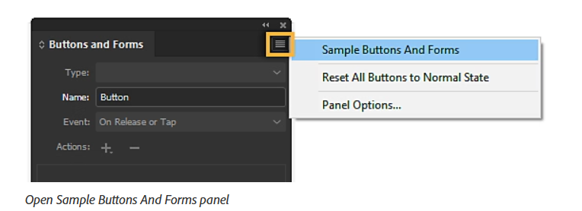

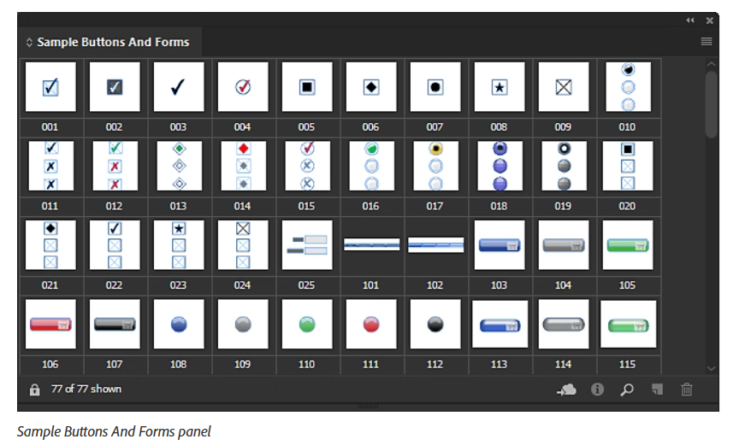
- Drag a button from the Sample Buttons And Forms panel to the document. If you want navigation buttons to appear on every page, add the buttons to a parent page.
- Select the button using the Selection tool, and then edit the button as necessary using the Buttons and Forms panel.
While editing the sample buttons, keep the following in mind:

  - If you add text to a button, remember to copy and paste the text from the Normal button state to the Rollover button state. Otherwise, the text you add does not appear when the mouse rolls over the button in the fixed layout EPUB or PDF file.
  - You can resize buttons. If you drag a pair of Next Page/Previous Page arrow buttons, resize the first button, and then select the second button, and choose Object > Transform Again > Transform Again.

- Use the Preview panel (Window > Interactive > EPUB Interactivity Preview) to test the button before you export the document to interactive fixed layout EPUB, or PDF. You can also publish your document online using Publish Online.

The Sample Buttons panel is an object library. As with any object library, you can add buttons to the panel and remove ones you don’t want to use.

Practical Example
Design an interactive company brochure:
- Link text frames to allow smooth reading.
- Insert images as linked files for easy updates.
- Add navigation buttons:
  - “Next Page” and “Previous Page.”
  - A clickable logo that links to the company website.
- Export as an interactive PDF.

Assignment
- Open a new A4 InDesign document.
- Create three pages:
  - Page 1: Title with logo.
  - Page 2: Product details with linked text frames.
  - Page 3: Contact page with clickable email and website links.
- Add navigation buttons (Next, Back, Home).
- Export as Interactive PDF and test all links and buttons.

