Module 1 – Layers & Object Organization

Layers in InDesign
Layers help you organize design elements such as text, images, and shapes. Each layer acts like a transparent sheet, and objects placed on higher layers appear above objects on lower layers.

Key Features of Layers
- Visibility: Show or hide layers to focus on specific parts of a design.
- Locking: Prevent accidental movement or editing of objects.
- Color-Coded: Each layer is assigned a color, making object boundaries visible.
How to Use Layers
- Go to Window → Layers to open the Layers Panel.
- Click New Layer (+) to add more layers.
- Drag objects between layers for better organization.

Grouping Objects
Grouping combines multiple objects into a single unit, allowing them to be moved or transformed together.

Steps to Group
- Select multiple objects using the Selection Tool (V).
- Right-click → Group or press Ctrl/Cmd + G.
Ungrouping
- Right-click → Ungroup or press Shift + Ctrl/Cmd + G.
Benefits
- Keeps related elements together (e.g., icons, text, and borders for a button).
- Prevents accidental misalignment.

Locking Objects
Locking prevents accidental changes to objects while editing other elements.
How to Lock
- Select the object → Right-click → Lock or press Ctrl/Cmd + L.
How to Unlock
- Right-click → Unlock or use Object → Unlock All on Spread.
Use Cases
- Lock background images while working on text overlays.
- Lock guides or grid elements for alignment consistency.

Object Styles
Object Styles are saved formatting settings that can be applied to shapes, text frames, or images to maintain consistency.

How to Create an Object Style
- Format an object (e.g., add a stroke, gradient, or shadow).
- Open Window → Styles → Object Styles.
- Click New Style and name it.
- Apply it to other objects with one click.

Why Use Object Styles?
- Saves time by applying pre-defined formatting quickly.
- Ensures consistent appearance across multiple objects.
- Easy to update – change the style and all linked objects update automatically.

Fit an Object to its Frame
You can use the Object > Fitting commands to achieve a perfect fit if the frame and its content are of different sizes.

Frame alignment options apply to frames with a graphic or a text frame but don't affect paragraphs inside a text frame.

NOTE: An imported image cannot exist without a frame.

Follow these steps to fit an object to its frame:
- Select the frame.
- Go to Object > Fitting and select any of the following options:

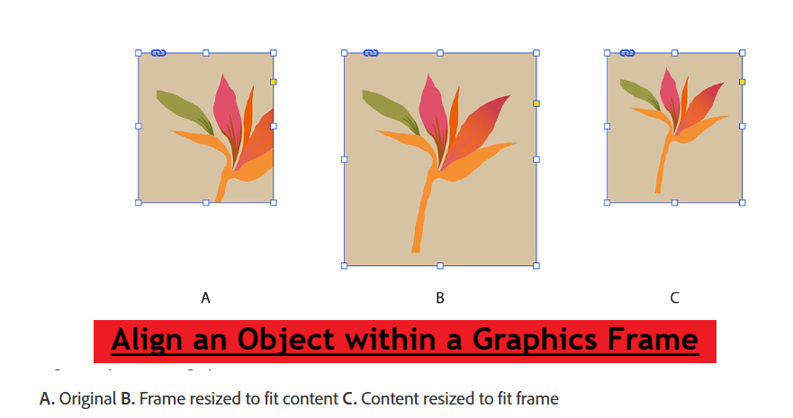

Fill Frame Proportionally | Resizes content to fill the entire frame while preserving the content’s proportions.
Fit Content Proportionally | Resizes content to fit a frame while preserving the content proportions.
Content-Aware Fit | Automatically fits an image inside the frame based on the image content and frame size. Go to Preferences > General and select Make Content-Aware Fit the default frame fitting option to make this the default frame-fitting option.
Fit Frame To Content | Resizes the frame to fit the content.
Fit Content To Frame | Resizes content to fit the frame.
Center Content | Centers content within a frame.
Clear Frame Fitting Options | Removes undesired fitting settings applied with Auto-Fit.

Practical Example
For a corporate flyer:
- Create separate layers: Background, Images, Titles, Body Text.
- Group a logo and tagline for easy resizing.
- Lock background and guide layers for safety.
- Apply an object style to all image frames (e.g., rounded corners, drop shadow).

Assignment
- Create a new A4 InDesign document.
- Add:
  - At least 3 layers (Background, Text, Graphics).
  - A grouped logo and tagline.
- Lock the Background layer.
- Create an Object Style for image frames with a 2pt stroke and drop shadow.
- Save as .indd and export as .pdf.

