Module 1 – Typography and Text Formatting

Text Frames
- InDesign uses text frames to hold and display text.
- Create using the Type Tool (T) and click-drag on the page.
- Frames can be resized, linked, or styled.

Types of Text Frames
- Point Type – Click once and start typing. Good for titles.
- Area Type – Drag a box to define text area. Best for paragraphs.

Linking Text Frames
- If text overflows, use the out port (+) to link to another frame.
- Text flows from one frame to the next (multi-column layouts).

Thread Text Frames
- The text in a frame can be independent of other frames, or it can flow between connected frames.
- To flow text between connected frames (also called text boxes), you must first connect the frames. Connected frames can be on the same page or spread, or on another page in the document.
- The process of connecting text among frames is called threading text. It is also referred to as linking text frames or linking text boxes.
- Each text frame contains an in port and an out port, which are used to make connections to other text frames.
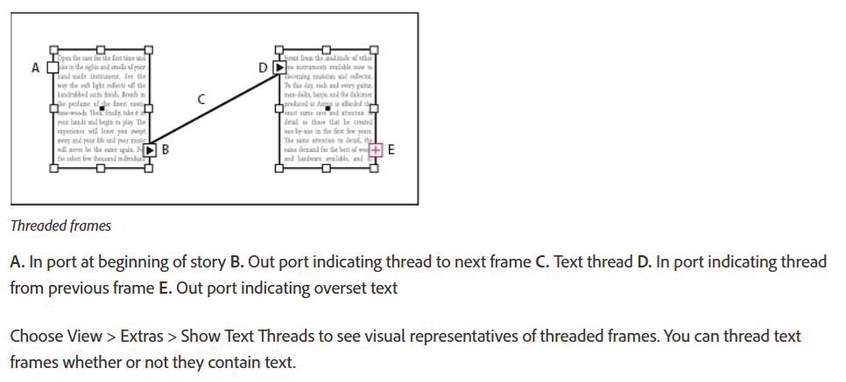
- An empty in port or out port indicates the beginning or end of a story, respectively. An arrow in a port indicates that the frame is linked to another frame. A red plus sign (+) in an out port indicates that there is more text in the story to be placed but no more text frames in which to place it. This remaining unseen text is called overset text.

Character & Paragraph Styles
- Character Styles control font, size, color, and spacing for individual words.
- Paragraph Styles control alignment, spacing, and overall paragraph formatting.
Benefits
- Consistency across the entire document.
- Quick global changes (update a style, all linked text updates automatically).

Adjust Paragraph Spacing
You can control the amount of space between paragraphs. If a paragraph begins at the top of a column or frame, InDesign does not honor the Space Before value. In such a case, you can increase the leading of the first line of the paragraph or increase the top inset of the text frame in InDesign.
- Select text.
- In the Paragraph panel or the Control panel, adjust the appropriate values for Space Before , Space After , and Space Between Paragraphs Having Same Style .

Use Drop Caps
You can add drop caps to one or more paragraphs at a time. The drop cap’s baseline sits one or more lines below the baseline of the first line of a paragraph.
You can also create a character style that can be applied to the drop-cap characters. For example, you can create a tall cap (also called a raised cap) by specifying a 1-line, 1-character drop cap and applying a character style that increases the size of the first letter.

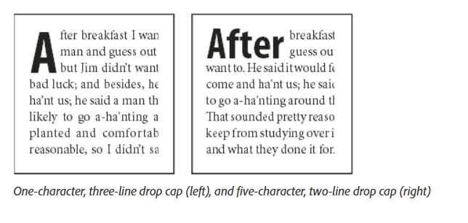
Kerning and Tracking
- Kerning – Adjusts spacing between two individual letters for balance.
- Tracking – Adjusts spacing across an entire word or paragraph.

Creative Text Effects
- Apply:
  - Gradient Fill – Gives colorful fades to text.
  - Stroke and Outline – Adds borders around text.
  - Drop Shadow & Glow – Adds depth and highlights.

Assignment
For a magazine cover:
- Use large bold title with kerning for perfect spacing.
- Apply drop shadow for a pop-out effect.
- Use paragraph styles for consistent headlines.



