Module 2 – Placing & Managing Graphics

Types of paths and shapes
You can create paths and combine them in a variety of ways in InDesign. InDesign creates the following types of paths and shapes:

- Simple paths
Simple paths are the basic building blocks of compound paths and shapes. They consist of one open or closed path, which may be self-intersecting.

- Compound paths
Compound paths consist of two or more simple paths that interact with or intercept each other. They are more basic than compound shapes and are recognized by all PostScript-compliant applications. Paths combined in a compound path act as one object and share attributes (such as colors or stroke styles).

- Compound shapes
Compound shapes consist of two or more paths, compound paths, groups, blends, text outlines, text frames, or other shapes that interact with and intercept one another to create new, editable shapes. Some compound shapes appear as compound paths, but their component paths can be edited on a path-by-path basis and do not need to share attributes.
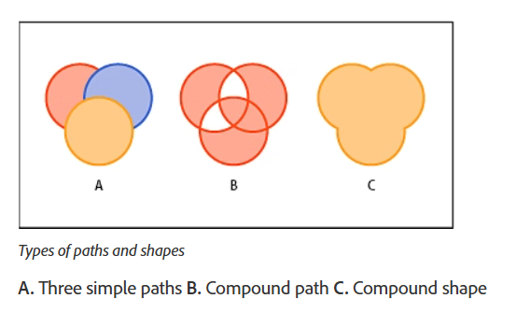

Importing Images
- Use File → Place (Ctrl/Cmd + D) to import images.
- Click or drag to place them in frames.

Linked vs Embedded
- Linked – Keeps file size small; image updates when original is updated.
- Embedded – Stores image in document; increases file size.

Fitting & Cropping
- Fitting: Adjust how images fit inside frames.
  - Fit Content to Frame – Stretches image.
  - Fit Frame to Content – Adjusts frame to image.
  - Fit Content Proportionally – Maintains aspect ratio.
- Cropping:
  - Use the Selection Tool (V) to adjust frame edges.
  - Image can be moved inside frame for better positioning.

Align objects using the Gap tool
The Gap tool provides a quick way to adjust the size of a gap between two or more objects. It also lets you resize several objects that have commonly aligned edges simultaneously, while keeping the gaps between them fixed. It’s a one-step way to adjust your layout by directly manipulating the space between objects.
The Gap tool ignores locked objects and parent page items.
- Select the Gap tool .
- Move the pointer between two objects, and do any of the following actions:

  - Drag to move the gap and resize all objects aligned along the gap.
  - Shift-drag to move the gap between only the two nearest objects.
  - Ctrl-drag (Windows) or Command-drag (Mac OS) to resize the gap instead of moving it. Adding the Shift key resizes the gap between only the two nearest objects.
  - Alt-drag (Windows) or Option-drag (Mac OS) to move the gap and objects in the same direction. Adding the Shift key moves only the two nearest objects.
  - Ctrl+Alt-drag (Windows) or Command+Option-drag (Mac OS) to resize the gap and move the objects. Adding the Shift key to resize the gap and move only the two nearest objects.

Creating Tables
- Tables are great for presenting structured information (menus, schedules, reports).
How to Create a Table
- Select the Type Tool (T) and drag a text frame.
- Go to Table → Insert Table.
- Specify rows and columns.
- Apply table styles (borders, alternating row colors).

Resize columns, rows, and tables
You can resize columns, rows, and tables using a number of different methods.
Resize columns and rows
- Select cells in the columns and rows you want to resize.
- Do one of the following:

  - In the Table panel, specify Column Width and Row Height settings.
  - Choose Table > Cell Options > Rows And Columns, specify Row Height and Column Width options, and then click OK.
  - Position the pointer over the edge of a column or row so that a double-arrow icon ( ) appears, and then drag left or right to increase or decrease the column width, or drag up or down to increase or decrease row height.

Merge and split cells
You can merge (combine) or split (divide) cells in a table.

Merge cells
You can combine two or more cells in the same row or column into a single cell. For example, you can merge the cells in the top row of the table to create a single cell to be used for the table title.
- Using the Type tool , select the cells you want to merge.
- Choose Table > Merge Cells.

Unmerge cells
- Place the insertion point in the merged cell and choose Table > Unmerge Cells.

Split cells
You can split cells horizontally or vertically, which is especially useful when creating form tables. You can select multiple cells and split them vertically or horizontally.
- Place the insertion point in the cell you want to split, or select a row, column, or block of cells.
- Choose Table > Split Cell Vertically or Split Cell Horizontally.

Practical Example
For a restaurant menu:
- Place images of dishes using File → Place.
- Crop and align them neatly.
- Add a table to list dishes, descriptions, and prices.

Assignment
- Open a new A4 InDesign document.
- Import 3–4 images and place them with proportional fitting.
- Create a 2-column table listing captions or details for the images.
- Save in .indd and export as .pdf.

