Module 1 – Overview and Key Uses of InDesign

What is Adobe InDesign?
Adobe InDesign is a desktop publishing software used to design and create print and digital layouts. It is widely used by designers, publishers, and marketing professionals to make high-quality projects such as brochures, magazines, posters, books, and interactive PDFs.
Unlike Photoshop (which is mainly for image editing) or Illustrator (used for creating vector graphics), InDesign is built for arranging text, images, and graphics in a clean and organized way.

Why Use InDesign?
- It is perfect for multi-page documents where maintaining consistency (fonts, colors, margins) is important.
- It allows easy integration with other Adobe tools (Photoshop, Illustrator, Acrobat).
- It supports both print and digital publishing, so you can prepare content for magazines, e-books, presentations, or websites.

Key Features of InDesign
- Page Layouts & Templates
  - Create professional designs quickly using pre-built templates.
  - Set up custom page sizes, columns, grids, and margins.
- Advanced Typography
  - Manage text with precision using Character and Paragraph styles.
  - Adjust spacing, alignment, and font styles for polished layouts.
- Graphics Integration
  - Place images, logos, and illustrations directly into your designs.
  - Control how images fit within frames using fitting options.
- Interactive Publishing
  - Add hyperlinks, buttons, and videos for digital outputs.
  - Export projects as interactive PDFs or EPUBs for online use.

Key Uses of Adobe InDesign
- Print Media
  - Designing brochures, flyers, posters, newspapers, magazines, business cards, and more.
  - Setting proper print specifications like CMYK color mode and bleed areas.
- Digital Media
  - Creating e-books, interactive PDFs, presentations, and social media graphics.
  - Adding clickable links, animations, and embedded media.
- Branding Projects
  - Designing corporate reports, catalogues, stationery, and branded layouts.

Workspace overview
The workspace in InDesign provides a customizable layout for windows, panels, and tools that allows you to create a personalized design environment.

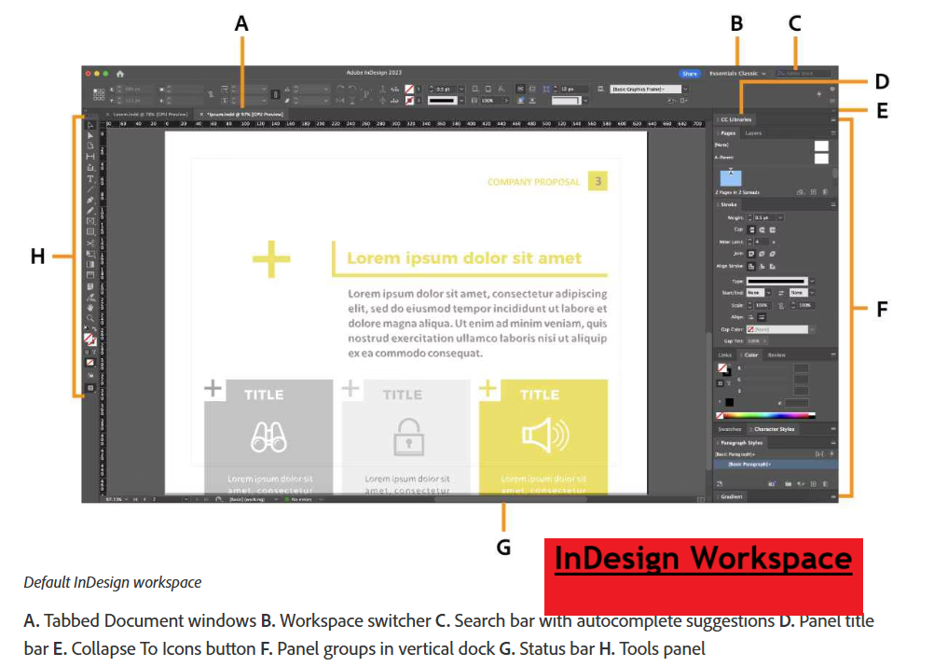

File extension: The main file extension for Adobe InDesign is .indd, which stands for InDesign Document and contains all the project's content and formatting.

Toolbox overview: Some tools in the toolbox are for selecting, editing, and creating page elements. Other tools are for choosing type, shapes, lines, and gradients.
