Fundamental Concepts of Marketing

7Ps of Marketing (Marketing Mix)
- Product – Anything offered to satisfy a customer’s need or want. This includes physical goods, services, or even ideas.
  - Example (India): Amul Butter – A high-quality dairy product used daily by Indian households.
- Price – The amount a customer pays to purchase a product or service. Pricing strategies can vary based on market demand, competition, or value perception.
  - Example (India): OYO Rooms – Affordable hotel stays with pricing adjusted according to location and season.
- Place – The channels through which a product is made available to customers, including physical stores, online platforms, or distributors.
  - Example (India): Big Bazaar – Products are available nationwide in stores and online for convenience.
- Promotion – Activities that communicate the product’s benefits and persuade customers to buy, including advertising, social media, and sales promotions.
  - Example (India): Surf Excel #DaagAcheHain campaign – Uses TV, social media, and billboards to convey the brand message.
- People – All individuals involved in delivering the product/service and influencing customer experience, including employees and customer service staff.
  - Example (India): Zomato delivery staff – Timely and friendly service enhances the overall experience.
- Process – The procedures, mechanisms, and flow of activities through which a product/service is delivered to the customer.
  - Example (India): IRCTC online booking system – Efficient, quick, and reliable ticket booking process.
- Physical Evidence – Tangible cues that help customers evaluate the product or service quality before purchase. This can include packaging, store layout, or brochures.
  - Example (India): FabIndia stores – The store ambience, décor, and product packaging reflect authenticity and quality.
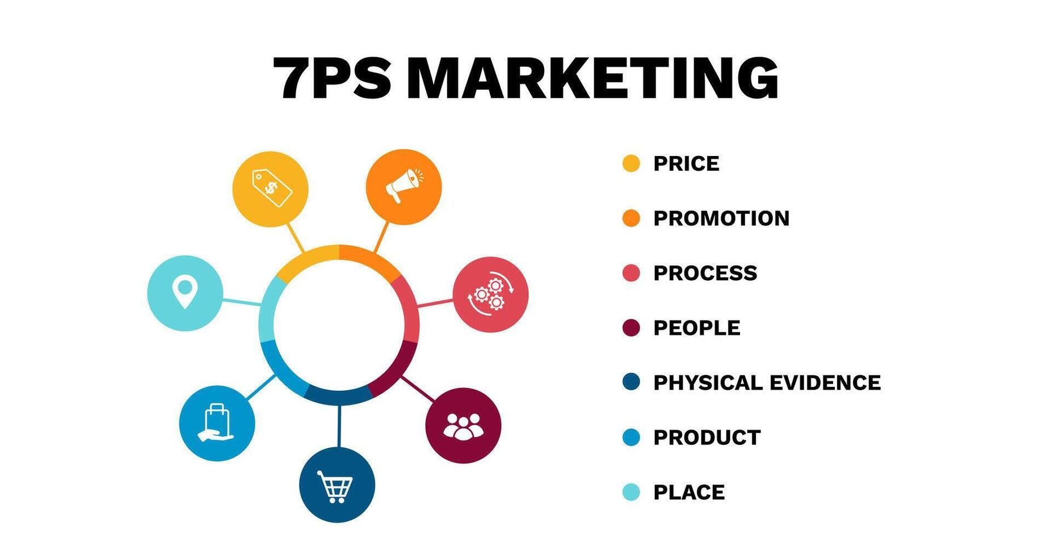
STP (Segmentation, Targeting, Positioning)
- Segmentation – Dividing the overall market into smaller groups of consumers who have similar needs, behaviors, or characteristics.
  - Example (India): Maruti Suzuki – Segments the market by income and usage (Alto for low-income, Brezza for premium customers).
- Targeting – Selecting one or more market segments to focus marketing efforts on.
  - Example (India): Parle-G – Targets low- and middle-income families across urban and semi-urban areas.
- Positioning – Creating a clear, unique image of the product in the minds of the target audience relative to competitors.
  - Example (India): Titan Watches – Positioned as reliable, stylish, and affordable luxury.

Practical Example: Amul Ice Cream
- Product: Ice cream bars, tubs, cones
- Price: Affordable for middle-class families
- Place: Grocery stores, online platforms, Amul parlours
- Promotion: TV ads, IPL sponsorships, social media campaigns
- People: Friendly Amul ice cream parlour staff
- Process: Cold-chain supply ensures quality and freshness
- Physical Evidence: Branded packaging and parlour interiors
- Segmentation: Kids, youth, families; urban and semi-urban areas
- Targeting: Middle-class families looking for tasty, affordable treats
- Positioning: “The taste of India” – trusted and loved brand

Categories of goods in marketing:

1. Consumer Goods
Goods purchased by individuals for personal use. They are usually intended to satisfy the consumer’s immediate needs or wants.
Subtypes & Examples:
- Convenience Goods: Frequently bought, low effort. Example: Toothpaste, Biscuits (Parle-G)
- Shopping Goods: Compared before purchase, more expensive. Example: Smartphones (Samsung, OnePlus)
- Specialty Goods: Unique characteristics, brand preference. Example: Titan Watches, Louis Philippe Clothing
- Unsought Goods: Not actively sought by consumers until needed. Example: Life Insurance, Fire Extinguishers
- FMCG (Fast-Moving Consumer Goods) are products that are sold quickly, at relatively low cost, and purchased frequently by consumers. Example: Parle-G biscuits, Maggi noodles, Coca-Cola, Amul milk

2. Industrial Goods
Goods purchased by businesses to produce other goods or provide services.
Examples:
- Machinery, raw materials, tools, industrial chemicals

3. Durable Goods
Goods that last for a long time and can be used repeatedly.
Example: Refrigerators, Cars, Furniture

4. Non-Durable Goods
Goods consumed quickly or have a short lifespan.
Example: Milk, Bread, Soft Drinks

5. Services (Intangible Goods)
Products that cannot be touched or stored, usually experienced rather than owned.
Example: Banking (HDFC, SBI), Travel (MakeMyTrip, Yatra), Education (AbhyasOnline)

Tabular form of famous brands with their taglines:

Category | Brand | Tagline
FMCG | Amul | The Taste of India
FMCG | Parle-G | G for Genius
FMCG | Dabur | Celebrate Life
FMCG | Colgate | Smile with Confidence
Beverages & Food | Coca-Cola | Taste the Feeling
Beverages & Food | Pepsi | Live For Now
Beverages & Food | Nescafé | It All Starts With a Nescafé
Beverages & Food | Maggi | 2-Minute Noodles
Technology & Gadgets | Samsung | Do What You Can’t
Technology & Gadgets | LG | Life’s Good
Technology & Gadgets | Apple | Think Different
Automobiles | Maruti Suzuki | Way of Life!
Automobiles | Tata Motors | Connecting Aspirations
Automobiles | Hero MotoCorp | Hum Mein Hai Hero
Retail & E-commerce | Flipkart | Ab Har Wish Hogi Poori
Retail & E-commerce | Big Bazaar | Aao Bazar Mein
Retail & E-commerce | Amazon India | Earth’s Biggest Selection
Banking & Finance | HDFC Bank | We Understand Your World
Banking & Finance | ICICI Bank | Hum Hain Na
Telecom | Airtel | Har Friend Zaroori Hota Hai
Telecom | Jio | Digital Life, Full Speed
Telecom | Vodafone Idea | The Future is Exciting. Ready?

