Marketing Goals in Traditional and Digital Media

What are Marketing Goals?
Marketing goals are specific objectives that a business wants to achieve through its marketing efforts. These goals guide all marketing strategies and campaigns, helping a company measure success and stay focused.

Key Points:
- Goals should be specific, measurable, achievable, relevant, and time-bound (SMART).
- They provide a roadmap for marketing activities.
- Goals can be short-term (monthly/quarterly) or long-term (yearly/5-year plan).

Common Marketing Goals
- Increase Brand Awareness
  - Definition: Make more people know about your brand or product.
  - Example: Fevicol posting humorous videos on social media to be recognized by more people.
- Generate Leads / Sales
  - Definition: Attract potential customers and convert them into buyers.
  - Example: BYJU’S running Facebook campaigns to get students to sign up for a free trial.
- Customer Retention / Loyalty
  - Definition: Encourage existing customers to keep buying and engage with your brand.
  - Example: Amazon Prime offering exclusive deals to retain subscribers.
- Increase Website / App Traffic
  - Definition: Drive more visitors to your online platforms.
  - Example: Swiggy promoting app downloads via Instagram ads.
- Enhance Engagement
  - Definition: Make customers interact with the brand (likes, comments, shares).
  - Example: Zomato posting polls, quizzes, and food reels on Instagram.
- Expand Market Share
  - Definition: Increase your brand’s portion of the market compared to competitors.
  - Example: Surf Excel targeting new regions to increase detergent market share in India.
- Improve Customer Experience
  - Definition: Make the buying or service experience easier and more satisfying.
  - Example: Big Bazaar introducing online grocery delivery to improve shopping convenience.

Tips for Defining Marketing Goals
- Be specific: Don’t just say “increase sales”—say “increase online sales by 20% in 6 months.”
- Make them measurable: Use numbers, percentages, or metrics.
- Ensure they are realistic: Avoid goals that are impossible to achieve.
- Align them with overall business objectives.

Understanding and Defining Marketing Goals — Case Study: Nestlé India

Five Common Marketing Goals:
- Increase Brand Awareness – Make more people recognize and trust the brand.
- Generate Sales – Convert potential customers into buyers.
- Customer Retention – Keep existing customers loyal.
- Engage Customers – Build interaction through social media or campaigns.
- Expand Market Share – Reach new customers or regions.
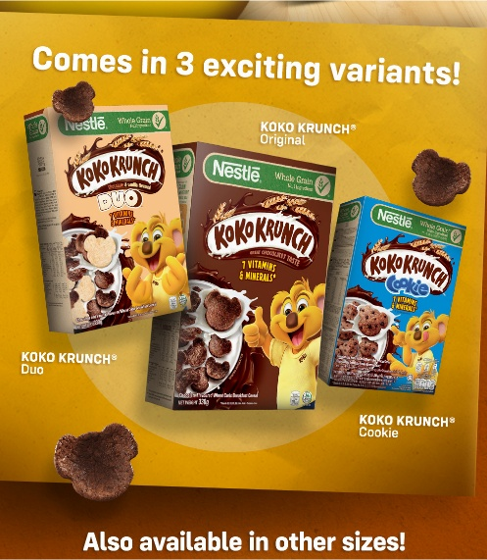
SMART Goals Application
SMART = Specific, Measurable, Achievable, Relevant, Time-bound
Two SMART Goals for Nestlé:
- Goal 1:
Increase the sales of Nestlé’s breakfast cereal brand “Koko Krunch” by 20% within 6 months through online advertising and influencer marketing.
  - Specific: Focused on “Koko Krunch” sales
  - Measurable: 20% increase in sales
  - Achievable: Realistic with proper marketing
  - Relevant: Aligns with Nestlé’s goal of expanding its breakfast segment
  - Time-bound: To be achieved in 6 months

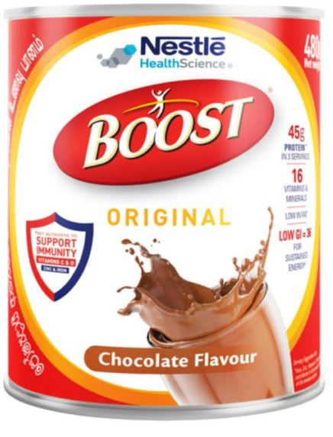
- Goal 2:
Boost Nestlé India’s Instagram engagement rate by 15% in 3 months through interactive content and contests.
  - Specific: Focus on Instagram engagement
  - Measurable: 15% increase
  - Achievable: Possible through creative posts and user participation
  - Relevant: Helps strengthen brand presence online
  - Time-bound: Targeted within 3 months

Digital Marketing vs Traditional Definition

Traditional Marketing: Promoting products/services using offline channels like TV, radio, newspapers, magazines, billboards, and direct mail.
  - Example (India): Amul ads in newspapers, LIC TV commercials, Big Bazaar hoardings

Digital Marketing: Promoting products/services using online channels like websites, social media, search engines, email, and apps.
  - Example (India): Swiggy Instagram campaigns, Amazon Google Ads, BYJU’S YouTube tutorials

Key Differences
Aspect | Traditional Marketing | Digital Marketing
Reach | Limited to geographical location | Global reach, accessible anywhere with the internet
Cost | Often expensive (TV, print, billboards) | Cost-effective; works even with small budgets (social media ads)
Targeting | Less precise; based on general demographics | Highly targeted; based on age, location, interests, behavior
Measurability | Difficult to measure ROI accurately | Easy to track clicks, conversions, engagement using analytics
Engagement | One-way communication | Two-way communication; allows interaction with customers
Speed | Slower; campaigns take time to design and implement | Faster; campaigns can be launched and modified in real-time

