Working with WordPress

WordPress is a free and easy-to-use tool for creating websites. It lets you build a website without needing to know coding. It is used for making:
- Personal blogs
- Business websites
- Online stores
- Portfolios, etc.
There are two versions of WordPress:
- WordPress.com – hosted by WordPress (easier, less control)
- WordPress.org – you install it on your own hosting (more control and freedom)

How to Make a Simple Website in WordPress
Step 1: Go to WordPress
- Open https://wordpress.com.
- Click Get Started.
Step 2: Create an Account
- Sign up with your email and password, or log in with Google.
Step 3: Choose a Website Name
- WordPress will ask you to pick a name (domain).
Example: mywebsite.wordpress.com (free version).
- Select the Free Plan to continue.
Step 4: Start Editing
- WordPress will create a simple starter site for you.
- On the left side, go to Site → Pages.
- You’ll see pages like Home, About, and Contact.
Step 5: Add or Edit Content
- Click Edit on a page (for example, Home).
- Type your text, add a heading, and insert pictures using the “+” button.
Example:
  - Add a heading: “Welcome to My Website”
  - Add a paragraph: “This is my simple website made with WordPress.”
- Click Update or Publish to save your page.
Step 6: Add a New Page (Optional)
- Go to Pages → Add New.
- Give it a name (like “Services” or “Gallery”) and add some text or images.
Step 7: Preview and Publish
- Click View Site (top right) to see your website.
- When ready, click Publish — your website is now live at your chosen address!

Example:
If you make a simple website called “My Travel Blog”:
- Home Page → “Welcome to My Travel Blog”
- About Page → “I love sharing my travel experiences.”
- Contact Page → “Email me at mytravel@gmail.com.”

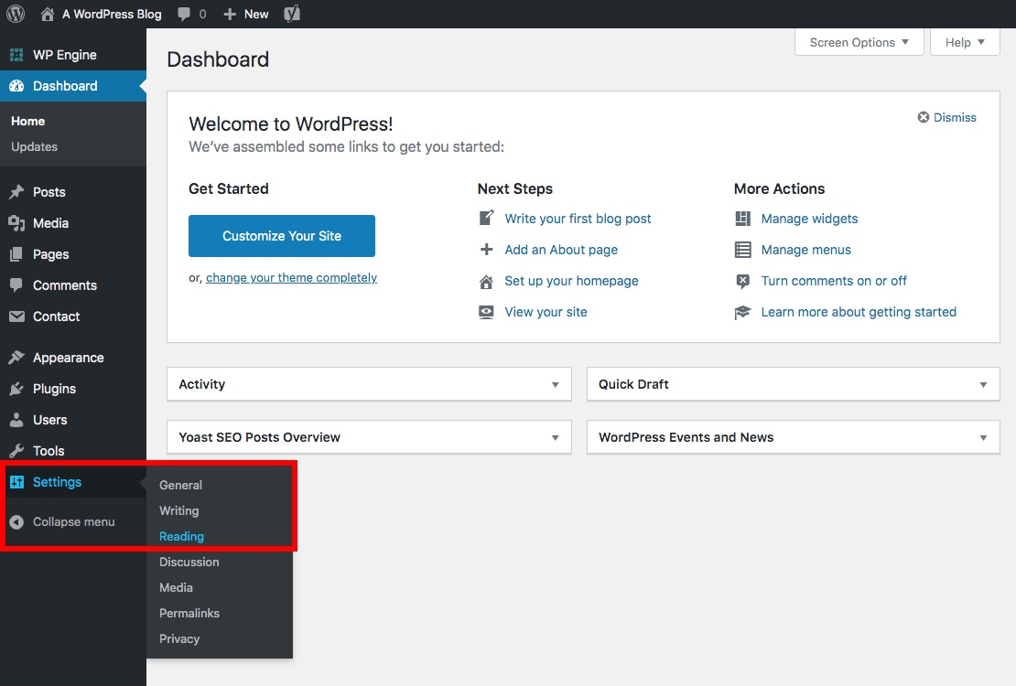

Solved Example: Objective

To design and publish a personal portfolio website using WordPress.com (or local WordPress installation) — using only basic themes and built-in tools, without any plugins.
You’ll learn how to:
- Create pages and add text/images
- Customize menus and themes
- Publish a simple working website

Overview
You will create a portfolio site with 4 pages:
- 🏠 Home
- 👤 About Me
- 🛠️ My Work / Projects
- 📞 Contact
Each page will have basic content and images added using the WordPress Block Editor.

Step-by-Step Instructions

Step 1: Create a WordPress Account
- Go to https://wordpress.com
- Click Start your website.
- Sign up using your email or Google account.
- Choose the Free Plan for this assignment.
If you are using local WordPress, install it through XAMPP or Local by Flywheel and open your dashboard.

Step 2: Choose a Simple Theme
Use only default or simple themes such as:
- Twenty Twenty-One
- Twenty Twenty-Three
- Blocksy (optional)
Steps:
- In Dashboard → Go to Appearance → Themes
- Click Add New
- Search for “Twenty Twenty-One”
- Click Install → Activate
💡 These themes are light, responsive, and easy to use for beginners.

Step 3: Create Basic Pages
Now, let’s add your main pages.
- Go to Pages → Add New
- Name it “Home” → add a welcome message and image.
- Publish the page.
- Repeat the same for About Me, My Work, and Contact.
Example content ideas:
- Home: “Welcome to my portfolio! I’m Mehul, a passionate learner and educator.”
- About: Write 3–4 lines about your education or interests.
- My Work: Add short descriptions of your achievements or projects.
- Contact: Include your email or phone number.

Step 4: Add Text & Images
Use the WordPress Block Editor (Gutenberg):
- Click the + icon to add blocks.
- Add:
  - Paragraph block for text
  - Image block for photos
  - Heading block for titles
  - List block for bullet points
Example: Add your photo on the About page using the Image block.
Step 5: Create a Menu
To link all your pages together:
- Go to Appearance → Menus
- Click Create a new menu
- Name it Main Menu
- Select all 4 pages (Home, About, My Work, Contact) → Add to Menu
- Click Save Menu
Now your site will have easy navigation.

Step 6: Customize Your Website
- Go to Appearance → Customize
- Edit the Site Title (e.g., “Mehul’s Portfolio”)
- Add a Tagline (e.g., “Learning, Creating, Growing”)
- Change Colors or Fonts if your theme allows.
- Set Homepage → A Static Page → Select Home
💡 This makes your “Home” page the first page visitors see.

Step 7: Preview and Publish
- Click Preview (top-right corner) to check your design.
- If everything looks fine, click Publish.
- Your live website link will look like this:
👉 https://yourname.wordpress.com

Assignment

Use a Simple, Default Theme A perfect simple theme that's already in WordPress is Twenty Twenty-Four.
- You can find this in your dashboard under Appearance > Themes.
- If it's not already active, just click Activate. You don't need to install anything new.
2. Create Your Pages Just like the portfolio has sections, you'll create static pages in WordPress.
- Go to Pages > Add New in your dashboard.
- Create four separate pages: Home, About, Projects, and Contact.
- On your "Projects" page, you can use the built-in Columns or Gallery block to add your project images and text.
- On your "Contact" page (since you're not using plugins), you can just add a text block with your email address or a simple message.
3. Set Up Your Navigation Menu (The part you highlighted)
- To create the navigation bar, go to Appearance > Editor.
- Click on your site's Header to edit it.
- You'll see a Navigation block. You can click it to add your new pages (Home, About, Projects, Contact) to this menu. WordPress will automatically create the links for you.
4. Set Your Homepage
- Finally, go to Settings > Reading in your dashboard.
- Change "Your homepage displays" to A static page and select the "Home" page you created from the list.

