Themes and Plugins in WordPress

What Are Themes in WordPress?
Themes control the appearance and design of your WordPress website — how it looks to visitors.
Think of it like the clothes of your website — it changes the style but not the content.
Your posts, pages, and images stay the same, but the layout, colors, and fonts change.
💡 Examples:
- A blog theme shows posts in a list with author and date.
- An eCommerce theme like Astra or Storefront displays products and a cart.
- A portfolio theme focuses on showcasing images and work samples.

Steps to Install and Activate a Theme in WordPress:
Method 1: From the WordPress Dashboard
- Login to your WordPress Admin Panel
→ Go to: https://yourwebsite.com/wp-admin
- Go to Appearance → Themes
In the left-hand sidebar, click Appearance, then Themes.
- Click “Add New” at the top of the Themes page.
- Browse or Search for a Theme
You can use the search bar to find free themes (like “Astra,” “OceanWP,” “Neve,” etc.).
- Preview the Theme (Optional)
Click Live Preview to see how your site would look with that theme.
- Click “Install” → then “Activate”
After activation, your new theme’s design is applied to your site.

Method 2: Upload a Theme (If you downloaded a .zip file)
- Go to Appearance → Themes → Add New → Upload Theme.
- Click Choose File and upload the .zip file of the theme.
- Click Install Now, and after installation, click Activate.

Customizing a Theme
After activation:
- Go to Appearance → Customize.
- You can edit:
  - Site title and logo
  - Colors and fonts
  - Header and footer layouts
  - Homepage settings
This opens the WordPress Customizer, a live preview tool.

What Are Plugins in WordPress?
Plugins add extra features or functionality to your website — things that your theme doesn’t provide.
Think of them as apps for your website.
Examples:

Function | Plugin Example
SEO Optimization | Yoast SEO, RankMath
Contact Forms | Contact Form 7, WPForms
Page Building | Elementor, Beaver Builder
Security | Wordfence, Sucuri
Backups | UpdraftPlus
Speed Optimization | WP Rocket, W3 Total Cache

Steps to Install and Activate a Plugin in WordPress:
Method 1: Install from the Plugin Directory
- Login to WordPress Dashboard
→ Go to: https://yourwebsite.com/wp-admin
- Go to Plugins → Add New
- Search for a Plugin
Example: Type “Contact Form 7” or “Yoast SEO.”
- Click “Install Now” next to the plugin name.
- Click “Activate” after installation.
- Once activated, you’ll find its settings in:
  - The sidebar (as a new menu item), or
  - Inside Settings → Plugin Name

Method 2: Upload a Plugin (.zip File)
If you’ve downloaded a plugin from another source:
- Go to Plugins → Add New → Upload Plugin.
- Click Choose File and select the .zip plugin file.
- Click Install Now.
- Click Activate Plugin after installation.

Managing Plugins
- To Deactivate or Delete, go to Plugins → Installed Plugins.
- Keep plugins updated for security and performance.
- Avoid installing too many plugins (it can slow down your site).

Summary:

Feature | Themes | Plugins
Purpose | Controls design/layout | Adds functions/features
Example | Astra, Neve, OceanWP | Yoast SEO, Elementor, WPForms
Installation | From Appearance → Themes | From Plugins → Add New
File Type | .zip (Theme Package) | .zip (Plugin Package)
Customization | Appearance → Customize | Settings or Plugin’s Menu

Assignment

Home Page | 
About Me Page | 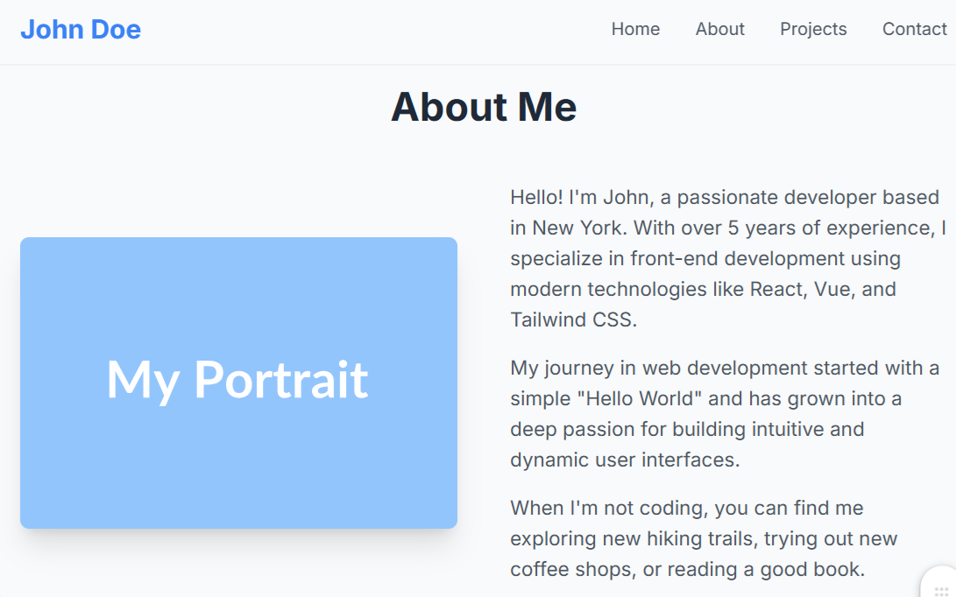
Projects Page | 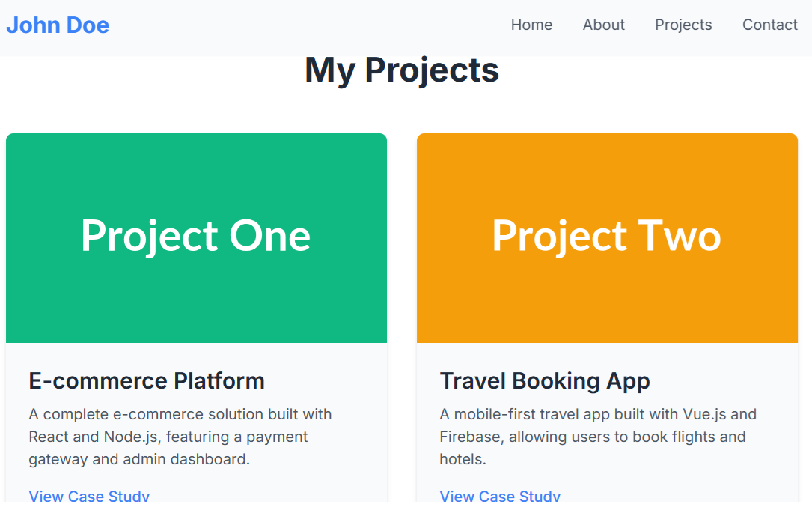
Contact Us Page | 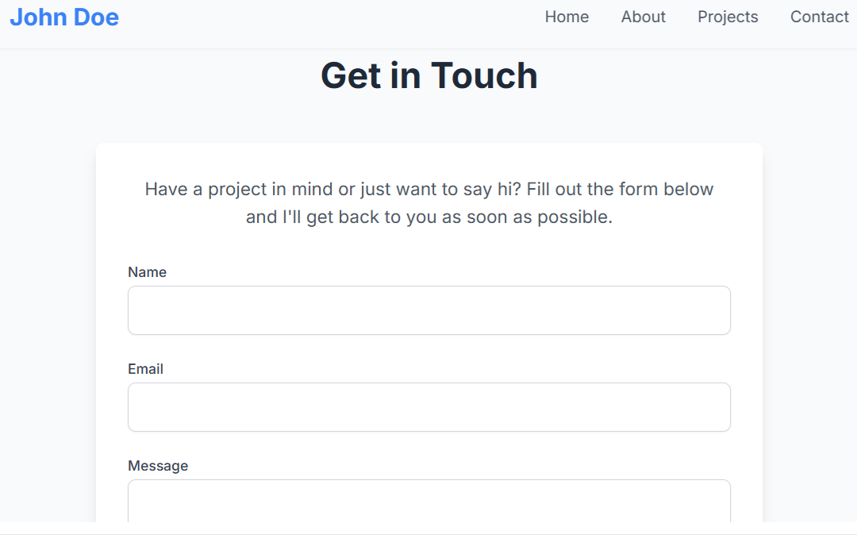

Instructions:
Here's a brief guide on how to make those four sections ("pages") in WordPress using the concepts from the assignment:
- Home Page:
  - Your theme controls the main layout. You can create a new page (Pages > Add New) and name it "Home".
  - Add any content you want.
  - To set this as your website's main homepage, go to Settings > Reading in your dashboard, change "Your homepage displays" to A static page, and select your "Home" page from the dropdown.
- About Page:
  - This is a standard static page. Just go to Pages > Add New in your dashboard.
  - Title it "About" and add your "About Me" text and images using the block editor.
- Projects Page:
  - This is also a static page. Go to Pages > Add New and title it "Projects".
  - You can use the built-in "Gallery" block to upload screenshots of your projects and create a grid just like the one in the portfolio.
- Contact Page:
  - This uses a plugin. First, create a page at Pages > Add New and title it "Contact".
  - Then, just like in Part 2 of the assignment, use a plugin like WPForms to create a contact form.
  - Finally, add the WPForms block to your "Contact" page to display the form.

