Working with Wix

What is Wix?
Wix is a cloud-based website builder that lets you create professional-looking websites without needing to code. It’s built around a drag-and-drop editor, meaning you can visually design your site — moving text, images, buttons, and more — exactly where you want them.
It’s popular among small businesses, freelancers, and creatives because it’s easy to use and all-in-one (hosting, design, and maintenance are included).

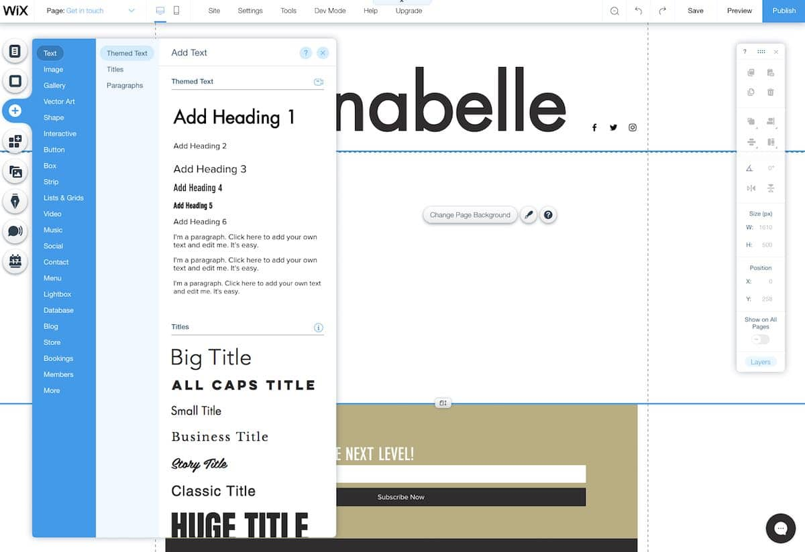

Core Components of Wix
1. Wix Editor
This is the main design tool. It allows you to:
- Drag and drop elements (text boxes, images, videos, buttons)
- Adjust layouts visually
- Add pages and menus
- Control mobile and desktop versions separately
- Customize fonts, colors, and backgrounds
Note: Great for beginners who want total control over visuals.

2. Wix ADI (Artificial Design Intelligence)
If you want to skip manual design, Wix ADI can build a site for you automatically.
- You answer a few questions (type of business, goals, style)
- ADI generates a complete website
- You can then tweak it using the editor
Note: Perfect for beginners who want a fast setup.

3. Wix Studio / Editor X (for professionals)
- Advanced, responsive design tools
- Better grid control for complex layouts
- Team collaboration features
- Ideal for designers and agencies
Note: This is for advanced users who want design flexibility similar to Figma or Webflow.

4. Wix App Market
Thousands of extensions and plugins for added functionality, such as:
- Chatbots
- Booking systems
- Online stores
- Social media integrations
- Email marketing tools (e.g., Wix Ascend)
Note: Like the “App Store” for your website.

5. Wix eCommerce
If you’re building an online store, Wix offers:
- Product listings with images and variants
- Shopping cart and checkout
- Payment gateways (Stripe, PayPal, etc.)
- Inventory management
- Coupons and discounts
Note: Includes built-in analytics and SEO tools for online businesses.

6. Wix CMS & Database (Wix Content Manager)
For dynamic websites (blogs, portfolios, listings), you can use the Content Manager:
- Create databases (collections) for content
- Design dynamic pages that automatically pull data (e.g., product or blog templates)
- Use Wix Velo (developer tools) to add logic, filtering, and automation
Note: This turns Wix into a low-code CMS, similar to WordPress or Webflow CMS.

7. Wix Velo (Developer Mode)
Velo by Wix is a JavaScript-based development platform built into Wix.
You can:
- Add custom interactivity and backend logic
- Create APIs
- Use databases and HTTP functions
- Write JavaScript directly inside Wix pages
Note: Useful for developers who want to extend Wix beyond drag-and-drop features.

How to Work with Wix (Step-by-Step)
Step 1: Sign Up
- Go to wix.com
- Create an account (Google, email, or Facebook)
Step 2: Choose a Method
- Use Wix ADI for an instant website
- Or open the Wix Editor for full manual design control
Step 3: Pick a Template
- Choose from 800+ pre-built templates by category (business, restaurant, portfolio, etc.)
- Templates are fully customizable
Step 4: Customize Your Site
- Edit text, colors, and images
- Add new pages (About, Contact, etc.)
- Manage your site menu
- Customize your mobile view
Step 5: Add Functionality
- Use the App Market for extras (booking, live chat, social media)
- Enable SEO tools
- Add blogs or stores if needed
Step 6: Set Up Domain & Hosting
- Wix provides free hosting
- You can use a free Wix domain (e.g., username.wixsite.com/mysite) or connect a custom one
Step 7: Publish
- Click “Publish” to go live
- You can make changes anytime and republish

Pro Tips
- Optimize for mobile: Wix allows a separate mobile layout editor.
- Use SEO Wiz: Wix’s built-in SEO tool helps you optimize content for Google.
- Track analytics: Connect Google Analytics or use Wix’s built-in analytics.
- Backup versions: Wix automatically saves versions, so you can revert anytime.
- Collaborate: Share your site with teammates or clients with role permissions.

Who Uses Wix?
- Small businesses (restaurants, salons, coaches)
- Freelancers and creatives (portfolios)
- E-commerce sellers
- Nonprofits and community groups
- Agencies building sites for clients

Create a simple website on Wix about Amul
We’ll make a 3-page website about Amul, India’s leading dairy brand, using Wix (www.wix.com). The pages will be:
- Home Page – Introduction to Amul
- Products Page – List of main Amul products
- About Us Page – History and achievements of Amul

Step-by-Step Instructions
Step 1: Sign Up and Start
- Go to https://www.wix.com
- Click “Get Started” or “Sign Up.”
- Create an account using Google or an email ID.
- Once logged in, click “Create New Site.”
- Choose “Business” → “Food & Drink” → “Dairy Brand” (or skip this).
- Select “Wix Editor” (so you can design manually).

Step 2: Choose a Template
- In the template section, search for “Food Brand” or “Dairy Company.”
- Choose a simple, clean template — for example, “Organic Dairy Farm” or “Food Company Website.”
- Click “Edit Template.”

Step 3: Create the Website Pages
🌟 Page 1: Home Page
Purpose: To introduce Amul and highlight its brand values.
Steps:
- Rename the homepage title to “Amul – The Taste of India.”
- Add the Amul logo (download from Google Images).
- Insert a large banner image (Amul products or cows on a farm).
- Add a short text box below the banner:
Content Example:
Welcome to Amul
Amul is India’s largest dairy brand, known for bringing high-quality milk and milk products to millions of homes every day. From butter and cheese to chocolates and ice cream, Amul products symbolize purity, taste, and trust.
- Add a button labeled “Explore Our Products” → link to the Products page.

🧈 Page 2: Products Page
Purpose: To showcase Amul’s popular product categories.
Steps:
- Add a new page → name it “Products.”
- Add a grid gallery or cards layout with product images.
Example categories:
  - Milk & Butter
  - Cheese
  - Ice Creams
  - Chocolates
  - Beverages
- Under each image, add a small description.
Example Content:
Amul Butter
The iconic Amul Butter has been India’s favorite since 1955. It’s smooth, creamy, and perfect for every breakfast.
Amul Cheese
Delicious and rich in protein, Amul Cheese adds flavor to every meal.
Amul Ice Cream
Made from pure milk and love, Amul Ice Cream offers happiness in every scoop.
Amul Chocolates
A perfect combination of milk and cocoa — a delight for chocolate lovers.
Amul Beverages
Refreshing flavored milk and energy drinks for every occasion.

🧭 Page 3: About Us Page
Purpose: To tell the story and mission of Amul.
Steps:
- Add a new page → name it “About Us.”
- Add an image of Dr. Verghese Kurien (the Father of the White Revolution).
- Insert the following text:
Example Content:
About Amul
Amul (Anand Milk Union Limited) was founded in 1946 in Anand, Gujarat.
It started as a cooperative movement to empower local dairy farmers.
Today, Amul is managed by the Gujarat Cooperative Milk Marketing Federation (GCMMF) and serves millions of consumers across India and abroad.
Vision: To provide quality dairy products to every household.
Mission: To empower farmers and promote the cooperative model.
Achievements:
- Pioneered India’s “White Revolution.”
- Exported dairy products worldwide.
- Iconic “Amul Girl” ads for over 50 years.

Step 4: Add Navigation Menu
- Click the Header section → Add Menu → Include:
  - Home
  - Products
  - About Us
This ensures users can move between pages easily.

Step 5: Customize the Design
- Choose blue and white theme colors (Amul brand style).
- Use fonts like Montserrat or Poppins for clean text.
- Add animations (e.g., fade-in for images or text).

Step 6: Publish the Website
- Click “Publish” (top right corner).
- Wix will give your site a free URL — something like:
https://yourname.wixsite.com/amul
- Share or preview your site.

Assignment

Home Page | 
About Me Page | 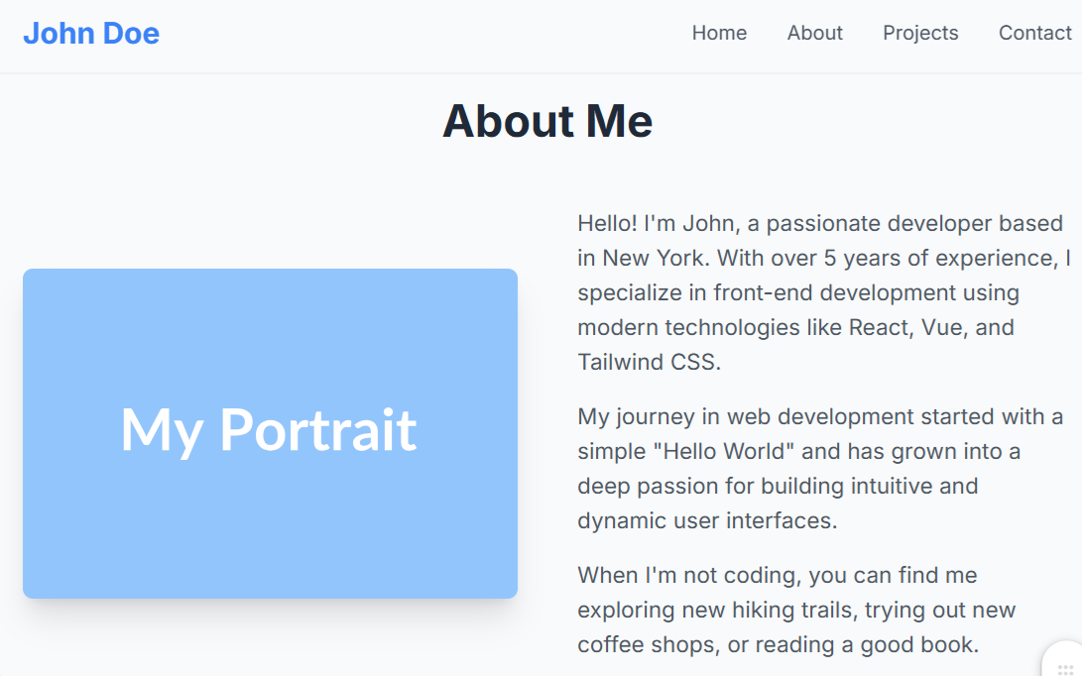
Projects Page | 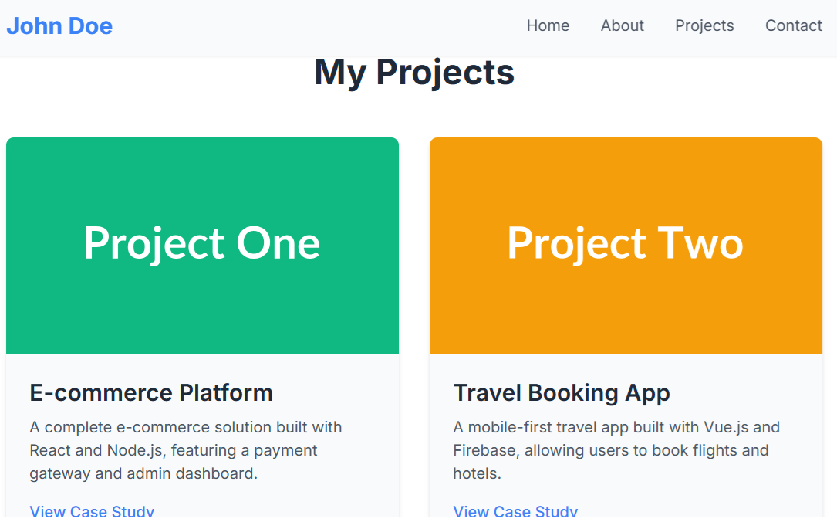
Contact Us Page | 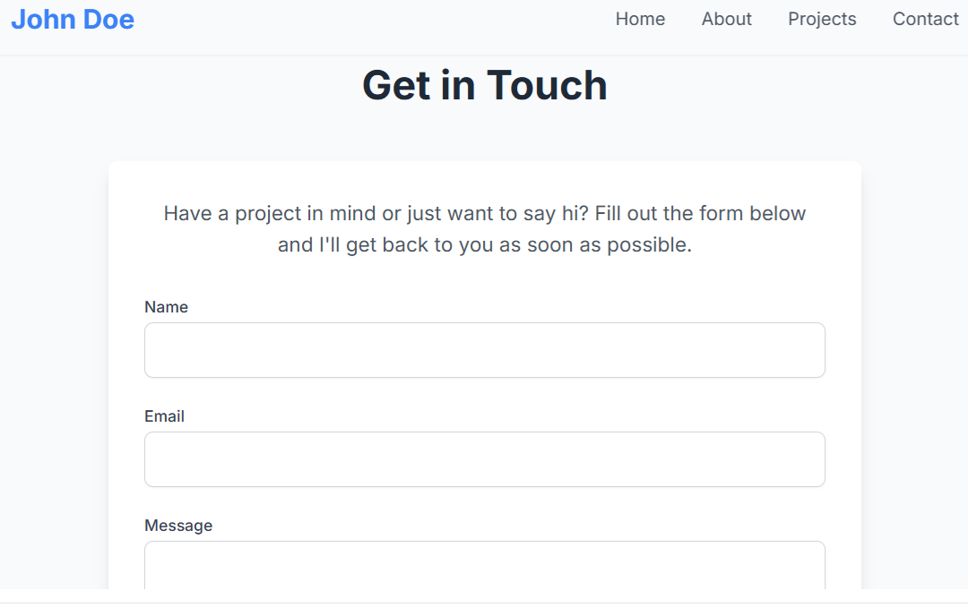

Instructions:
Here's a brief guide on how to make those four sections ("pages") in WordPress using the concepts from the assignment:
- Home Page:
  - Your theme controls the main layout. You can create a new page (Pages > Add New) and name it "Home".
  - Add any content you want.
  - To set this as your website's main homepage, go to Settings > Reading in your dashboard, change "Your homepage displays" to A static page, and select your "Home" page from the dropdown.
- About Page:
  - This is a standard static page. Just go to Pages > Add New in your dashboard.
  - Title it "About" and add your "About Me" text and images using the block editor.
- Projects Page:
  - This is also a static page. Go to Pages > Add New and title it "Projects".
  - You can use the built-in "Gallery" block to upload screenshots of your projects and create a grid just like the one in the portfolio.
- Contact Page:
  - This uses a plugin. First, create a page at Pages > Add New and title it "Contact".
  - Then, just like in Part 2 of the assignment, use a plugin like WPForms to create a contact form.
  - Finally, add the WPForms block to your "Contact" page to display the form.

