SERP

Understanding the SERP (Search Engine Results Page)

Definition
The Search Engine Results Page (SERP) is the page you see after typing a search query into a search engine like Google, Bing, or Yahoo.
It shows a combination of:
- Organic results (unpaid) – websites ranked through SEO.
- Paid results (ads) – listings that appear through PPC or Google Ads.
In India, Google dominates the market with over 95% share, making it the primary focus for digital marketers.

Purpose of the SERP
- To show users the most relevant results for their query.
- To give users quick answers — whether informational, transactional, or navigational.
- To give businesses opportunities for visibility and traffic through SEO or SEM.

Key Elements of a Google SERP
1. Search Bar
- Where users enter their queries (for example: “Best phones under ₹20,000”).
- The suggestions that drop down are based on popular Indian search trends.

2. Organic Results (Unpaid SEO Listings)
- These are regular search results that appear naturally because of good SEO.
- The ranking depends on content quality, relevance, and backlinks.
Example:
When you search “Best budget smartphones 2025 India”, websites like 91mobiles, Gadgets360, and TechRadar India appear.
Marketing Insight:
Indian brands like Flipkart and Croma use SEO-optimized content (reviews, buying guides) to appear in these results and attract free, long-term traffic.

3. Paid Results (Search Ads / PPC Ads)
- Appear at the top or bottom of the SERP with a small “Ad” label.
- Created through Google Ads campaigns.
- Businesses bid on keywords relevant to their products.
Example:
Searching “buy running shoes online” shows ads from Myntra, Ajio, and Amazon India.
Marketing Insight:
Indian e-commerce companies run PPC campaigns during festive sales like Big Billion Days or Diwali offers to boost traffic and conversions.

4. Featured Snippet (Position Zero)
- A highlighted box at the top that gives a quick answer to a query.
- Often shown as a paragraph, list, or table.
Example:
For “What is GST in India?”, Google may display a summary from ClearTax or IndiaFilings.
Marketing Insight:
Bloggers and companies optimize their content for FAQ-type queries to appear as the featured snippet and build authority.

5. Knowledge Panel
- Appears on the right-hand side (desktop) or top (mobile).
- Shows details about brands, public figures, or organizations.
Example:
Searching “Tata Group” displays a box with the company logo, founder, headquarters, and subsidiaries.
Marketing Insight:
Brands manage this data through Google Business Profile and Wikipedia to maintain accurate public information.

6. Local Pack (Google Map Pack)
- Shows nearby businesses with a map and top three listings.
- Triggered by searches with local intent like “salon near me” or “restaurants in Mumbai”.
Example:
A search for “cafes near Connaught Place” displays local cafés like Blue Tokai Coffee, Starbucks, and Café Delhi Heights.
Marketing Insight:
Local businesses in India use Local SEO and maintain their Google Business Profile with updated photos, reviews, and contact details to appear here.

7. People Also Ask (PAA) Section
- Displays related questions and short answers.
- Expands as you click on each question.
Example:
Searching “digital marketing course in India” may show questions like:
- “Which is the best digital marketing institute in India?”
- “Is digital marketing a good career in India?”
Marketing Insight:
Marketers create FAQ sections and blog posts addressing these queries to capture additional visibility.

8. Images, Videos & News Results
- Image results: Appear for visual queries like “lehenga designs 2025”.
- Video results: Often from YouTube India, e.g., “How to make paneer at home.”
- News results: Display updates from Times of India, NDTV, or Hindustan Times for trending searches.
Marketing Insight:
Indian brands use YouTube SEO, image optimization, and press releases to show up in these result types.

9. Related Searches
- Found at the bottom of the SERP; shows similar or trending search terms.
Example:
Searching “Best MBA colleges in India” might show:
- “Top private MBA colleges in India”
- “MBA entrance exams 2025”
- “Online MBA programs India”
Marketing Insight:
Marketers use these suggestions for keyword research and content planning in their SEO strategy

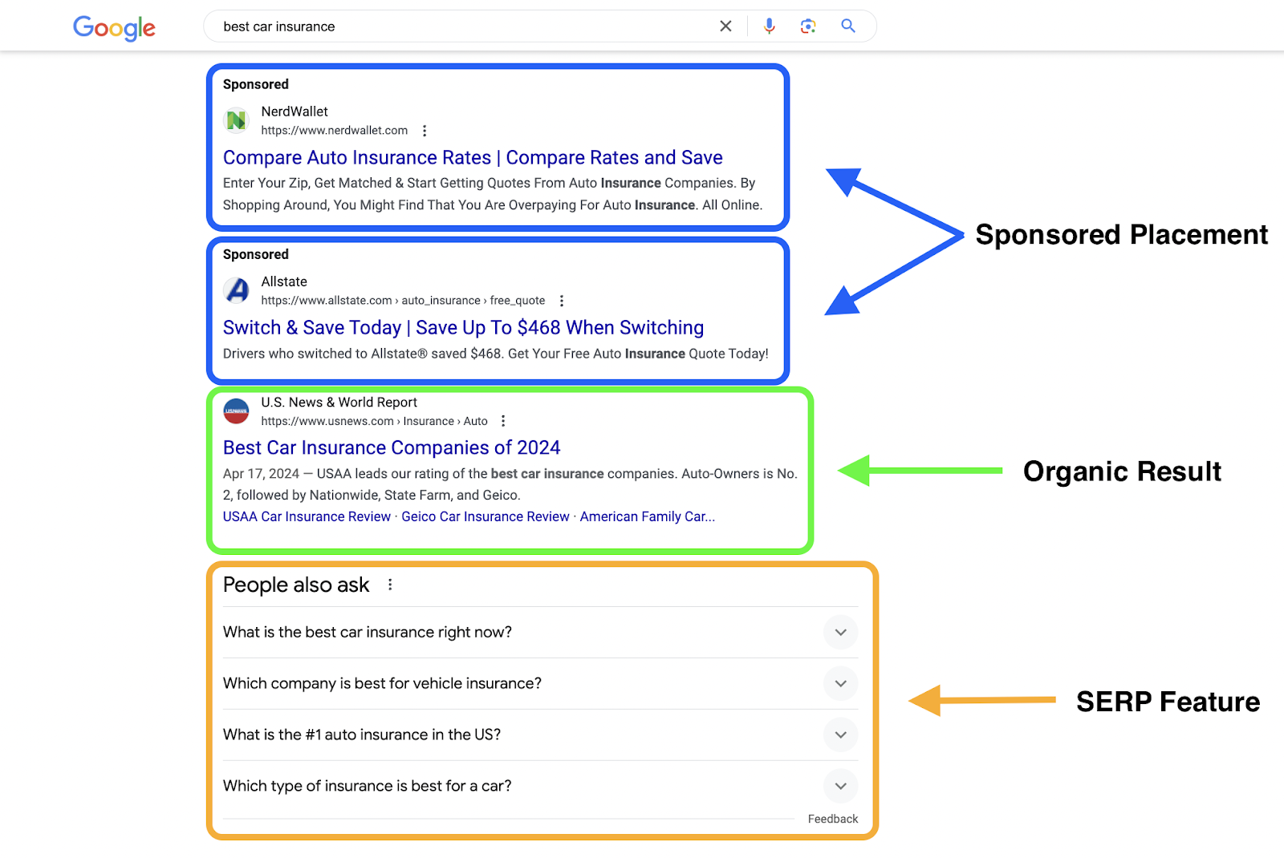
Assignment

Ques 1: What does SERP stand for?
A. Search Engine Ranking Process
B. Search Engine Results Page
C. Search Easy Result Panel
D. Search Engine Response Program

Ques 2: Which of the following is an example of a paid result on a SERP?
A. Featured Snippet
B. Organic blog result
C. People Also Ask result
D. Google Ads listing

Ques 3: The “Local Pack” (Google Map Pack) appears when:
A. A user searches for global brands
B. A search query has local intent
C. The user searches for images
D. The result is from Wikipedia

Ques 4: Which SERP feature provides a quick, highlighted answer at the top of the page, often called “Position Zero”?
A. People Also Ask
B. Featured Snippet
C. Knowledge Panel
D. Related Searches

Ques 5: What is the marketing benefit of the “People Also Ask” (PAA) section?
A. Helps websites appear on Google Maps
B. Allows brands to publish paid ads
C. Provides extra keyword ideas and opportunities to rank for FAQs
D. Shows only video results to users

