Introduction to Canva

What is Canva?
Canva is an online design tool that allows anyone to create:
- Posters
- Social media posts
- Logos
- Presentations
- Videos
- Business cards
- Thumbnails
- Banners
You don’t need graphic design skills. Everything is drag-and-drop (just click, move, resize, edit).

Why It’s Popular?
- Easy to use
- Free version available
- Thousands of templates
- Works on mobile & computer
- Gives professional-looking designs

Example
If you want to make an Instagram post:
- Open Canva
- Search “Instagram Post Template”
- Choose a template
- Edit text & color
- Download → Done!

Creating a Canva Account
Creating a Canva account is very easy.
Steps:
- Go to www.canva.com
- Click Sign up
- Choose how to create your account:
  - Google account
  - Email
  - Facebook
  - Apple ID
- Enter your details
- Your Canva account is created instantly

After Signup
Canva may ask:
- “What will you use Canva for?”
(Personal / Student / Business / Teacher)
This helps Canva show templates based on your need.

Example
If you choose Student, Canva will show:
- Class presentations
- Assignments
- Study notes templates

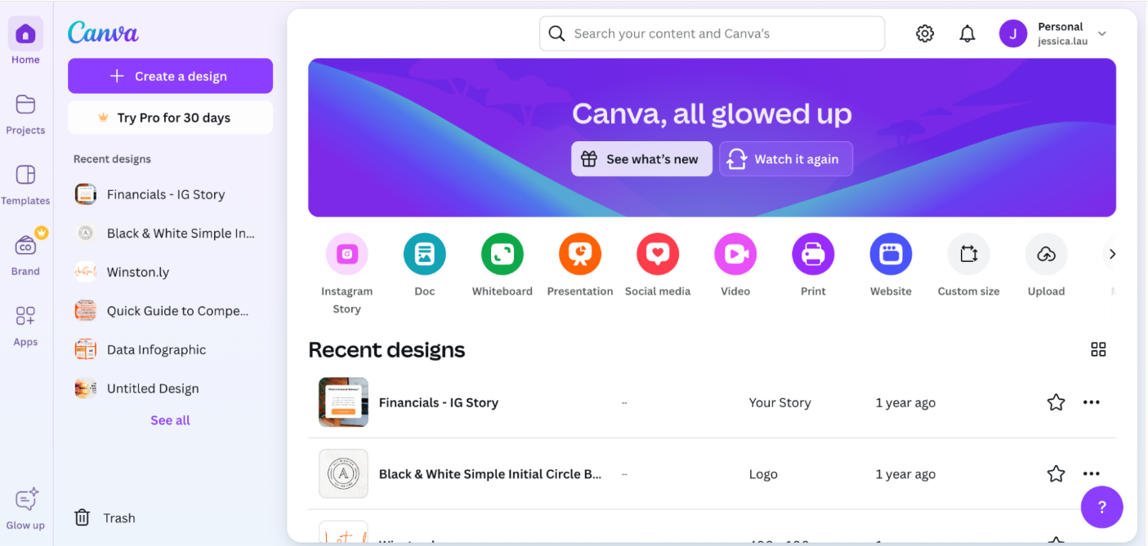

Canva Dashboard Overview
After logging in, you reach the Canva Dashboard.
This is your home area where you can access everything.
Main Parts of the Dashboard:
1️. Search Bar
Search any design type:
- “Instagram post”
- “Logo”
- “Poster”
- “Resume”
2️. Create a Design Button
Start a blank design from scratch.
3️. Your Projects / Designs
All your previously created designs are saved here.

4️. Templates Section
You will find ready-made templates for:
- Social media
- Business
- Videos
- Presentations
5️. Brand Hub (for Pro)
Stores your logo, colors, and fonts.
6️. Recent Designs
Shows your latest work so you can quickly continue.
7️. Sidebar Menu
Contains:
- Home
- Templates
- Projects
- Brand
- Apps
- Trash
Example
You want to design a resume →
Go to search bar → Type “resume” → Canva shows 1000+ resume templates.

Free vs. Pro Features in Canva
Canva has two versions:
A) Free Version
What You Get:
- Thousands of free templates
- Basic fonts
- Basic elements (shapes, icons, photos)
- Basic animations
- Download in JPG, PNG, PDF
- Unlimited designs
✔ Good For:
- Students
- Beginners
- Small businesses
Example:
You can make social media posts, resumes, logos, banners for free.

B) Pro Version (Paid)
Extra Features:
- Access to entire library (100 million+ elements)
- Premium photos and videos
- Magic tools (AI design, background remover)
- Save brand colors & fonts
- Resize your design automatically
- Remove backgrounds from photos
- More animations
- Schedule social media posts
✔ Good For:
- Professionals
- Freelancers
- Businesses
- Content creators
Example:
You upload a photo → want to remove background →
✔ Available only in Canva Pro.
Or, you want to turn an Instagram post into a Facebook banner in 1 click →
✔ Use Magic Resize (Pro feature).

Understanding Design Templates
What Are Templates? Templates are pre-made designs.
You just edit:
- text
- color
- photos
- layout
Templates save time and look professional.

Canva Has Templates for:
- Instagram posts
- Posters
- Business cards
- YouTube thumbnails
- Presentations
- Menu cards
- Wedding cards
- Resumes
- Flyers
- Certificates
Literally hundreds of categories.

Solved Example:
You want to create a birthday invitation card.
Instead of starting from scratch:
- Search “birthday invitation template”
- Choose a design you like
- Edit the name, date, place
- Download
Done in 2 minutes!



Assignment
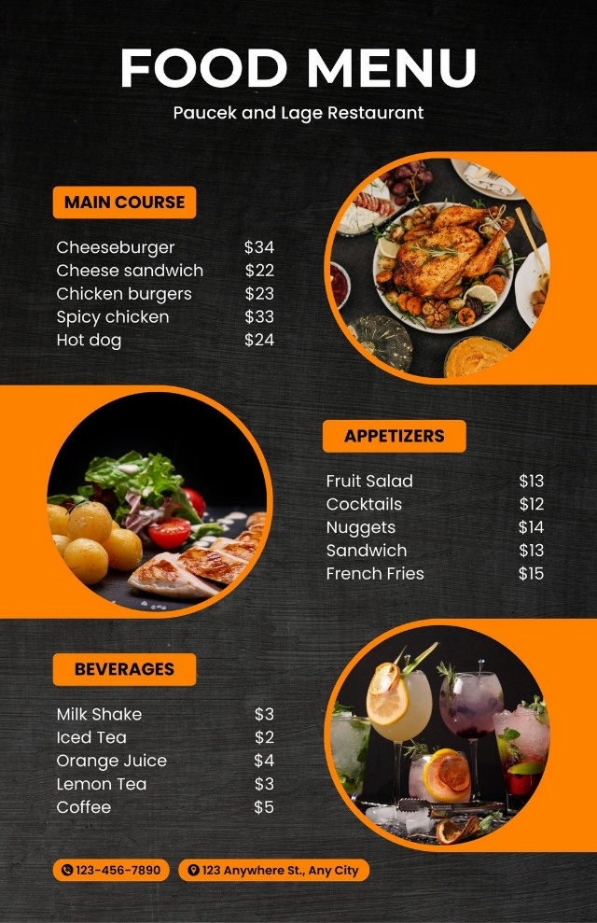
You want to make a restaurant menu.
Search “menu template” → edit items → add prices → change colors → download.
Something like this (not exactly this):

