Working With Canva Tools

1. Introduction to Canva Tools
Canva provides a simple, user-friendly editor that allows users to create designs using drag-and-drop tools. Understanding these tools helps in creating attractive and professional designs easily.

2. Using the Editor: Canvas, Pages & Layers
Canvas
- The canvas is the main design area
- All text, images, and elements are placed on the canvas
- Size of canvas depends on the design type (poster, post, presentation, etc.)
Pages
- A design can have multiple pages
- Used for presentations, brochures, and social media carousels
- Pages can be added, duplicated, deleted, or rearranged
Layers
- Each element is placed on a separate layer
- Layers control the order of elements (front or back)
Layer Options:
- Bring forward / Send backward
- Lock / Unlock elements
- Group / Ungroup items
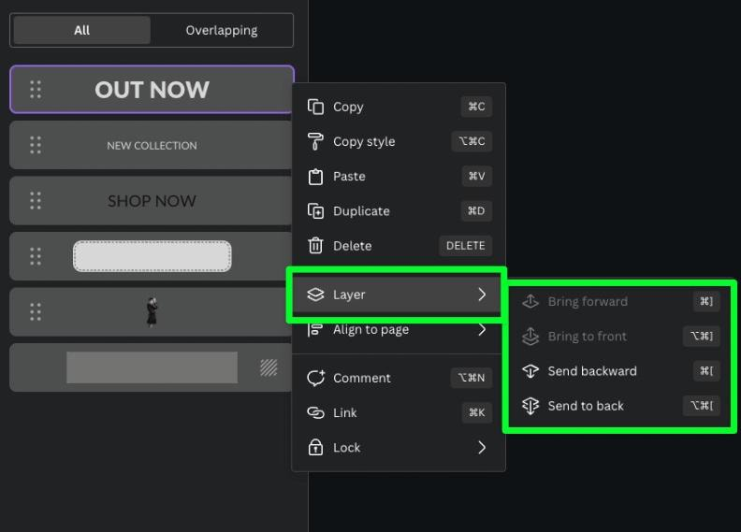
3. Adding Text, Images, Shapes & Icons
Adding Text
- Canva provides text boxes and text styles
- Different fonts, sizes, and colors can be used
- Headings, subheadings, and body text are available
Adding Images
- Use Canva’s free stock images
- Images can be resized, cropped, and adjusted
Shapes
- Shapes like rectangles, circles, and lines are used for layout design
- Helpful for backgrounds, highlights, and borders
Icons
- Icons are small graphic symbols
- Used to represent ideas visually
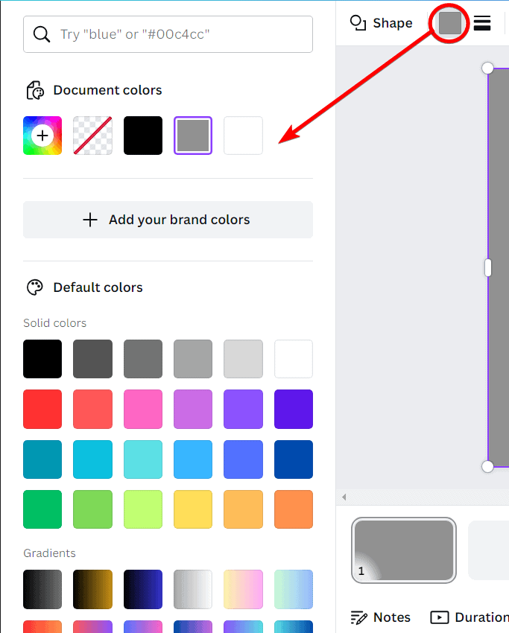
- Available in the Elements section

4. Using Backgrounds & Colors
Backgrounds
- Backgrounds fill the entire canvas
- Canva provides solid colors, gradients, and image backgrounds
Colors
- Colors enhance visual appeal
- Users can select colors from:
  - Color palette
  - Custom color codes
Tips:
- Use limited colors
- Ensure good contrast between text and background

5. Uploading Your Own Images & Videos
Uploading Files
- Canva allows uploading:
  - Images
  - Videos
  - Audio files
Steps:
- Click Uploads
- Choose files from device
- Drag and drop onto canvas
Uses:
- Personal photos
- Company logos
- Custom videos

6. Using Elements (Photos, Graphics, Stickers, Charts)
Photos
- High-quality stock photos
- Used for backgrounds and visual appeal
Graphics
- Illustrations and vector designs
- Used for creative designs
Stickers
- Animated or decorative elements
- Commonly used in social media posts
Charts
- Used to represent data visually
- Includes bar charts, pie charts, and line charts
How to Use Elements:
- Go to Elements
- Select required element
- Drag and drop onto canvas
- Resize or customize

Assignment: Computer Skills Poster in Canva

Objective
Create a Computer Skills poster in Canva using layers and background colors only (no images).

Steps in Canva
Step 1: Create Design
- Open Canva → Create a Design → Poster (A4)
Step 2: Background (Bottom Layer)
- Click the page
- Apply a light background color
Step 3: Title Box (Middle Layer)
- Elements → Shapes → Rectangle
- Use a dark color
- Place it at the top
Step 4: Title Text (Top Layer)
- Text → Add a Heading
- Type COMPUTER SKILLS COURSE
- Color: White
- Place over the rectangle
Step 5: Skills Section
- Add another rectangle (light shade)
- Add text:
  - Basics of Computer
  - MS Word
  - MS Excel
  - MS PowerPoint
  - Internet & Email
Step 6: Course Details
- Add one more rectangle at the bottom
- Add text:
  - Duration: 3 Months
  - Mode: Online / Offline
  - Certificate Provided
Step 7: Arrange Layers
- Position → Forward / Backward
- Order: Background → Shapes → Text
Step 8: Lock Background
- Select background → Lock 🔒
